6G PoE+2G兆PoE+4G SFP端口千兆网
EKI-7712G-4FMPI 管型工业^{PoE}交换机
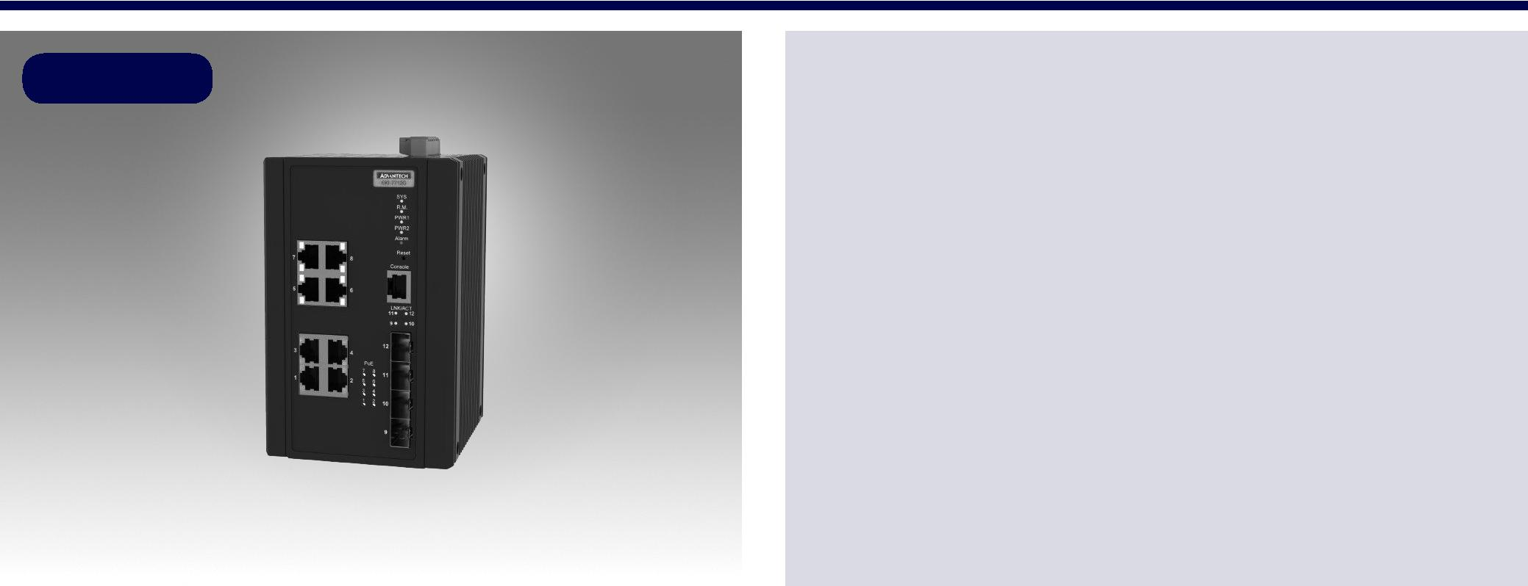

Preliminary

RoHS
COMPLIANT

2011/65/EU

介绍

特性

支持IEEE 802.3bt 8级90W兆PoE、6 x IEEE 802.3 af/at PoE千兆端口+2 x IEEE 802.3 bt PoE千兆端口+4个SFP端口
SFP插座，方便灵活的光纤扩展

冗余：X-Ring Pro（超高速恢复时间，<20 ms），RSTP STP（802.1w/1d）
IXM功能支持快速部署

安全：802.1X（基于端口，MD5/TLS/TTLS/PEAP加密），radius

管理：SNMP v1/v2c/v3、web、telnet、标准MIB、私有MIB
用于交通控制的NEMA TS2
EN50121-4铁路轨旁部署审批
-40~70°C宽范围工作温度
双48 Vdc电源输入和1 x继电器输出

EKI-7712G-4MPI是下一代PoE交换机，支持IEEE802.3BT 8级90W PoE用于大功率应用。EKI-7712G-4MPI与6 x 802.3 af/at PoE千兆端口、2 x 802.3 bt PoE千兆端口和4 x SFP端口相结合，为不同的场景提供多种用途。EKI-7712G-4MPI嵌入了Advantech的IxM功能，通过快速部署可以为用户带来好处，并且可以节省大量的工程时间和成本。它还支持NMS，帮助IT经理进行网络维护和故障预防。该系列还配备了X-Ring Pro，可以实现<20 ms的超高速恢复时间，确保网络稳定。

规格

接口

- I/O 接口

控制接口
电源连接器

物理特性

外壳
防护等级
安装
尺寸 (W x H x D)

LED 显示

 系统LED

 接口 LED

8 x 10/100/1000BASE-T/TX RJ-45

4 x SFP (mini-GBIC) port

RS-232 (RJ45)

6-pin screw Terminal Block (including relay)

Metal Shell

IP 30

DIN-Rail

97 x 152 x 105 mm (3.819" x 5.984" x 4.134")

PWR1, PWR2, SYS, Alarm and R.M.

Link / Speed / Activity

认证

 | 安全 | UL 61010
 | EMI | CE, FCC Class A
 | EMS | EN 61000-4-2
 |  | EN 61000-4-3
 |  | EN 61000-4-4
 |  | EN 61000-4-5
 |  | EN 61000-4-6
 |  | EN 61000-4-8
 Shock |  | IEC 60068-2-27
 Freefall |  | IEC 60068-2-32
 Vibration |  | IEC 60068-2-6
 Traffic control |  | NEMA TS2
 Railway Track Side |  | EN 50121-4
 Patent |  | http://www.advantech.com/legal/patent

环境

 | 工作温度 | -40 | ~ 70°C (-40 ~ 158°F)
 | 储存温度 | -40 | ~ 85°C
 | 环境相对湿度 | 10 ~ 95% (非凝结)
 | 储存湿度 | 10 ~ 95% (非凝结)

电源

 | 功耗 | 20W @ 48VDC (System)
 | 电源输入 | 48 | VDC (46 to 57 VDC),
 |  | 53 | -57 VDC is recommended for 802.3at and

802.3bt, redundant dual power input

 电力预算 370W

 故障输出 1 Relay Output

二级特性

 | L2 MAC Address | 8K
 | Jumbo Frame | 9216 Bytes
 | VLAN Group | 256 (VLAN ID 1 ~ 4094)
 | VLAN Arrange | Port based VLAN, Q-in-Q (VLAN Stacking), GVRP
 | Port Mirroring | Per port, Multi-source port,
 | IP Multicast | IGMP Snooping v1/v2/v3, MLD
 |  | Snooping, IGMP Immediate leave
 | Storm Control | Broadcast, Multicast, Unknown unicast
 | 冗余 | IEEE 802.1D-STP, IEEE 802.1s-MSTP, IEEE
 |  | 802.1w-RSTP, X-Ring Pro, with ultra high-speed
 |  | recovery time less than 20ms

Industrial Ethernet Solutions

All product specifications are subject to change without notice. Last updated: 5-Sep-2018

EKI-7712G-4FMPI

结构图

97 [3.819]

[2.813]
25060.[2.372]
45071.
[0.591]
15

152 [5.984] 9.900 [0.390]

Unit: mm [inch]

 | 10071. [2.799]
37.720 | 35.560
[1.485] | [1.400]
84 [3.287]
114 [4.488] |  | 97 [3.819]
105 [4.134] |  | 47 [1.850]
35.180 | 40.640 | 45 | 24.500 |  |  | 105 [4.134]
 |  | [1.772] | [0.965]
[1.385] | [1.600]
 |  |  |  | 29[1.142]94[3.701] | 900161.[6.374]
 | [2.212] | 152[5.984] | 10014.555][0. |  |  | 152[5.984]
 | 56.181 |  | 800123.
 | 850][1. |  | 984][5.
 | 47
 |  | 6-M3xP0.5 Draw Hole
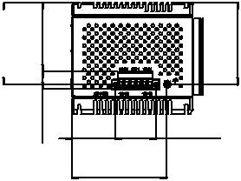
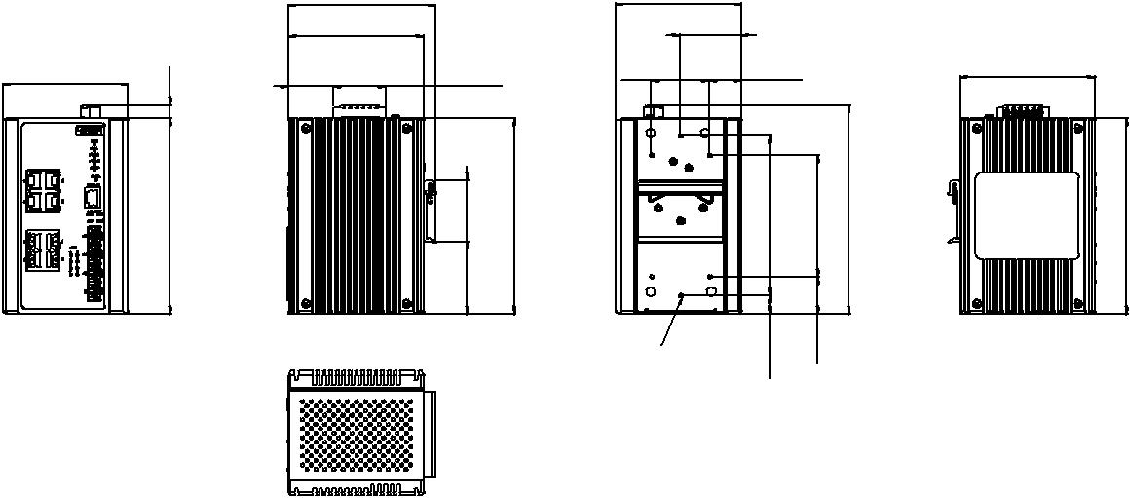

 | Panel Cut-out Dimensions: 105 x 152 x 97 (4.134" x 5.98" x 3.819")
QoS |  | 订购信息
 Priority Queue | WRR (Weighted Round Robin), SP (Strict Scheduling |  EKI-7712G-4FMPI-AE 6G PoE + 2G Mega PoE + 4G SFP PoE Ethernet Switch
Scheduling | Priority) Hybrid Priority
 |  | w/Wide Temp
 Class of Service | IEEE 802.1p Based CoS, IP TOS, DSCP based CoS
 Rate Limiting | Ingress Rate limit, Egress Rate limit
 Link Aggregation | IEEE 802.3ad Dynamic Port Trunking, Static Port
 | Trunking

安全

 接口安全

认证

管理

- DHCP

- Access

- 安全访问

- 软件升级

- NTP

Static, Dynamic IP Source Guard, ARP Spoofing

Prevention, Access Control List, DHCP Snooping,

802.1x (Port-Based, MD5/TLS/TTLS/PEAP

Encryption), TACACS+

Client, Server, Option66/67/82

SNMP v1/v2c/v3, WEB, Telnet, RMON, Standard MIB,

Private MIB

SSH2.0, SSL

TFTP, HTTP, Dual Image

SNTP client

Online Download www.advantech.com/products

