EKI-9628G-4CI
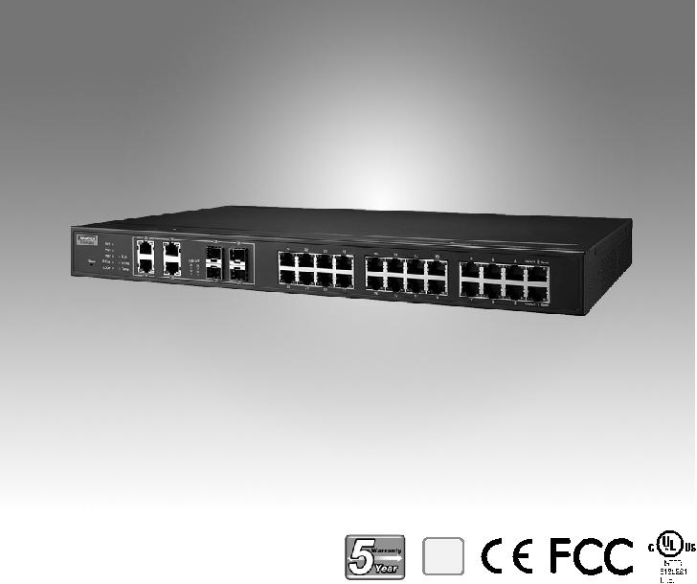

RoHS
COMPLIANT

2002/95/EC

介绍

24G+4G组合端口工业级L3网管交换机

特性

机架式24G+4G组合端口L3网管交换机

L3功能：静态路由，NAT

SFP插座，方便灵活的光纤扩展

管理：SNMP v1/v2c/v3、web、telnet、标准MIB

安全性：802.1X、https、ssh和snmpv3

冗余：Gigabit X-Ring Pro（超高速恢复时间，<20 ms）、RSTP

STP（802.1w/1d）、MSTP

宽工作温度范围-40~70°C

EKI-9628G是一种工业级L3管理交换机，支持静态路由和NAT。它内置了24个千兆端口和4个千兆组合端口，专为机架式安装而设计，可在苛刻的工业环境中部署。它适用于边缘到核心的工业网络，支持-40~70°C的工作温度。它还嵌入了Advantech IXM，使用户可以快速部署，大大节省了工程时间和成本。

规格

通信

 | 标准 | IEEE 802.3, 802.3u, 802.3x, 802.3z, 802.1D, 802.1w,
 |  | 802.1p, 802.1Q, 802.1X, 802.3ad, 802.3ab
 | LAN | 10/100/1000BASE-TX, optional 100BASE-FX,
 |  | 1000BASE-SX/LX/LHX/XD/ZX/EZX
 | 传输距离 | Ethernet: Up to 100 m (4- wire Cat.5e, Cat.6 RJ45
 |  | cable suggested for Gigabit port)
 |  | SFP: Up to 110 km (depends on SFP)
 |  传输速度 | Gigabit Copper: 10/100/1000 Mbps, Auto-Negotiation
 |  | Gigabit Fiber: Up to 1000 Mbps

构

 | 外壳 | IP30, metal shell with solid mounting kits
 尺寸 (W x H x D) |  | 438 x 43.6 x 259.20 mm (17.24" x 1.72" x 10.2")
 | 安装 | 1U 19" Rack mount

源

 电力消耗 | 20W @ 24V
电源输入 | 12-48 VDC
故障输出 | 2 Relay Outputs

接口

 连接器 24 x RJ45 (Ethernet)

4 x RJ45/SFP (mini-GBIC) combo ports

4-pin removable screw terminal (Power)

3-pin removable screw terminal (Relay)

 LED 指示灯 10/100T (X): Link/Activity, Duplex/Collision
Gigabit Copper: Link/Activity, Speed (1000 Mbps)

SFP: Link/Activity

控制器 RS-232 (RJ45)

管理

 | 配置 | Web browser, Telnet, Serial console, TFTP, SNMPv1/
 |  | v2c/v3, Port Speed/Duplex Configuration, IPv6
 | VLAN | IEEE 802.1Q, GVRP
 | 冗余 | Advantech X-Ring, 802.1w/D RSTP/STP
 | 安全 | IP Access security, port security, DHCP client, 802.1X
 |  | Port Access Control,
 | Traffic Control | IGMP Snooping/Query for multicast group
 |  | management, Port Trunking, Static/802.3ad LACP, Rate
 |  | limit and storm control, IEEE 802.1p QoS CoS/TOS/
 |  | DSCP priority queuing, IEEE 802.3x flow control
诊断 |  | Port Mirroring, Real-time traffic statistic, MAC Address
 |  | Table, SNTP, Syslog, E-Mail Alert, SNMP Trap, RMON
 | Unicast Routing | NAT,Static routing

护

 反极性 Present

 过载电流 Present

 环境

 工作温度 - 40 ~ 70°C (-40 ~ 158°F)

 储存温度 -40 ~ 85°C (-40 ~ 185°F)

 工作湿度 10 ~ 95% (non-condensing)

 储存湿度 10 ~ 95% (non-condensing)

 MTBF 787,940 hours

证
 | 安全 | UL 61010-2-201
 | EMI | CE FCC EN55022 Class A
 | EMS | EN 61000-4-2
 |  | EN 61000-4-3
 |  | EN 61000-4-4
 |  | EN 61000-4-5
 |  | EN 61000-4-6
 |  | EN 61000-4-8
 | Shock | IEC 60068-2-27
 | Freefall | IEC 60068-2-32
 | Vibration | IEC 60068-2-6
 | Railway Track Side | EN 50121-4
 | Patent | http://www.advantech.com/legal/patent

Industrial Ethernet Solutions

All product specifications are subject to change without notice. Last updated: 27-Jun-2018

EKI-9628G-4CI

结构图

426 [16.77]
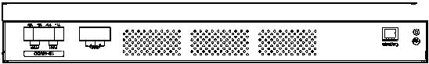

79.30 31.50
[3.12] [1.24]
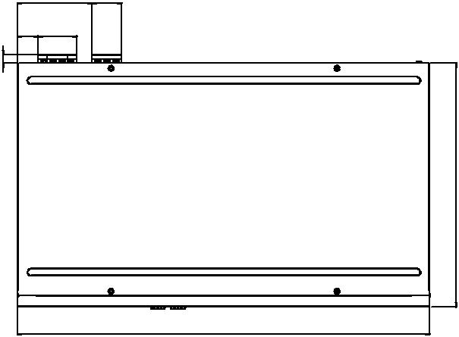
22 41
[0.87] [1.61]

[0.36] 209.

438 [17.24]
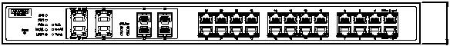

Unit: mm [inch]

12 [0.47]

259.20 [10.20]

72][1. 6043.

订购信息

 EKI-9628G-4CI-AE 24GE +4G Combo Port L3 rackmount Managed

Ethernet Switch w/ Wide Temp

Online Download www.advantech.com/products

