EKI-9728G-4X8CI 带AC/DC的工业机架式L3网管交
换机
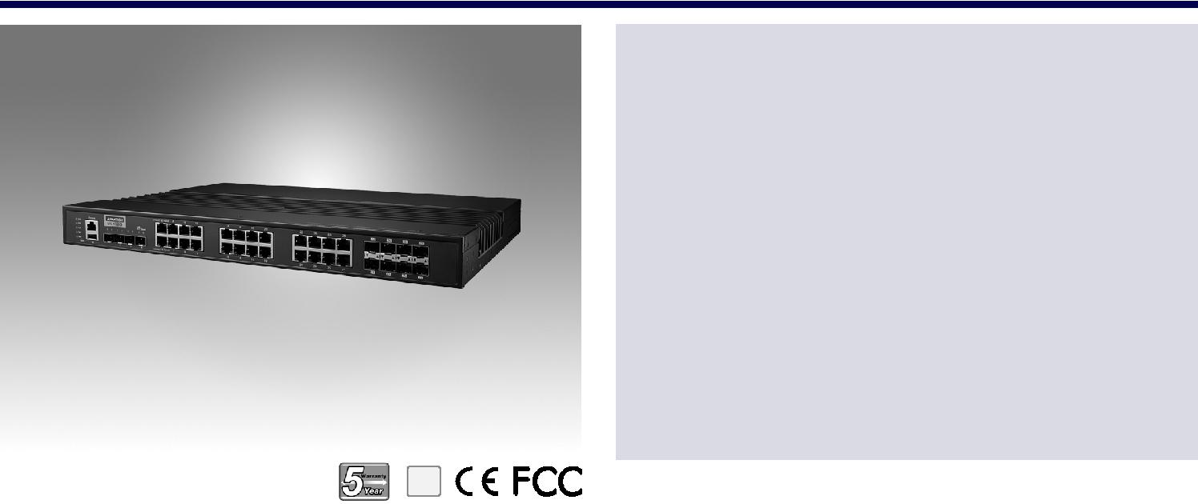

特性

16个千兆RJ-45端口+4个万兆SFP端口+8个千兆组合端口

L3功能：静态路由、RIP v1/v2、OSPF v2、VRRP

SFP插座，方便灵活的光纤扩展

管理：SNMP v1/v2c/v3、web、telnet、标准MIB

安全：802.1X https、ssh和snmpv3

双电源输入和2 x继电器输出

宽工作温度范围-40~85˚C

RoHS
COMPLIANT

2002/95/EC

介绍

EKI-9728G是一个L3管理交换机，支持RIP v1/v2、OSPF v2和VRRP。宽工作温度-40~85°C，能在恶劣环境下可靠工作。该设备设计有16个千兆端口、4个万兆SFP端口和8个千兆端口，提供丰富灵活的连接选项。最后，EKI-9728G系列具有双电源输入以确保系统稳定性，以及2个继电器输出以提高用户灵活性。

规格

通信

 | 标准 | IEEE 802.3, 802.3u, 802.3x, 802.3z, 802.1D, 802.1w,
 |  | 802.1p, 802.1Q, 802.1X, 802.3ad, 802.3ab
 | LAN | 10/100/1000BASE-TX, optional 100BASE-FX,
 |  | 1000BASE-SX/LX/LHX/XD/ZX/EZX
 传输距离 |  | Ethernet: Up to 100 m (4- wire Cat.5e, Cat.6 RJ45
 |  | cable suggested for Gigabit port)
 |  | SFP: Up to 110 km (depends on SFP)
 | 传输速度 | Ethernet: 10/100 Mbps Auto-Negotiation
 |  | Gigabit Copper: 10/100/1000 Mbps, Auto-Negotiation
 |  | Gigabit Fiber: Up to 1000 Mbps

源

电力消耗 19.24 W @ 110VAC
电源输入 90 ~ 264AC/88 ~ 370VDC
故障输出 2 Relay Outputs

护

 反极性 Present
 过载电流 Present

境

 操作温度 -40 ~ 85°C (-40 ~ 185°F)
 储存温度 -40 ~ 85°C (-40 ~ 185°F)

接口

 连接器

- LED 指示灯

- 控制器

16 x RJ45 (Ethernet)

8 x RJ45/SFP (mini-GBIC) combo ports

4 x SFP Ports

3-pin removable screw terminal (Power)

4-pin removable screw terminal (Relay)

10/100T (X): Link/Activity, Duplex/Collision

Gigabit Copper: Link/Activity, Speed (1000 Mbps)

SFP: Link/Activity

RS-232 (RJ45)

 工作湿度 10 ~ 95% (non-condensing)
 储存湿度 10 ~ 95% (non-condensing)

证

 EMI | CE FCC EN55022 Class A
 EMS | EN 61000-4-2
 | EN 61000-4-3
 | EN 61000-4-4
 | EN 61000-4-5
 | EN 61000-4-6
 | EN 61000-4-8

构

 外壳 IP30, metal shell with solid mounting kits

 尺寸 (W x H x D) 442 x 44 x 352 mm (17.4" x 1.73" x 13.85")
 安装 1U 19" Rack mount

 | Shock | IEC 60068-2-27
 | Freefall | IEC 60068-2-32
 | Vibration | IEC 60068-2-6

Industrial Ethernet Solutions

All product specifications are subject to change without notice. Last updated: 27-Jun-2018

EKI-9728G-4X8CI

结构图 Unit: mm

442
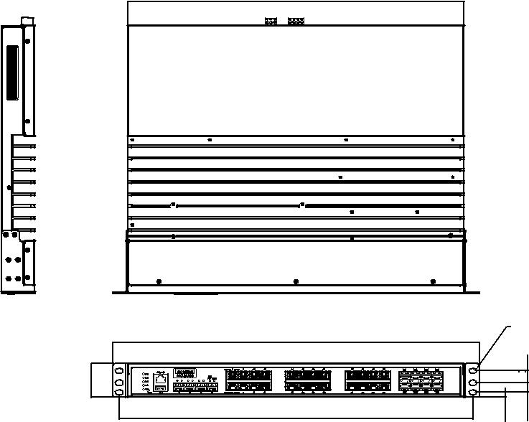

482

44

465

352
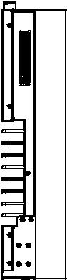

Ø6.8x10.3 OB Hole

6.20 | 12.70 5.90

二级功能

 L2 MAC Address 16K

 Jumbo Frame 12KB

 VLAN Group 4093 (VLAN ID 1~4093)

 VLAN Mac based VLAN, Protocol based VLAN,

IP subnet based VLAN, Port based VLAN, GVRP

 Port Mirroring Per port, Multi-source port

 IP Multicast IGMP Snooping v1/v2/v3, MLD Snooping,

IGMP Immediate leave

 Storm Control Broadcast, Multicast, Unknown unicast

 Spanning Tree IEEE 802.1D-STP, IEEE 802.1s-MSTP,

IEEE 802.1w-RSTP

 Unicast Routing Static Routing, RIPV1/V2, OSPF

QoS

 | Priority Queue | WRR (Weighted Round Robin), SP (Strict Priority)
 | Scheduling
 Class of Service |  | IEEE 802.1p based CoS, IP TOS, DSCP based CoS
 | Rate Limiting | Egress Rate limit, Ingress Rate limit
 | Link Aggregation | IEEE 802.3ad Dynamic Port Trunking, Static Port
 |  | Trunking

安全

 Port Security Static, Dynamic

 Authentication 802.1x (Port-Based), RADIUS, TACACS+

 Advanced Security IP Source Guard

管理

 DHCP Client, Server

 Access SNMP v1/v2c/v3, WEB, Telnet, RMON, Standard MIB,

Private MIB

 Security Access SSH 2.0, SSL

 Software Upgrade TFTP, HTTP, Dual Image

 NTP SNTP client

 Routing Redunance VRRP

订购信息

 EKI-9728G-4X8CI-AE Ind. Rackmount L3 Managed Switch with AC/DC

Online Download www.advantech.com/products

