EKI-2712G-4FPI | 8G+4SFP Port Gigabit Unmanaged
 | Redundant Industrial PoE Switch
 | Features
 |  8 x IEEE 802.3 af/at PoE Gigabit ports + 4 x SFP ports
 |  SFP socket for easy and flexible fiber expansion
 |  NEMA TS2 for traffic control
 |  EN50121-4 approval for railway trackside deployment
 |  -40 ~ 75°C wide-range operating temperature
 |  Dual 48 VDC power input and 1 x relay output
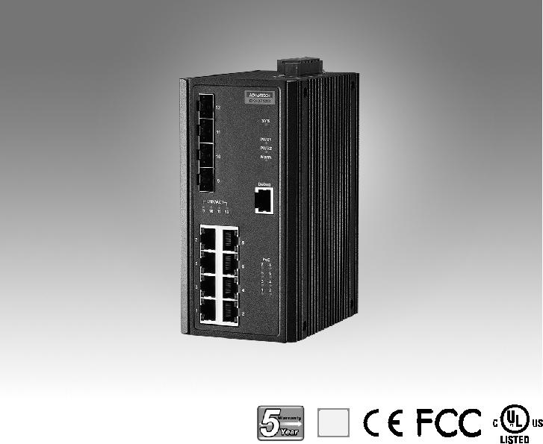
RoHS
COMPLIANT

2002/95/EC

Introduction

EKI-2712G-4FPI supports 8 Gigabit IEEE 802.3 af/at PoE ports and 4 SFP (mini-GBIC) ports. They can provide up to 30 watts per port to fulfill high power consumption PD (Power Device). The switch also features a wide -40° to 75°C operating temperature and NEMA TS2 rating, making the switch an ideal solution for use in traffic applications and have successfully passed the EN50121-4 European railway standard requirements of emission and immunity for railway platforms and trackside deployment.

Specifications

Interface

 I/O Port 8 x 10/100/1000BASE-T/TX RJ-45

4 x SFP (mini-GBIC) port

 Debug Port RS-232 (RJ45)

 Power Connector 6-pin screw Terminal Block (including relay)

Physical

 Enclosure Metal Shell

 Protection Class IP 30

 Installation DIN-Rail

 Dimensions (W x H x D) 74 x 152 x 105 mm (2.91" x 5.98" x 4.13")

LED Display

 System LED PWR1, PWR2, SYS, and Alarm

 Port LED Link / Speed / Activity

Certification

 EMI | CE, FCC Class A
 Safety | UL61010
 EMC | EN 61000-4-2
 | EN 61000-4-3
 | EN 61000-4-4
 | EN 61000-4-5
 | EN 61000-4-6
 | EN 61000-4-8
 | EN50121-4
 Shock | IEC 60068-2-27
 Freefall | IEC 60068-2-32
 Vibration | IEC 60068-2-6
 Traffic control | NEMA TS2
 Patent | http://www.advantech.com/legal/patent

Environment

 | Operating Temperature | -40 | ~ 75°C (-40 ~ 167°F)
 | Storage Temperature | -40 | ~ 85°C
 Ambient Relative Humidity |  | 10 ~ 95% (non-condensing)
 | Humidity | 10 ~ 95% (non-condensing)

Power

 Power Consumption | 12.1W @ 48VDC (System)
 Power Input | 48 | VDC (46 to 57 VDC),
 | 53 | -57 VDC is recommended for 802.3at,
 | redundant dual power input
 Power Budget | 240W
 Fault Output | 1 Relay Output

Industrial Ethernet Solutions

All product specifications are subject to change without notice. Last updated: 26-Jun-2018

EKI-2712G-4FPI

Dimensions

[2.222]
 | 781][1.
4556. | 2545.
 | 591][0.
 | 15

Unit: mm [inch]

1056. [2.209]
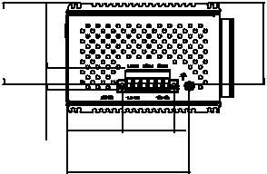

37.72 35.56

[1.485] [1.400]

83.50 [3.287]

 | 114 [4.488] |  |  | 74 [2.913]
 |  |  |  | 37 [1.457]
 | 105 [4.134]
 |  |  |  | 35
74 [2.913] | 35 | 40.64
 | [1.385] | [1.600] |  | [1.378]
 | [0.390]
 | 9.90
 | 152 [5.984] |  | [2.165] 47 [1.850] | 152 [5.984]
 |  |  | 55
 |  |  |  | 6-M3xP0.5
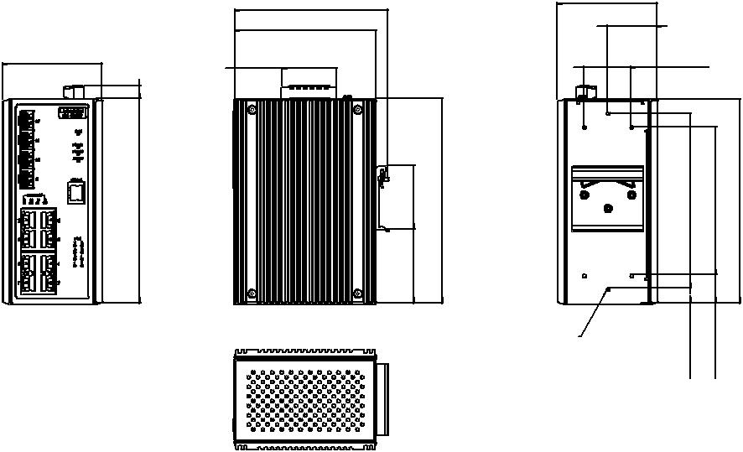

19.50 |  |  | 105 [4.134]
[0.768]
130 [5.118] | 110 [4.331] | 152 [5.984] | 152 [5.984]
11 [0.433] | 21 [0.827]
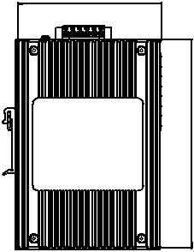

Panel Cut-out Dimensions: 105 x 152 x 74 (4.134" x 5.98" x 2.913")

Ordering Information

 EKI-2712G-4FPI-AE 8GE + 4SFP Port Unmanaged PoE Ethernet Switch

w/Wide Temp

Online Download www.advantech.com/products

