PCI-1671UP

IEEE-488.2 Interface Low Profile Universal PCI Card

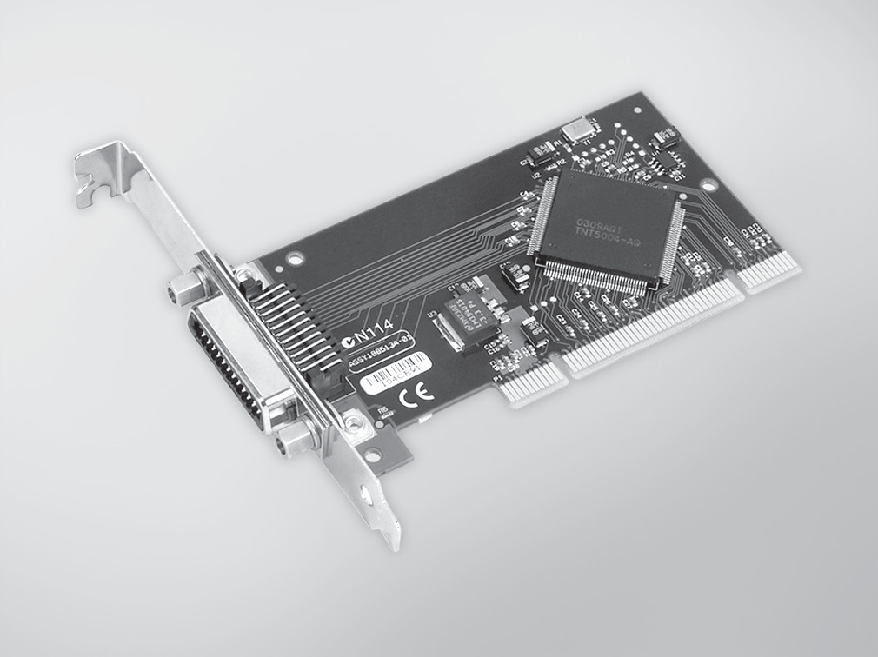
RoHS
COMPLIANT
2002/95/EC
Features
- IEEE 488.2 Standard interface
- Complete Talker/Listener/Controller
- Industry standard 32-bit PCI bus
- Data transfer rates over 1.5 MB/s
- 1,024-word FIFO buffer
- High-Speed State Machine Bus Manager
- 7 Interrupt lines, shared interrupt capability
- Transparent interrupt enabling/disabling
- Includes GPIB-Library software
- Low profile MD1 size

Introduction
The PCI-1671UP IEEE-488 interface converts any PCI bus personal computer into an instrumentation control and data acquisition system. Connect up to 14 instruments using standard IEEE-488 cables such as the PCL-10488-2, 2 meter IEEE-488 interface cable. The PCI-1671UP transfers data over the GPIB at rates in excess of 1.5 million bytes per second using the maximum IEEE-488 specification cable length (2 meters times the # of devices). A 1,024-word FIFO buffer and the advanced REP-INSW ISR data transfer method provide the horsepower required to then transfer the data between the GPIB board and the host computer. The high-speed state machine also provides byte-to-word packing and unpacking, and because words carry twice the information that bytes do, packed data requires fewer bus cycles to transfer the same GPIB information.
The PCI-1671UP adheres to ANSI/IEEE Standard 488-1978. Often referred to as the IEEE-488.2 bus, GPIB bus or HP-IB bus, the GPIB (General Purpose Interface Bus) is a standard for instrumentation communication and control for instruments from manufacturers the world over. The GPIB provides handshaking and interface communications over an 8-bit data bus employing 5 control and 3 handshake signals. Equipped with PCI-1671UP, a personal computer can control GPIB instruments, gather data from GPIB test equipment, or become a data acquisition station in a GPIB system.

Specifications

GPIB
- Compatibility IEEE 488.1, 488.2
- GPIB Transfer Rate 1.5 MB/s
- OS Support Windows® 2000/XP/Vista and Win 7
- Library Support Visual C++, Visual C#, Visual Basic, Visual Basic .NET,
Delphi, LabView
- Max. GPIB Connections 15 (14 Listener)

General
- Bus Type Universal PCI V2.2
- I/O Connectors 1 x 24-pin IEEE 488
- Dimensions (L x H) 120 x 64 mm (Low profile MD1)
- Power Consumption 5 VDC @ 375 mA
- Operating Temperature 0 ~ 60°C (32 ~ 158°F) @ 0-90% RH
 Storage Temperature -40 ~ 100°C (-40 ~ 212°F) @ 5-90% RH
- Operating Humidity 0 ~ 90% RH, non-condensing

Ordering Information
- PCI-1671UP High-perform. IEEE-488.2 Interface PCI Card

Accessories
- PCL-10488-2E IEEE-488 Cable, 2 m

Data Acquisition Boards
All product specifications are subject to change without notice Last updated : 24-Nov-2016

