PCLD-8115 PCLD-8710
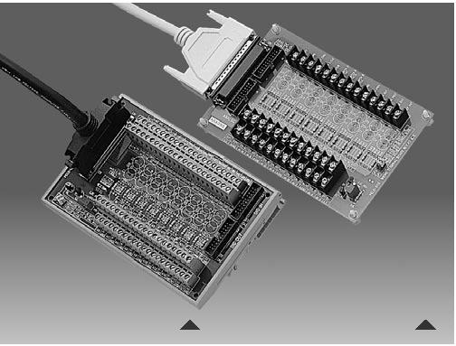

Industrial Wiring Terminal Board With CJC Circuit

Features

▪ Low-cost screw-terminal boards

▪ Onboard CJC (Cold Junction Compensation) circuits for direct thermocouple measurement.

▪ Reserved space for signal-conditioning circuits such as low-pass filter, voltage attenuator and current shunt.

▪ Industrial-grade screw-clamp terminal blocks for heavy-duty and reliable connections.

PCLD-8115 only

▪ Supports PCL-818 series multifunction cards

▪ Nylon standoffs, screws and washers included for easy mounting ▪ Dimensions (W x L): 169 x 112 mm (6.7" x 4.4" )

PCLD-8710 only

 |  |  | ▪ Supports PCI-1710/1710L/1710HG/1710HGL/1711/1711L/1716/1716L cards
 |  |  | ▪ | DIN-rail mounting case for easy mounting
PCLD-8710 |  | PCLD-8115 | ▪ | Dimensions (W x L x H): 169 x 112 x 51 mm (6.7" x 4.4" x 2.0")

Introduction

The PCLD-8115 screw-terminal board offers convenient and reliable signal wiring for multifunction cards with 20-pin flat cable connectors or DB37 connectors, such as the PCL-818 series cards. PCLD-8710 is designed to match multifunction cards with 68-pin SCSI-II connectors, such as the PCI-1710/1710L/1710HG/1710HGL/1711/1711L/1716/1716L cards. This screw-terminal board also includes cold junction sensing circuitry that allows direct measurements from thermocouple transducers. Together with software compensation and linearization, every thermocouple type can be accommodated.

Due to its special PCB layout, you can install passive components to construct your own signal-conditioning circuits. So you can easily construct a low-pass filter, attenuator or current shunt converter by adding resistors and capacitors onto the board circuit pads.

Applications

Field wiring for analog and digital I/O channels of PC-LabCard™ products.

Signal conditioning circuits can be implemented as illustrated in the following examples:

- Straight-through connection (factory setting) RAn = 0 Ω (short)

RBn = none Cn = none
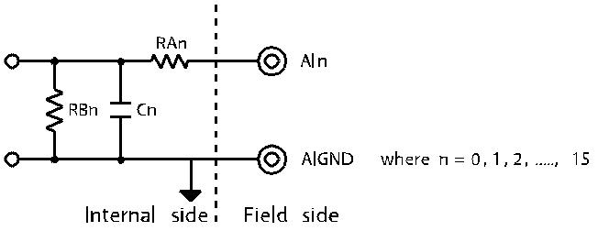

- 1.6 kHz (3 dB) low pass filter RAn = 10 KΩ

RBn = none Cn = 0.01 μF

f3dB = 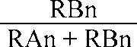

- 10 : 1 voltage attenuator: RAn = 9 KΩ

RBn = 1 KΩ

Cn = none
Attenuation = 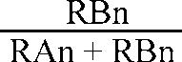 (Assume source impedance << 10 KΩ)

- 4 ~ 20 mA to 1 ~ 5 VDC signal converter: RAn = 0 Ω (short)

RBn = 250 Ω (0.1% precision resistor) Cn = none

Ordering Information

▪ | PCLD-8115 | Industrial Wiring Terminal Board with CJC circuit and
 |  | DB37 cable assembly
▪ | PCLD-8710 | Industrial Wiring Terminal Board with CJC circuit for
 |  | DIN-rail mounting (cable not included)
▪ PCL-10137-1 |  | DB37 cable assembly, 1 m
▪ PCL-10137-2 |  | DB37 cable assembly, 2 m
▪ PCL-10137-3 |  | DB37 cable assembly, 3 m
▪ | PCL-10168-1 | 68-pin SCSI-II cable with special shielding for noise
 |  | reduction, 1 m
▪ | PCL-10168-2 | 68-pin SCSI-II cable with special shielding for noise
 |  | reduction, 2 m

Online Download www.advantech.com/products

Terminal Board Dimensions

PCLD-780

5.0mm | 93.25mm | 5.0mm
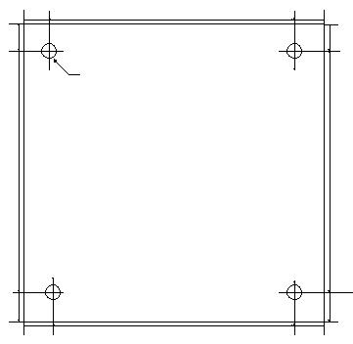

PCLD-782

5mm

PCLD-782B

0mm.5 | 0mm.5
 | D=4.5mmX4
 | 25mm.104
0mm.5 | 0mm.5
5.0mm | 5.0mm

5mm 107mm 5mm

205mm

D=5.0mmX4

 | PCLD-785
5 mm | 220 mm | 5 mm
m
5
 | D=5.0mmX4
m
107
m
5

PCLD-785B

5 mm | 210 mm
m
5
 | D=3.0mmX4
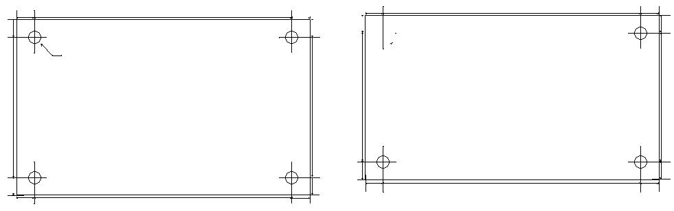

5 m 122 m

5mm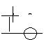

PCLD-788

D=5.0mmX4

PCLD-789D

5mm

D=4.0mmX4

PCLD-880

9.7mm | 203.23mm | 9.7mm
9 |  | .9
m | D=4.5mmX4 | m

105mm

5mm

5mm

195mm _{5mm}

105mm

5mm

5mm

195mm

 |  | 1
 |  | m
9 |  | 9
m |  | m
 | 9.7mm | 9.7mm

5mm

PCLD-885 PCLD-7216

PCLD-8115

5mm | 205mm | 5mm
5mm
 | D=5.0mmX4

5mm 106mm

6.

m

6.

m

7.2mm

D=5.0mmX4

7.2mm

345.77mm

5.5mm

6

m

7

m

6

m

5.5mm

^{5.0mm} 97.25mm
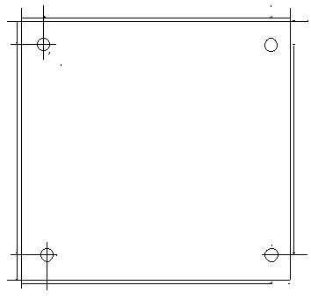
5.0mm

D=4.5mmX4

5.0mm

5.0mm

5.0mm

5

104.25mm

5.0mm

5.0mm

Online Download www.advantech.com/products

