PCLD-8751
PCLD-8761

PCLD-8762
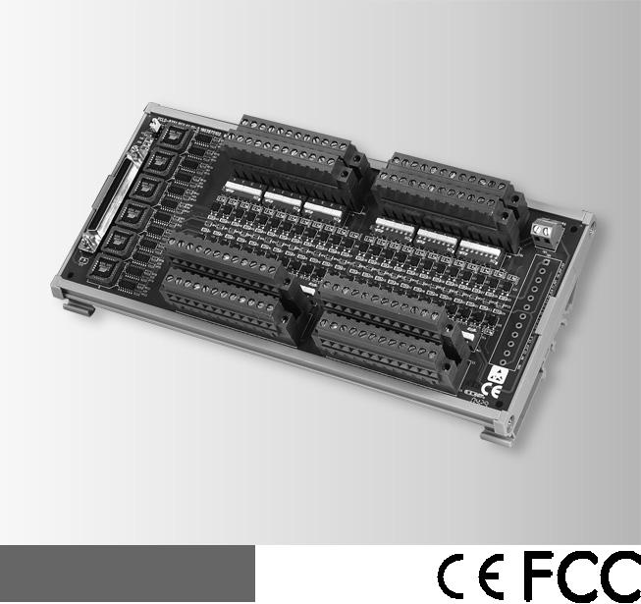

48-ch Opto-Isolated Digital Input Board

24-ch Opto-Isolated DI and 24-ch Relay Output Board

48-ch Relay Output Board
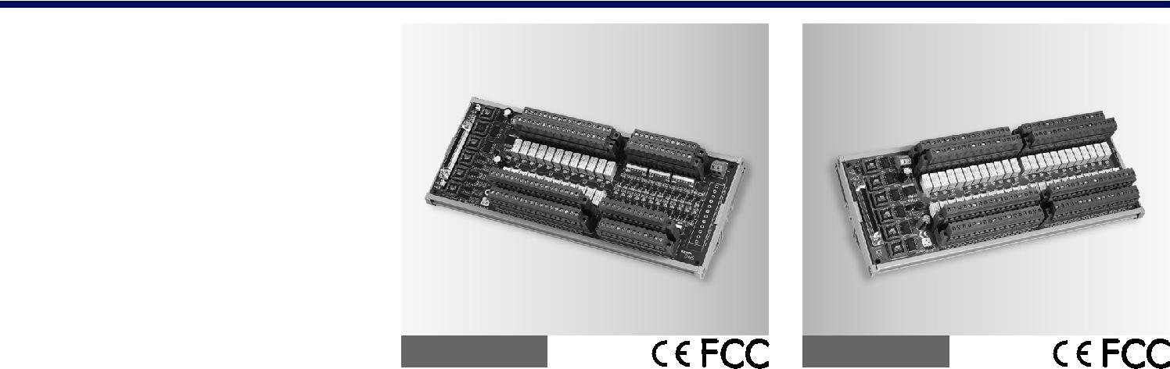

PCLD-8751

PCLD-8761 | PCLD-8762

Features

 48 optically-isolated digital input channels

 Built-in plug-in screw terminals for easier wiring  LEDs indicate input logic status

 Input buffered with voltage comparators  Wet/Dry contact set by DIP switches  Input logic set by jumper
 Wide input range from 5 to 30 V

Specifications

Digital Input

 | Channels | 48 isolated digital inputs
 | Contact Mode | Wet contact
 |  | Dry contact (set by switch)
 | Isolation Voltage | 3,500 V
 | Logic Modes | Positive Logic
 |  | Negative Logic
 |  | (set by jumper)
 | Signal Voltage | 0 ~ 30 V
 |  | VIH (MIN) : 4 V,
 |  | VIL (MAX) : 1 V

General

 Certification CE, FCC

 Connectors Cable: SCSI-68 pin

Signals: Plug-in screw

terminals (#14 - 24 AWG)

 Dimensions 255 x 121 mm

(10.04" x 4.76")

 LED Indicators One for each channel to

indicate logic status

 Mounting DIN-rail

Ordering Information

 PCLD-8751 48-ch Opto-isolated Digital

Input Board

Features

 | Built-in plug-in screw terminals for easier wiring
 | LED status indicators for D/I and relay output
 | Digital inputs buffered with voltage comparators
 | Wet/Dry contact set by DIP switches for D/I
 | Wide input range from 5 to 30 V
 | INT/EXT Power selection by jumper
Specifications
Digital Input
 | Channels | 24 IDI with LED
 | Contact Mode | Wet contact and dry contact for
 | Digital Input | each IDI (set by switch)
 |  | 0 ~ 30 V VIH (MIN) : 4 V, VIL
 | Isolation Voltage | (MAX) : 1V
 |  | 3,500 V (Isolated DI), 1,500V
 | Logic Mode | (Relay)
 |  | Positive Logic
 | (IDI and Relay are | Negative Logic
 | independent) | (set by jumper)
Relay Output
 | Channels | 24 SPDT (Form C)
 | Contact Rating | 30 VDC @ 1 A,
 |  | 120 VAC @ 0.5 A
 | Contact Resistance | 100 mΩ
 | Electrical Endurance | 5 x 107 times at 12 V/10 mA
 | Mechanical | 108 times
 | Endurance
 | Operation Time | 5 ms Max
 | Release Time | 6 ms Max
General
 | Certification | CE, FCC
 | Connectors
 | Cable: SCSI-68 pin
 | Signals: Plug-in screw terminals (#14 - 24 AWG)
 | Dimensions | 285 x 121 mm
 | Mounting | (11.22" x 4.76")
 |  | DIN-rail
 | Power Consumption | +5 V @ < 380 mA +50*n (mA)
 |  | +12 V @ < 240 mA +70*n
 |  | (mA)
 |  | (*n indicate the number of
 | Power Selection | relays)
 |  | PCI Bus or External
power (7 ~ 30 V) by jumper

Features

 Built-in plug-in screw terminals for easier wiring  LED status indicators for Relay output  DIN-rail mounting

 Onboard relay driver circuits

Specifications

Relay Output

 Channels 48 SPDT (Form C)

 Contact Rating 30 VDC @ 1 A,

120 VAC @ 0.5 A

 Contact Resistance 100 mΩ

 Electrical Endurance 5 x 107 times at 12 V/10

mA

 Mechanical 108 times
Endurance

 Operation Time 5 ms Max

 Release Time 6 ms Max

General

 Certification CE, FCC

 Connectors

Cable: SCSI-68 pin

Signals: Plug-in screw terminals (#14 - 24 AWG)

 Dimensions 285 x 117 mm

(11.22" x 4.61")

 Mounting DIN-rail

 Power Input Unregulated 7 ~ 30 VDC

 Power Consumption 7 V @ 1.8 A,

30 V @ 0.45 A

(External power supply is

required)

Ordering Information

 PCLD-8762 48-ch Relay (SPDT) Output

Board

Ordering Information

 PCLD-8761 24-ch Opto-isolated DI and
24-ch Relay (SPDT)
Output Board

Signal Conditioning Modules and Terminal Boards

All product specifications are subject to change without notice Last updated : 19-Mar-2014

