

**ADAM-4050**

**ADAM-4051**

**ADAM-4052**

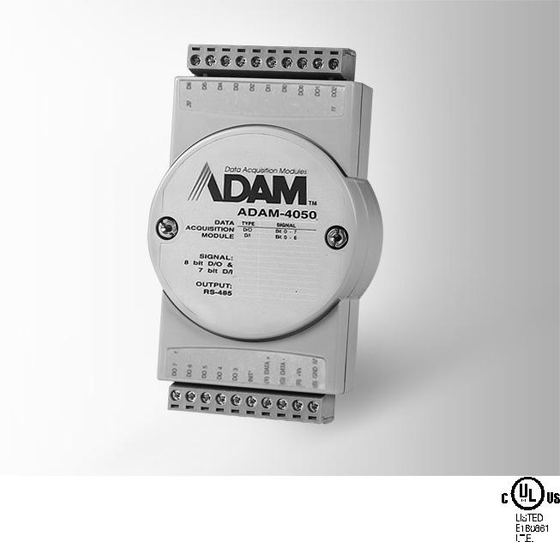

**15-ch Digital I/O Module**

**16-ch Isolated Digital Input Module with Modbus**

**8-ch Isolated Digital Input Module**

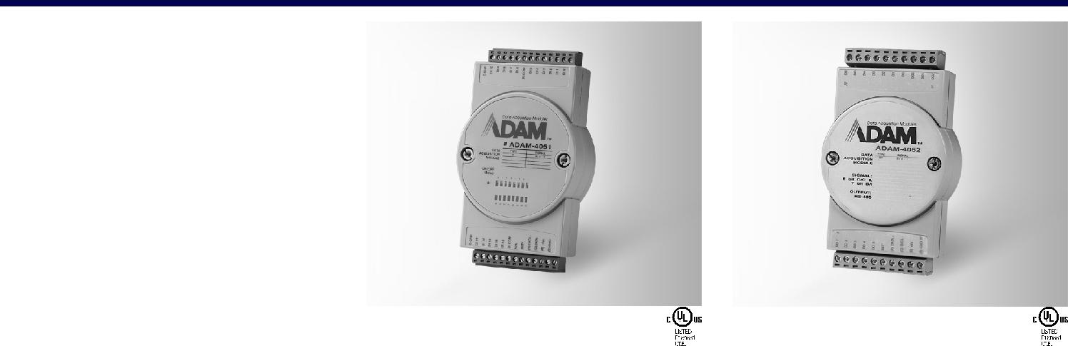

|  |  |  |  |  |  |
| --- | --- | --- | --- | --- | --- |
| **ADAM-4050** |  |  |  | |  |
|  |  | **COMPLIANT** |  |  |
|  |  |  | **RoHS** |  |  |
|  |  |  | 2002/95/EC |  |  |
| **Specifications** | | | | |  |
| **General** | |  |  |  |  |
| ** Connectors** | | 2 x plug-in terminal blocks | | |  |
|  |  | (#14 ~ 22 AWG) | | |  |
| ** Power Consumption** | | 0.4 W @ 24 VDC | | |  |
| ** Watchdog Timer** | | System (1.6 second) | | |  |
| ** Supported Protocols** | | ASCII command | | |  |
| **Digital Input** | |  |  |  |  |
| ** Channels** | | 7 |  |  |  |
| ** Input Level** | | Logic level 0: 1 V max. | | |  |
|  |  | Logic level 1: 3.5 ~ 30 V | | |  |
|  |  | Pull up current: 0.5 mA, | | |  |
|  |  | 10 kΩ resistor to 5 V | | |  |
| **Digital Output** | |  |  |  |  |
| ** Channels** | | 8 |  |  |  |
|  |  | open collector to 30 V, | | |  |
|  |  | 30 mA max. load | | |  |
| ** Power Dissipation** | | 300 mW | | |  |



|  |  |  |  |  |
| --- | --- | --- | --- | --- |
| **ADAM-4051** |  |  |  | **COMPLIANT** |
|  |  |  |  | **RoHS** |
|  |  |  |  | 2002/95/EC |
| **Specifications** | | | | |
| **General** | | | |  |
| ** Connectors** | | | | 2 x plug-in terminal blocks |
|  |  |  |  | (#14 ~ 28 AWG) |
| ** Power Consumption** | | | | 1 W @ 24 VDC |
| ** Watchdog Timer** | | | | System (1.6 second) |
| ** Supported Protocols** | | | | ASCII command and |
|  |  |  |  | Modbus/RTU |
| ** LED Indicators** | | | | Yes |
| **Digital Input** | | | |  |
| ** Channels** | | | | 16 |
| ** Input Voltage** | | | | 50 V max |
| ** Input Level** | | | |  |
| Dry contact: | | | | Logic level 0: open |
|  |  |  |  | Logic level 1: close to |
|  |  |  |  | GND |
| Wet contact: | | | | Logic level 0: 3 V max |
|  |  |  |  | Logic level 1: 10 ~ 50 V |
| (Note: Digital Input levels 0 and 1 can be inverted) | | | | |
| ** Isolation Voltage** | | | | 2,500 VDC |
| ** Input Resistance** | | | | 5.2 kΩ |
| ** Overvoltage** | | | | 70 VDC |
| **Protection** | | | |  |



|  |  |  |  |  |  |
| --- | --- | --- | --- | --- | --- |
| **ADAM-4052** |  |  |  | |  |
|  |  | **COMPLIANT** |  |  |
|  |  |  | **RoHS** |  |  |
|  |  |  | 2002/95/EC |  |  |
| **Specifications** | | | | |  |
| **General** | |  |  |  |  |
| ** Connectors** | | 2 x plug-in terminal blocks | | |  |
|  |  | (#14 ~ 22 AWG) | | |  |
| ** Power Consumption** | | 0.4 W @ 24 VDC | | |  |
| ** Watchdog Timer** | | System (1.6 second) | | |  |
| ** Supported Protocols** | | ASCII command | | |  |
| **Digital Input** | |  |  |  |  |
| ** Channels** | | 8 |  |  |  |
|  |  | (6 fully independent | | |  |
|  |  | isolated channels, 2 | | |  |
|  |  | isolated channels with | | |  |
|  |  | common ground) | | |  |
| ** Input Level** | | Logic level 0: 1 V max. | | |  |
|  |  | Logic level 1: 3 ~ 30 V | | |  |
| ** Isolation Voltage** | | 5,000 VRMS | | |  |
| ** Input Resistance** | | 3 kΩ | | |  |



**Common Specifications**

|  |  |  |  |  |  |
| --- | --- | --- | --- | --- | --- |
| **General** |  | **Environment** |  |  |  |
| ** Power Input** | Unregulated 10 ~ 30 VDC | ** Operating Humidity** | 5 ~ 95% RH | | |
|  |  | ** Operating** | - | 10 | ~ 70°C (14 ~ 158°F) |
|  |  | **Temperature** |  |  |  |
|  |  | ** Storage Temperature** - | | 25 | ~ 85°C |
|  |  |  | (-13 ~ 185°F) | | |



**Ordering Information**

|  |  |
| --- | --- |
| ** ADAM-4050** | 15-ch Digital I/O |
|  | Module |
| ** ADAM-4051** | 16-ch Isolated Digital |
|  | Input Module with |
|  | Modbus |
| ** ADAM-4052** | 8-ch Isolated Digital |
|  | Input Module |

**RS-485 I/O Modules: ADAM-4000**

All product specifications are subject to change without notice. Last updated: 27-Jun-2018