ADAM-4510/4510S ADAM-4520/4522 ADAM-4521

$ RS-422/485 $
$ RS-232 fi 422/485 §
! RS-422/485 fi RS- 232 §

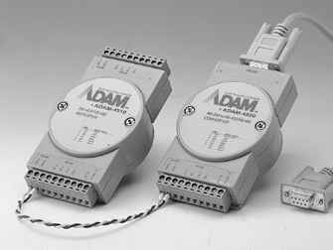
#A
- fi RS-485 !"
- 1000 VDC (ADAM-4521)/3000 VDC (ADAM-4510S/4520) y !
- RS-485 !"#$
- § "# 115.2 Kbps
- fi ! #$% 1200 (4000 øR
- !"#$%
- $ƒ "# %&'()* ,-
- $ !:+10 ‰ +30 VDC
- fl DIN ¤fl § !"#$
§ ADAM-4521
- RS-232 RS-485 !"#$
- fi ! #
- $ !"#$%&'()&'* ,-./
- $ !"# %&' EEPROM $

$ä
$Ç !"#$%&')*+, RS-232 # RS-232 ‰ !" %&; !" %§ !"#$%&'()*+ ./RS- 422 RS-485 ƒ‰ !"#$%&'()+,-()./012þ RS-232 fl !ADAM-4520/4522 y !"#$%&'() RS-232
[ !"# RS-422 RS-485 !; ! RS-232 ª !"#$ RS-422 RS-485 ª fl !" PC [ !"#$%#&ADAM-
4520/4522 !"$%& PC fl !"#$ & ()*+,-
ADAM-4521 %— !" RS-422/485 ‰ RS-232 § !;% !"# RS-422/485 RS-232 fi !"#$ &RS-232 %— !"# %&'
‰,fl$ !"#$%&'ë !"PLC þ‡ !"#$%&'( *+,$ RS-232 %— !"# %&';fl ! $ fi !"
fi !#$ &'(* -.ADAM-4521 !"#$%&'()*+,; !" RS-232 !"#$%& $ RS-232 !
— !"# RS-485 fi
ADAM-4510/4510S $ƒ !"#$%&'()*+,-./ !"#$%& )*; !"#%&'( 1200 (4000 øR $ !
32 4 !"#

fi "#
ADAM-4521 $ ! #$%&'; !"# UART, !"#$%& RS-232 !"#$%&'()*‰fl !" ADAM-4521 fi RS- 232 RS-485 fi ! #$%& ( fi !"#$%&'()*+,-./0% 234‰fl !" RS-485 fi  RS-232 !"
 PC ¾ !"#$

ø$ !"#$%&'$$ RS-232 fl$ RS-485 $
RS-485 ƒ‰ !"#$%&'‰ #$%&( *+,-. 012345 p !"#$ RTS( !"# !"# %&'fl ADAM- 4510/4510S/4520/4521/4522 $ !"#$ I/O $ ; !"#$%&'()*+,-.'( 01*+2fl‰ !"#$%&'(
$— !# %&'—( RS-485 fi RS-485 õ !"#$%&'() +fi ! RS-232 "#$%&'() +,- '/

fi$  !  - $ ! |  | $ +10 ~ +30 VDC !"#$%&'() | ADAM-4520/4521/4522  - § ! 300, 600 ( ADAM-4521), 1200, 2400, 4800, 9600,  (bps) 19.2 k, 38.4 k, 57.6 k 115.2 k, RTS fi RS-422  fi(¼ !"#$%
◆ | § | ABS 9 !" | ◆ | ! | 3000 VDC | ( ADAM-4520)
◆ | fl( ! | ABS DIN ¤fl !"#$% | ◆ | RS-232 ®§ | fl DB9
 |  | fi !"#$%& ( ADAM-4521) |  | ü®

◆
‡ !" | SECC § !"#  @ AWG 1- #12 | - RS-422/RS-485  ®§ ®! | fl) !"#$
\ !  ‡fl   flfl | 2- #14 ~ #22 (0.5 to 2.5 mm2) $Š  -10 ~ 70º C (14 ~ 158 ºF)  60 x 120 mm (2.36”x 4.41”) | - fl | 1.2 W (ADAM-4520/4522)  1 W @ 24 VDC (ADAM-4521)

◆

◆

ADAM-4510/4510S
§ ! | 1200, 2400, 4800, 9600, | - ADAM-4510 | RS-422/RS-485 $ƒ
(bps) | 19.2 k, 38.4 k, 57.6 k, 115.2 k (¼¾ !"#) | - ADAM-4510S | y RS-422/RS-485 $ƒ
! | 3000 VDC ( ADAM-4510S) | - ADAM-4520 | y RS-232 ‰ RS-422/485 §
RS-422/RS-485 | fl) !"#$ | - ADAM-4522 | RS-232 ‰ RS-422/485 §
®§  fl | 1.4 W @ 24 VDC | - ADAM-4521 | 1000 VDC y ! #$%& RS-422/485 ‰  RS-232 §

◆

◆

◆

◆

fi !

ADAM 4000 fi

$ !

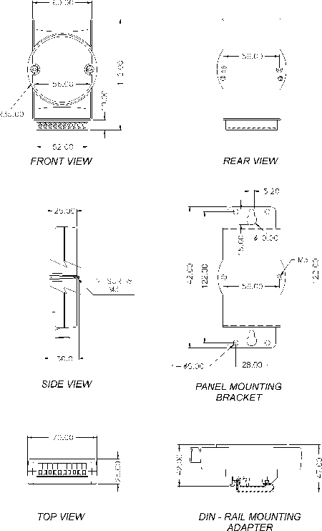 $ !

$ :

- RS-485(2 )‰.
- :1200, 2400, 4800, 9600, 19200, 38400, 57600, 115200 bps
(ADAM-4080˛ADAM-4080D @ ! 38400bps)
- !#:4000 øR (1.2 $)
- $ !" LED
- ASCII ¼½ / !
- $ !" $%&'(
- ª½ !"#:1 ƒfl ƒ!8 ƒ ƒ!1 ƒ ƒ!flƒ
- !"#$%& 256
- !"#
- RS-485 fi ! #$%&

$ !
- $ +10 ~ +30 VDC
- $ !"#

$ !
- § ABS 9 !"
- ‡ !" ¤ 0.5 mm2 ‰ 2.5 mm2,
\ 1-#12 2-#14 ~ #22 AWG

fl
- ‡fl  -10 ~ 70º C (14 ~ 158 ºF)
- EMI FCC Class A
- ‰fl  -25 ~ 85º C (-13 ~185 ºF)
- 5 ~ 95%,fl
Qfl

