ADAM-5560CDS

7-slot PC-based Intel® Atom™ CPU soft logic Controller with integrated target visualization

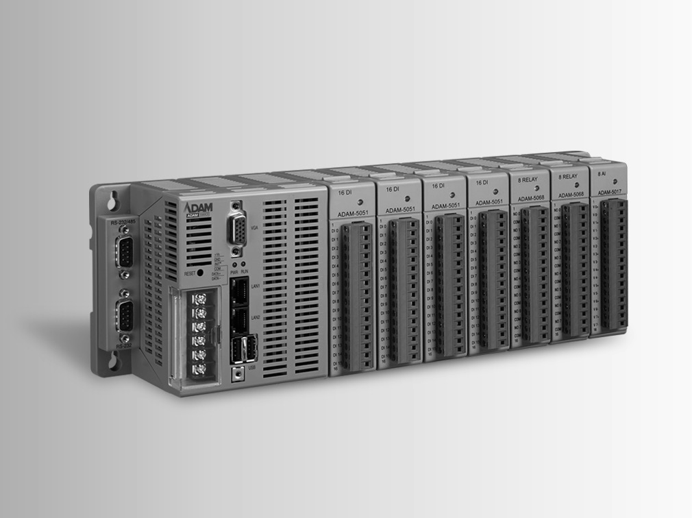
NEW
RoHS
COMPLIANT
2002/95/EC
Features
- Cost effective DIN Rail IPC with VGA port for integrated target visualization
- Optional CODESYS web Visu for Remote monitoring using Web browser based HMIs
- Free of charge CODESYS V3 IEC-61131-3 development tool
- Supports five logic programming languages (LD,IL,FBD,SFC,CFC)
- Supports Modbus/RTU (Master/Slave) and Modbus/TCP (Server/Client)
- Supports SD Storage I/O Module
- Fully integration of all Advantech Modbus TCP/RTU remote I/O modules of the ADAM 4000/6000 series
- Seven I/O expansion slots supporting a wide range of cost effective local I/O Modules
- Two alternative slots for serial communication expansion (RS-232/422, CAN)

Introduction
The ADAM-5560CDS is a cost effective DIN-Rail IPC for control and data acquisition tasks which require Industrial PC computing performance with a PLC’s robustness. The ADAM-5560CDS, is equipped with an Intel Atom CPU, along with control specific features such as watchdog timer, battery backup RAM and deterministic I/O. The ADAM-5560CDS features five standard IEC 61131- 3 programming languages in Windows CE, so PLC users can develop control strategies with their own familiar programming languages such as LD,IL,FBD,SFC,CFC. The powerful CODESYS V3 Development Software and CODESYS Integrated stable run time allows the ADAM-5560CDS to become the best choice for building cost effective, compact and reliable control solutions on the market today. With integrated target visualization HMI software and built-in VGA port there is no need to develop software for an additional Operator Panel. The additional optional CODESYS web Visu allows easy integration for remote monitoring through cost effective browser based HMI terminals or mobile devices. The powerful and flexible ADAM-5560CDS DIN RAIL IPC controller is ideal for a variety of control and data acquisition applications ranging from factory facilities, green house automation, water and waste water to environmental monitoring.

Specifications

Control System
- CPU Intel Atom Z510P
- I/O Capacity 7 slots
- LED Indicators Power, User defined
- Memory 1 GB DDR2 SDRAM
- Storage 1 x CompactFlash® Card (Internal, 1 GB)
- Operating System Windows CE5.0

Real-time Clock Yes
- Watchdog Timer OS and Application

Protection
- Communication RS-485 Isolation 1.5 kV for COM1, COM3 and COM4
RS-485 Isolation 2.5 kV for COM2

Power Reversal Yes
Power
- Power Consumption 17W @ 24 VDC (Not include I/O modules)
- Power Input 12 ~ 24 VDC, ± 20%

General
- Certification CE, FCC Class A
- Dimensions 355 x 110 x 75 mm
- Enclosure ABS+PC
- Mounting DIN-rail, wall mount (panel mount)
- Plug-in Screw Terminal Accepts 0.5 mm2 to 2.5 mm2, 1 – #12 or
2 - #14 to #22 AWG

I/O Interfaces
- Serial Ports 1 x RS-485, Terminal, 50~115.2kbps 3 x RS-232/485, DB9, 50~115.2kbps
- LAN Ports 2 x RJ-45, 10/100Mbps
- USB Ports 2 x USB 2.0
- Displays 1 x VGA, supports 1024 x 768

Environment
- Humidity 5% to 95%, non-condensing
- Operating Temperature 0 ~ 55°C (32 ~ 131°F)
- Storage Temperature -25 ~ 85°C (-13 ~ 185°F)

Software
- Development Tool CODESYS V3
- Runtime Control Win
- OPC Server OPC DA
- Protocol Modbus/RTU, Modbus/TCP
- Visualization Target, Web

Ordering Information
- CDS-ADAM5560-E0TCE 7-slot PC-based Controller with Intel Atom CPU and
CODESYS V3 runtime with Target Visualization
- CDS-ADAM5560-EWTCE 7-slot PC-based Controller with Intel Atom CPU
and CODESYS V3 runtime with Target and Web Visualization

Programmable Automation Controllers
All product specifications are subject to change without notice Date updated: 28-Mar-2016

ADAM-5560CDS

Part Number | Description | Part Number | Description
Analogue I/O Module |  | Digital I/O Module
ADAM-5013 | 3-ch RTD Input | ADAM-5051 | 16-ch DI
ADAM-5017 | 8-ch AI | ADAM-5051D | 16-ch DI w/LED
ADAM-5017P | 8-ch AI w/Independent Input Range | ADAM-5051S | 16-ch Isolated DI w/LED
ADAM-5018P | 7-ch TC Input w/Independent Input Range | ADAM-5052 | 8-ch Isolated Differential DI
ADAM-5017UH | 8-ch Ultra High Speed AI | ADAM-5056 | 16-ch DO
ADAM-5024 | 4-ch AO | ADAM-5056D | 16-ch DO w/LED
ADAM-5018 | 7-ch TC Input | ADAM-5056S | 16-ch Isolated DO w/LED
 |  | ADAM-5056SO | 16-ch Source Type Isolated DO w/LED
 |  | ADAM-5055S | 16-ch Isolated DI/O w/LED
 |  | ADAM-5060 | 6-ch Relay Output
 |  | ADAM-5069 | 8-ch Power Relay Output w/LED
 |  | ADAM-5081 | 4-ch/8-ch High Speed Counter/Frequency

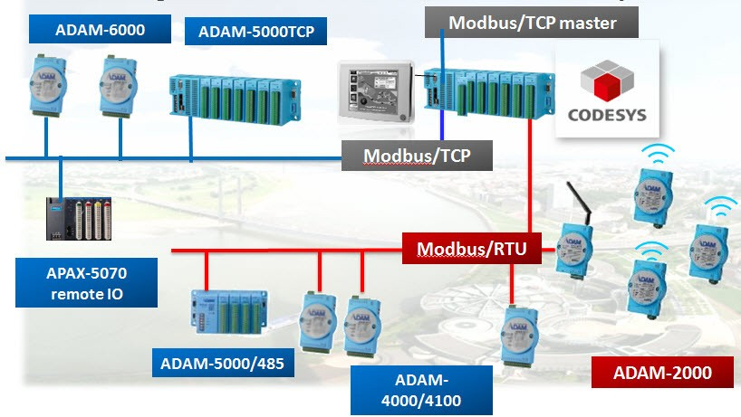

Online Download www.advantech.com/product
s

