WISE-4210-AP WISE-4210-S231 WISE-4210-S251

LPWAN IoT Wireless to Ethernet AP LPWAN IoT Wireless Sensor Node LPWAN IoT Wireless Sensor Node

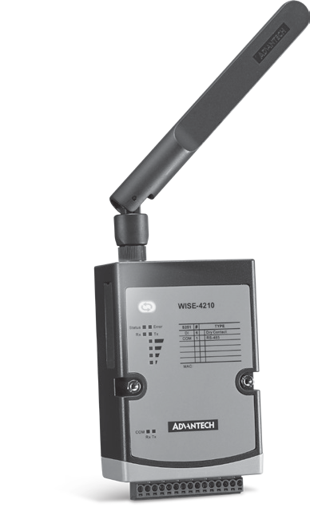
Features
- Proprietary LPWAN with using sub-1GHz wireless frequency
- Battery power for 5 years with 3 x 3.6V AA batteries
- Up to 5 km communication range in open space
- Longer communication range than 2.4GHz
- Better penetration through concrete and steel than 2.4GHz
- Less interference than 2.4GHz spectrum
- Application-ready I/O combination with modularization design

Introduction
LPWAN, created for machine-to-machine (M2M) and Internet of things (IoT) networks, is not a single technology, but a variety of low-power, wide area network technologies. Compare with traditional mobile network, LPWAN is known as lower cost with higher power efficiency. WISE-4210 series is the proprietary LPWAN which provides better connection compare with traditional 2.4G WiFi, WISE-4210 series is helpful of eliminating network interference.
Additionally, WISE-4210 utilize a LPWAN(low-power, wide-area networks) wireless interface, which has a kilometer-long communication distance and battery power. The features of LPWAN make WISE modules ideal solutions for energy and environment monitoring.

Reduced Interference and Extended Communication Range
Compared with Wi-Fi, Bluetooth, Zigbee, or other 2.4GHz wireless interfae, a sub-GHz interface can reduce interference at sites. Moreover, Sub-GHz is a type of LPWAN designed for long-range communications. Under the same power consumption, sub-GHz offers a longer communication range with low data rate than other 2.4 GHz. technologies.

Powered by a 3.6V AA Lithium Battery
The low power consumption of sub-GHz enables the sensor node to be powered by a battery. With a 3.6V AA Lithium battery, the sensor node can maintain communication at a distance of 5 km for up to 5 years, thereby eliminating the need to recharge or change batteries.

MQTT and RESTful API IoT Protocol Support
IoT Wireless sensor nodes are designed for not only automation applications but also IoT applications that may use MQTT or RESTful web API IoT protocols for cloud integrations.

Azure IoT Hub Support
To provide a complete IoT sensing solution, the WISE-4210 series goes beyond being a wireless communication interface for sensors—it also provides cloud connectivity for additional user applications. With support for HTTPS and integrated APIs for Azure IoT Hub, the WISE-4210 series can automatically push data to the cloud without requiring an IoT gateway.
Private Server
Modbus MQTT RESTful
LPWAN AP
WISE-4210-AP

5 years
5 km

Star Topology
Star topology, also known as star network, is the most common network setup. In star topology, every node connects to a central network device which means WISE-4210-S200 series nodes acts as clients should be connected with WISE-4210-AP. In this configuration, user can organize their own network with 64 nodes paired. Data on a star network pass through WISE-4210-AP before continuing to its destination. WISE-4210-AP with a LAN cable manages and controls most of all functions of the network.
X64

LPWAN Sensor Node
WISE-4210-S200 Series

Wireless IoT Sensing Devices
All product specifications are subject to change without notice. Last updated: 29-Nov-2018

Common Specification

Wireless Communication
- IEEE Standard 625bps: IEEE 802.15.4g FSK Modulation
50kbps: IEEE 802.15.4g GFSK Modulation
 Frequency Band AS923: 923MHz (920.60~924.60), BW: 400kHz

Serial Port

Port Number 1
- Type RS-485
- Data Bits 7, 8
- Stop Bits 1, 2
- Parity None, Odd, Even

WISE-4210

EU868: 868MHz (865.00~869.00), BW: 400kHz UN433: 433MHz (433.05~434.55), BW: 300kHz
- Antenna Gain 902~928MHz:1.33 dBi 863~870MHz:2.19 dBi
- Data Rate 625bps, 50kbps
- Outdoor Range 625bps: 5 km with line of sight
50kbps: 2 km with line of sight
- Topology Star
- Network Capacity 64 clients

General
- Power Input AP: 10 ~ 50 VDC
Sensor Node: 3 x AA, 3.6V Lithium Battery or 10 ~ 50 VDC
- Battery Life 625bps: 5 years with 10 minute update rate
50kbps: 5 years with 1 minute update rate

Configuration Interface
 Baud Rate (bps) 1200, 2400, 4800, 9600, 19200, 38400, 57600,
115200
 Protocol Modbus/RTU (Total 32 address by max. 8 instructions)

Pin Assignment

WISE-4210-AP WISE-4210-S231 WISE-4210-S251
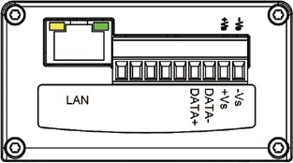
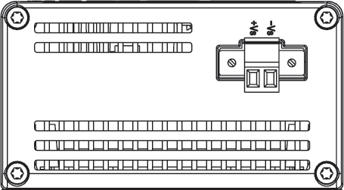
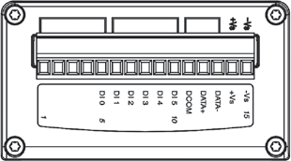

Ordering Information

- AP: LAN port
Sensor Node: Micro-B USB
- LED Indicator Status, Error, Tx, Rx, Battery/Signal Level
- Mounting DIN 35 rail, wall, pole and stack
- Dimension (W x H x D) 70 x 102 x 38 mm
- Certification CE (RED), FCC, IC, NCC, TELEC

Environment
- Operating Temperature -25 ~ 70°C
- Operating Humidity 5 ~ 95% RH
- Storage Temperature -40 ~ 85°C
- Storage Humidity 0 ~ 95% RH

WISE-4210-AP

General
- Ethernet RJ-45 (for configuration and data query)
- RS-485 Data+, Data- (for query node data)
- Messaging Protocol Modbus/TCP, Modbus/RTU, REST, MQTT
- Application Protocol HTTP, HTTPS, SNTP, DHCP
- Transport Protocol TCP, UDP

Supports RESTful Web API in JSON format
- Supports Web Server in HTML5

WISE-4210-S231
Temperature Sensor
 Operating Range -25°C ~ 70°C (-13°F ~ 157.9°F)
- Resolution 0.1 (°C/°F/K)
- Accuracy ±1.0°C (±1.8°F) (vertical installation)

Humidity Sensor
- Operating Range 10 ~ 90% RH
- Resolution 0.1% RH
- Accuracy ±4% RH @ for 0%~50% RH
±6% RH @ 50%~60% RH
±10% RH @ 60%~90% RH

WISE-4210-S251

Digital Input
- Channels 6 (Dry Contact)

Supports 32-bit counter input function (maximum signal frequency 200Hz)
- Supports keep/discard counter value on power-off
- Support inverted digital input status

Wireless Access Point
- WISE-4210-APNA* LPWAN Wireless to Ethernet AP – AS923/EU868
- WISE-4210-APUA LPWAN Wireless to Ethernet AP – UN433

Wireless Sensor Node
- WISE-4210-S231NA* LPWAN WSN with Temp/RH Sensors – AS923/EU868
- WISE-4210-S251NA* LPWAN WSN with 6DI and RS-485 – AS923/EU868
- WISE-4210-S231UA LPWAN WSN with Temp/RH Sensors – UN433
- WISE-4210-S251UA LPWAN WSN with 6DI and RS-485 – UN433

Accessories
- 1760002647-01 Bat.Cylindrical 3.6V/2500mAh AA Li/SOCl2
 1750008836-01 863-870MHz Dipole Antenna for WISE-4210
 1750008837-01 902-928MHz Dipole Antenna for WISE-4210
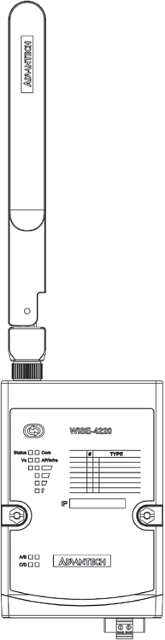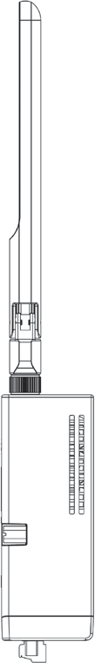* AS923/EU868 version of WISE-4210 need to order antenna separately
Side View
Front View
38
Unit: mm
Dimensions
70

163
275
Online Download www.advantech.com/products
102

