ADAM-4021 ADAM-4015 ADAM-4024

1-ch Analog Output Module
6-ch RTD Module with Modbus
4-ch Analog Output Module with Modbus

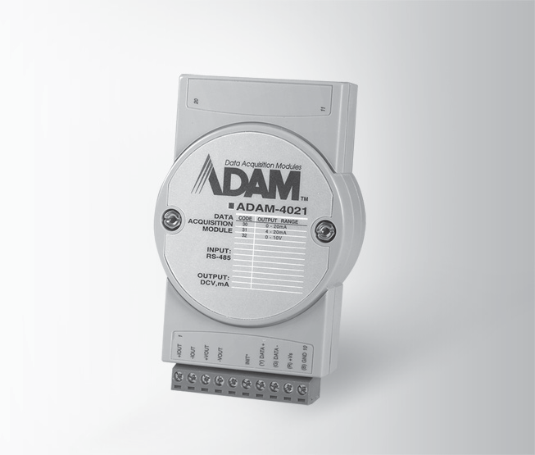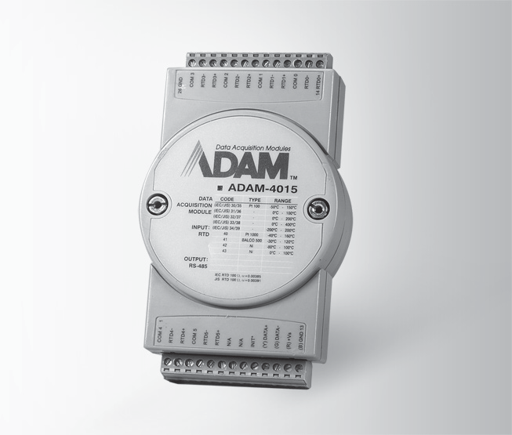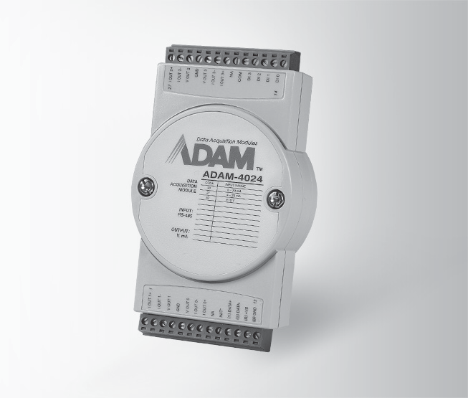
ADAM-4021
RoHS
COMPLIANT
2002/95/EC
ADAM-4015
RoHS
COMPLIANT
2002/95/EC
ADAM-4024
RoHS
COMPLIANT
2002/95/EC

Specifications

General
- Connectors 2 x plug-in terminal blocks (#14 ~ 22 AWG)
- Power Consumption 1.4 W @ 24 VDC
- Watchdog Timer System (1.6 second)
- Supported Protocols ASCII command

Specifications

General
- Connectors 2 x plug-in terminal blocks (#14 ~ 28 AWG)
- Power Consumption 1.2 W @ 24 VDC
- Watchdog Timer System (1.6 s) &
Communication
- Supported Protocols ASCII command and

Specifications

General
- Connectors 2 x plug-in terminal blocks (#14 ~ 28 AWG)
- Power Consumption 3 W @ 24 VDC
- Watchdog Timer System (1.6 second) &
Communication
- Supported Protocols ASCII command and

Analog Output

Channels 1
- Burnout Detection
Analog Input
Modbus/RTU Yes

Analog Output
Modbus/RTU

- Output Impedance 0.5 Ω
- Output Range 0 ~ 20 mA, 4 ~ 20 mA,
0 ~ 10 V
- Output Type mA, V
- Accuracy ±0.1% of FSR for current output
±0.2% of FSR for voltage output
- Current Load 0 to 500 Ω (source)

Resistor
- Resolution 12-bit
- Isolation Voltage 3,000 VDC
- Programmable 0.125 ~ 128 mA/sec.
Output Slope 0.0625 ~ 64.0 V/sec.
- Readback Accuracy ±1% of FSR
- Span Temperature ±25 ppm/°C

Coefficient
- Zero Drift
Voltage output: ±30 µV/°C
Current output: ±0.2 µA/°C

Common Specifications

General
 Power Input Unregulated 10 ~ 30 VDC
- Channels 6 differential
- Input Connections 2, 3-wire
- Input Impedance 10 MΩ
- Input Type Pt, Balco and Ni RTD

RTD Types and Temperature Ranges Pt 100 RTD:
Pt -50°C to 150°C
Pt 0°C to 100°C
Pt 0°C to 200°C
Pt 0°C to 400°C
Pt -200°C to 200°C IEC RTD 100 ohms (a = 0.00385) JIS RTD 100 ohms (a = 0.00392) Pt 1000 RTD
Pt -40°C to 160°C

Balco 500 RTD
-30°C to 120°C

Ni 50 RTD
Ni -80°C to 100°C

Ni 508 RTD
Ni 0°C to 100°C

BA1
-200°C to 600°C
- Accuracy ±0.1% (Typical)
 CMR @ 50/60 Hz 120 dB
- Span Drift ± 25 ppm/°C
- Zero Drift ± 3 µV/°C

Environment
- Operating Humidity 5 ~ 95% RH
 Operating -10 ~ 70°C (14 ~ 185°F)

Temperature
- Storage Temperature - 25 ~ 85°C
(-13 ~ 185°F)

Channels 4
- Output Impedance 0.5 Ω
- Output Range 0 ~ 20 mA, 4 ~ 20mA,
±10 V
- Output Type mA, V (Differential)
- Accuracy ±0.1 % of FSR for current output
±0.1 % of FSR for voltage output
- Current Load Max. 500 Ω
Resistor (source)
- Voltage Load Min. 1K Ω

Resistor
- Resolution 12-bit
- Isolation Voltage 3,000 VDC
- Programmable 0.125 ~ 128 mA/sec.
Output Slope 0.0625 ~ 64.0 V/sec.
- Span Temperature ±25 ppm/°C

Coefficient
- Zero Drift Voltage output: ±30 µV/°C Current output: ±0.2 µA/°C

Digital Input

Channels 4
- Input Level Logic level 0: 1 V max. Logic level 1: 10 ~ 30 VDC
- Isolation Voltage 3,000 VDC
Ordering Information
- ADAM-4021 1-ch Analog Output Module
- ADAM-4015 6-ch RTD Module with Modbus
- ADAM-4024 4-ch Analog Output Module with Modbus

RS-485 I/O Modules: ADAM-4000
All product specifications are subject to change without notice. Last updated: 27-Jun-2018

