ADAM-5510 Series | 4/8 slots PC-based Controller
 | Features
 |  Supports Modbus/RTU, Modbus/TCP Master and Slave function libraries
 |  Windows-based utility
 |  Optional support C Programming and IEC-61131-3 standard
 |  Complete set of I/O modules
 |  Built-in real-time clock and watchdog timer
 |  ROM-DOS operating system
 |  4 serial communication ports
 |  Optional support Ethernet Interface with network function, such as Web
 | Server, FTP Server and Email Alarm.
 |  4 or 8 I/O slot expansion
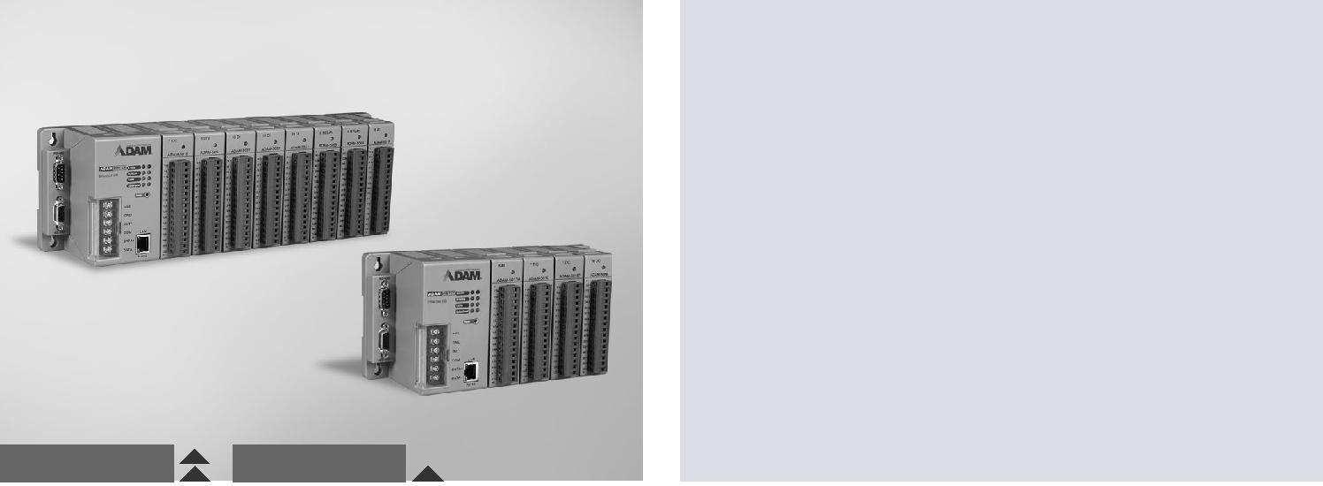

ADAM-5510E ADAM-5510

RoHS
COMPLIANT

2002/95/EC

Introduction

The ADAM-5510 Series are ideal for PC-based data acquisition and control applications. They are compact, controllers with an Intel x86- based CPU running Datalight ROM-DOS. Built-in battery backup SRAM is the best choice for complex logic or data storage applications. For professional C/C++ programmers, the ADAM-5510 Series application programs may be written and compiled in Borland C++ 3.0, and downloaded to the controller.

For user who familiar with PLC programing environment, we provide the option for customer to use the KW softlogic which supports 5 standard IEC 61131-3 programming languages, including LD/FB/SFC/IL/ST.

Specifications

Control System

 CPU | 80188, 16-bit microprocessor
 I/O Slots | Optional 8 or 4 slots
 LED Indicators | Power, CPU, communications and battery
 Memory | Flash disk: 1 MB (960 KB for user applications)
 | Flash memory: 256 KB
 | Flash ROM: 256 KB
 Memory | RAM: 640 KB (up to 384 KB with battery backup)
 | Flash disk: 512KB
(Softlogic version) | Flash memory: 768KB
 | Flash ROM: 256KB
 | RAM: 640KB SRAM, 32KB with battery backup
 | (ADAM-5510KW)
 | RAM: 768KB SRAM, 17KB with battery backup
 Operating System | (ADAM-5510KW/TCP,ADAM-5510EKW/TP)
 | ROM-DOS (MS-DOS 6.22 Compatible)
 Real-time Clock | Yes
 Watchdog Timer | Yes

Serial Communication

 Max. Nodes | 256 (in RS-485 daisy-chain network)
 Distance | 1.2 km (4,000 feet)
 Speed | 1,200 bps ~ 115.2 kbps (9600, 19200, 38400 bps for
 Isolation | Softlogic version)
 | 2500 VDC (COM2 only)

Ethernet Communication

 Medium Cat.5 cable with RJ-45 connector
 Distance 100 m
 Speed 10/100Base-T

Power

 Power Consumption 4 W @ 24 VDC (not including I/O modules)
 Power Input Unregulated 10 ~ 30 VDC
 Isolation 3000 VDC
 Reverse Protection Yes

Software

 ROM DOS version C library for Borland C++ 3.0
 Softlogic version Development tool : KW Multiprog
Runtime kernel : ProConOS

General

 Certification | CE, FCC Class A
 Connectors | COM1 : DB9-M
 | COM2 : Screw terminal(RS-485)
 | COM3 : DB9-F (RS-232/Programming)
 | COM4 : DB9-M (RS-232/485)
 | Power : Screw terminal
 Dimensions | LAN : RJ-45 (option)
 | 4-slot: 231 x 110 x 75 mm
 Enclosure | 8-slot: 355 x 110 x 75 mm
 | ABS+PC
 Mounting | DIN-rail, stack, wall

Environment

 | Humidity | 5 ~ 95%, non-condensing
 | Operating Temperature | -10 ~ 70°C | (14 ~ 158°F)
 | Storing Temperature | -25 ~ 85°C | (-13 ~ 185°F)

Ordering Information

 ADAM-5510M 4-slot PC-based Controller
 ADAM-5510E 8-slot PC-based Controller
 ADAM-5510/TCP 4-slot PC-based Controller with Ethernet
 ADAM-5510E/TCP 8-slot PC-based Controller with Ethernet
 ADAM-5510KW 4-slot Softlogic Controller
 ADAM-5510KW/TCP 4-slot Softlogic Controller with Ethernet
 ADAM-5510EKW/TP 8-slot Softlogic Controller with Ethernet
 MPROG-PRO535E KW Multiprog Pro v5.35 (128k bytes I/O, Win7 support)

Online Download www.advantech.com/products

All product specifications are subject to change without notice Last updated : 5-May-2015

