ADAM-4017/4017+
ADAM-4018/4018+
ADAM-4019+
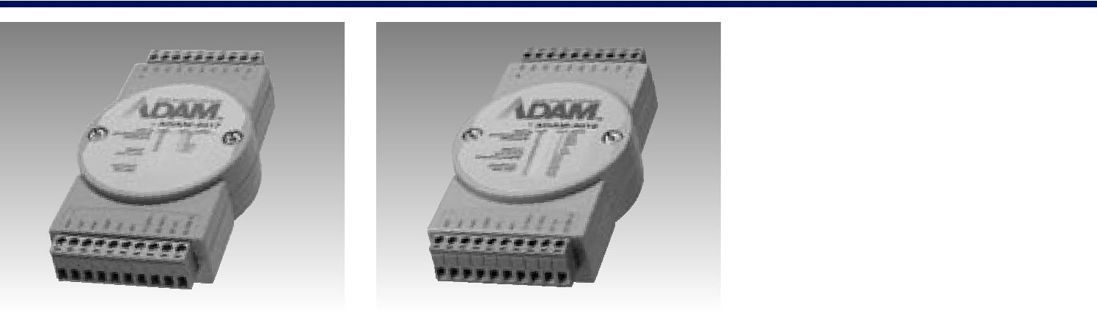

8-ch Analog Input Modules with Modbus®

8-ch Thermocouple Input Modules with Modbus

8-ch Universal Analog Input Module with Modbus
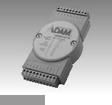

ADAM-4017/4017+ | ADAM-4018/4018+ | ADAM-4019+

Specifications

General

▪ | Power Consumption | 1.2 W @ 24 VDC
▪ | Watchdog Timer | ADAM-4017:
 |  | System (1.6 second)
 |  | ADAM-4017+:
 |  | System (1.6 second) &
 |  | Communication
▪ | Support Protocol | ASCII command
 |  | (ADAM-4017)
 |  | ASCII command and
 |  | Modbus/RTU
 |  | (ADAM-4017+)

Analog Input

▪ | Channels | ADAM-4017:
 |  | 6 differential, and 2
 |  | single-ended
 |  | ADAM-4017+:
 |  | 8 differential
▪ | Channel Independent | ADAM-4017+ only
 | Configuration
▪ | Input Impedance | Voltage: 20 MΩ
 |  | Current: 120 Ω
 |  | (4017+ only)
▪ | lnput Type | mV, V, mA

- lnput Range
ADAM-4017 ±150 mV, ±500 mV, ±1 V,
±5 V, ±10 V, ±20 mA

ADAM-4017+ ±150 mV, ±500 mV, ±1 V,
±5 V, ±10 V, ±20 mA,

4 ~ 20 mA

Specifications

General

▪ | Power Consumption | 0.8 W @ 24 VDC
▪ | Watchdog Timer | ADAM-4018:
 |  | System (1.6 second)
 |  | ADAM-4018+:
 |  | System (1.6 second) &
 | Support Protocol | Communication
▪ |  | ASCII command
 |  | (ADAM-4018)
 |  | ASCII command and
 |  | Modbus/RTU
 |  | (ADAM-4018+)

Analog Input

▪ | Channels | ADAM-4018: 6 differential,
 |  | and 2 single-ended
 | Channel Independent | ADAM-4018+: 8 differential
▪ |  | ADAM-4018+ only
 | Configuration | Voltage: 20 MΩ
▪ | Input Impedance
 |  | Current: 120 Ω
 | lnput Type | (4018+ only)
▪ |  | ADAM-4018
 |  | Thermocouple, mV, V, mA
 |  | ADAM-4018+
 | Voltage/Current | Thermocouple, mA
▪ |  | ADAM-4018 ±15 mV,
 | Input Range | ±50 mV, ±100 mV, ±500 mV,
 |  | ±1 V, ±2.5 V, ±20 mA
 |  | ADAM-4018+
 |  | ±20 mA, 4 ~ 20 mA

- T/C Types and Temperature Ranges

 | J | 0 | ~ 760° C | R | 500 ~1750° C
 | K | 0 | ~ 1370° C | S | 500 ~1750° C
 | T | -100 ~ 400° C |  | B | 500 ~1800° C
 | E | 0 | ~ 1000° C
▪ Burn-out Detection |  |  |  | All T/C (ADAM-4018+ only)

Specifications

General

▪ | Power Consumption | 1.0 W @ 24 VDC
▪ | Watchdog Timer | System (1.6 second) &
 |  | Communication
▪ | Support Protocol | ASCII command and
 |  | Modbus/RTU

Analog Input

▪ | Channels | 8 differential channels
 |  | for individual input type
▪ | Channel Independent | Yes
 | Configuration
▪ | Input Impedance | Voltage: 20 MΩ
 | Input Type | Current: 120 Ω
▪ |  | T/C, mV, V, mA
▪ | Voltage/Current | ±1 V, ±2.5 V, ±5 V,
 | Input Range | ±10 V, ±100 mV,
 |  | ±500 mV, ±20 mA,
 |  | 4 ~ 20 mA

- T/C Types and Temperature Ranges

 | J | 0 ~ 760 °C | R |  | 500 ~ 1750 °C
 | K | 0 ~ 1370 °C | S |  | 500 ~ 1750 °C
 | T | -100 ~ 400 °C | B |  | 500 ~ 1800 °C
 | E | 0 ~ 1000 °C
▪ Burn-out Detection |  |  | 4 | ~ 20 mA & all T/C

Common Specifications |  |  | ▪ | Isolation Voltage | 3000 VDC
General |  |  | ▪ | Overvoltage Protection | ±35 VDC
 |  |  | ▪ | CMR @ 50/60 Hz | 120 dB
▪ | Power Input | Unregulated 10 ~ 30 VDC
 |  |  | ▪ | NMR @ 50/60 Hz | 100 dB
▪ | Connectors | 2 x Plug-in terminal block | ▪ | Span Drift | ±25 ppm/° C
 |  | (#14 ~ 22 AWG) | ▪ | Zero Drift | ±6 μV/° C
Analog Input |  |  | ▪ | Built-in TVS/ESD Protection
▪ | Accuracy | Voltage mode: ±0.1% or | Environment
 |  | better | ▪ | Humidity | 5 ~ 95% RH
 |  | Current mode: ±0.2% | ▪ | Operating Temperature | -10 ~ 70° C
 | Resolution | or better |  |  | (14 ~ 158° F)
▪ |  | 16-bit | ▪ | Storage Temperature | -25 ~ 85°C
▪ | Sampling Rate | 10 sample/second (total) |  |  | (-13 ~ 185° F)

Ordering Information

▪ ADAM-4017 8-ch Analog Input
Module
- ADAM-4017+8-ch Analog Input Module with Modbus

- ADAM-40188-ch Thermocouple Input Module

- ADAM-4018+8-ch Thermocouple Input
Module with Modbus

▪ ADAM-4019+ 8-ch Universal Analog Input Module with Modbus

RS-485 I/O Modules

