ADAM-4021
ADAM-4015

ADAM-4024
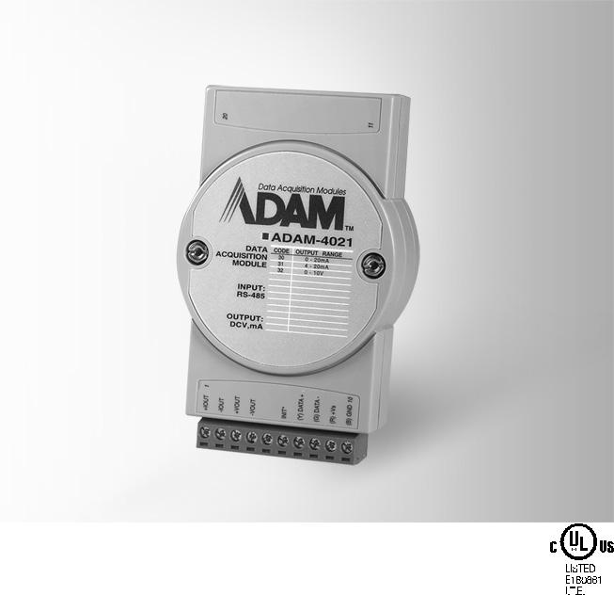

1-ch Analog Output Module

6-ch RTD Module with Modbus

4-ch Analog Output Module with Modbus
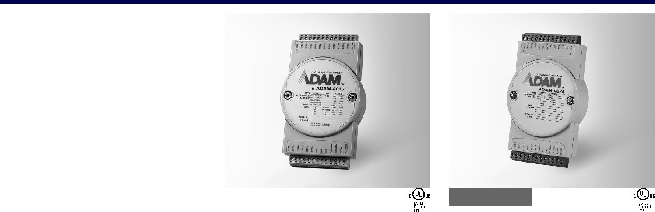

ADAM-4021
 |  |  | COMPLIANT
 |  |  | RoHS
 |  |  | 2002/95/EC
Specifications
General
 Connectors |  | 2 x plug-in terminal
 |  | blocks (#14 ~ 22 AWG)
 Power Consumption |  | 1.4 W @ 24 VDC
 Watchdog Timer |  | System (1.6 second)
 Supported Protocols |  | ASCII command
Analog Output
 Channels |  | 1
 Output Impedance |  | 0.5 Ω
 Output Range |  | 0 ~ 20 mA, 4 ~ 20 mA,
 |  | 0 ~ 10 V
 Output Type |  | mA, V
 Accuracy |  | ±0.1% of FSR for current
 |  | output
 |  | ±0.2% of FSR for voltage
 |  | output
 Current Load |  | 0 to 500 Ω (source)
Resistor
 Resolution |  | 12-bit
 Isolation Voltage |  | 3,000 VDC
 Programmable |  | 0.125 ~ 128 mA/sec.
Output Slope |  | 0.0625 ~ 64.0 V/sec.
 Readback Accuracy |  | ±1% of FSR
 Span Temperature |  | ±25 ppm/°C
Coefficient
 Zero Drift
Voltage output: |  | ±30 µV/°C
Current output: |  | ±0.2 µA/°C

ADAM-4015
RoHS
COMPLIANT
2002/95/EC

Specifications

General

 Connectors | 2 x plug-in terminal blocks
 Power Consumption | (#14 ~ 28 AWG)
 | 1.2 W @ 24 VDC
 Watchdog Timer | System (1.6 s) &
 Supported Protocols | Communication
 | ASCII command and
 Burnout Detection | Modbus/RTU
 | Yes

Analog Input

 Channels |  | 6 differential
 Input Connections |  | 2, 3-wire
 Input Impedance |  | 10 MΩ
 Input Type |  | Pt, Balco and Ni RTD
 RTD Types and Temperature Ranges
Pt 100 RTD:
Pt -50°C | to | 150°C
Pt 0°C | to | 100°C
Pt 0°C | to | 200°C
Pt 0°C | to | 400°C
Pt -200°C | to | 200°C
IEC RTD 100 ohms (a = 0.00385)
JIS RTD 100 ohms (a = 0.00392)
Pt 1000 RTD
Pt -40°C | to | 160°C
Balco 500 RTD
-30°C | to | 120°C
Ni 50 RTD
Ni -80°C | to | 100°C
Ni 508 RTD
Ni 0°C | to | 100°C
BA1
-200°C | to | 600°C
 Accuracy |  | ±0.1% (Typical)
 CMR @ 50/60 Hz |  | 120 dB
 Span Drift |  | ± 25 ppm/°C
 Zero Drift |  | ± 3 µV/°C

ADAM-4024 | 2002/95/EC
 | RoHS
 | COMPLIANT

Specifications

General

 Connectors | 2 x plug-in terminal blocks
 Power Consumption | (#14 ~ 28 AWG)
 | 3 W @ 24 VDC
 Watchdog Timer | System (1.6 second) &
 Supported Protocols | Communication
 | ASCII command and
 | Modbus/RTU
Analog Output
 Channels | 4
 Output Impedance | 0.5 Ω
 Output Range | 0 ~ 20 mA, 4 ~ 20mA,
 Output Type | ±10 V
 | mA, V (Differential)
 Accuracy | ±0.1 % of FSR for current
 | output
 | ±0.1 % of FSR for voltage
 | output
 Current Load | Max. 500 Ω
Resistor | (source)
 Voltage Load | Min. 1K Ω
Resistor
 Resolution | 12-bit
 Isolation Voltage | 3,000 VDC
 Programmable | 0.125 ~ 128 mA/sec.
Output Slope | 0.0625 ~ 64.0 V/sec.
 Span Temperature | ±25 ppm/°C
Coefficient
 Zero Drift | Voltage output: ±30 µV/°C
 | Current output: ±0.2 µA/°C

Digital Input

 | Channels | 4
 | Input Level | Logic level 0: 1 V max.
 | Isolation Voltage | Logic level 1: 10 ~ 30 VDC
 |  | 3,000 VDC

Common Specifications |  |  |  |  | Ordering Information
General |  | Environment |  |  |  ADAM-4021 | 1-ch Analog Output
 |  |  |  |  |  | Module
 Power Input | Unregulated 10 ~ 30 VDC |  Operating Humidity | 5 ~ 95% RH
 |  |  |  |  |  ADAM-4015 | 6-ch RTD Module with
 |  |  Operating | -10 ~ 70°C (14 ~ 185°F)
 |  |  |  |  |  | Modbus
 |  | Temperature |  |  |  ADAM-4024 | 4-ch Analog Output
 |  |  Storage Temperature - 25 ~ 85°C
 |  |  |  |  |  | Module with Modbus
 |  |  | (-13 ~ 185°F)

RS-485 I/O Modules: ADAM-4000

All product specifications are subject to change without notice. Last updated: 27-Jun-2018

