IPC-610-L/
IPC-611

4U 15-Slot Rackmount Chassis with Front-Accessible Fan
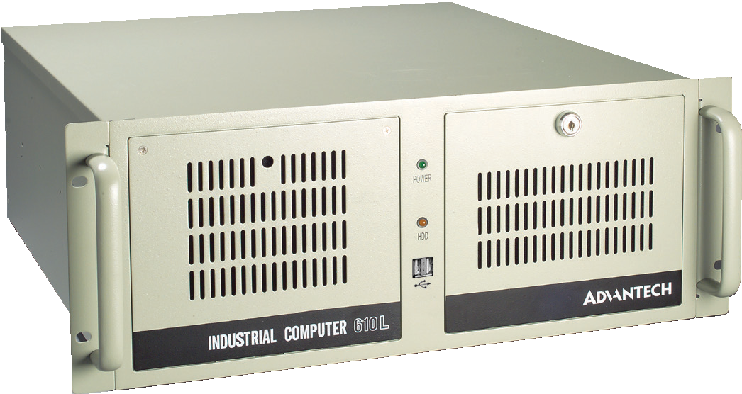
IPC-610-L
Features
- Supports an ATX motherboard or a backplane with up to 15 slots
- Shock-resistant disk drive bay design holds up to three 5.25" and one 3.5" disk drives
- Special hold-down clamp design with rubber cushions protects the cards from shocks and vibrations
- Power and HDD activity notification improves system availability
- Front-accessible air filter for easy system maintenance
- Lockable front door prevents unauthorized access

Specifications

Drive Bay | External
 | 3.5" | 1
 | 5.25" | 3
Cooling | Fan | 1 (12 cm / 85 CFM)
 | Air Filter | Yes
Miscellaneous | LED Indicators | Power and HDD activity
 | Control | Power switch and system reset button
 | Rear Panel | Backplane version: One 9-pin D-Sub opening  Motherboard version: Five 9-pin D-Sub & one 25-pin D-sub openings
Environment |  | Operating | Non-Operating
 | Temperature | 0 ~ 40 °C (32 ~ 104 °F) | -20 ~ 60 °C (-4 ~ 140 °F)
 | Humidity | 10 ~ 85 % @ 40 °C, non-condensing | 10 ~ 95 % @ 40 °C, non-condensing
 | Vibration (5 ~ 500 Hz) | 1 Grms | 2 G
 | Shock | 10 G (with 11 ms duration, 1/2 sine wave)
Physical Characteristics | Color / Logo | IPC-610-L: Beige / Advantech Logo IPC-611: Black / No Logo
 | Dimensions (W x H x D) | 482 x 177 x 479 mm (19" x 7" x 18.9")
 | Weight | 14.5 kg (31.9 lb) / 14.2 kg (31.2 lb)

Front View

IPC-610-L

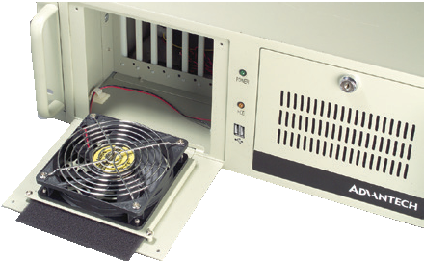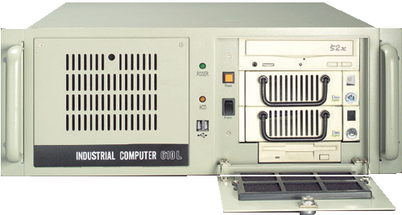Power LED

System reset button

IPC-611

HDD LED Power
switch

One 3.5"
drive bay

Three 5.25" drive bays
Easy-to-replace cooling fan and filter
One 12 cm / 85 CFM cooling fan

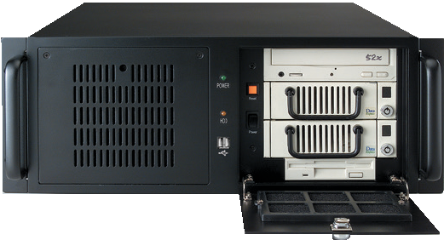Devices not included

Industrial Chassis
All product specifications are subject to change without notice. Last updated: 10-Apr-2019

IPC-610-L / IPC-611

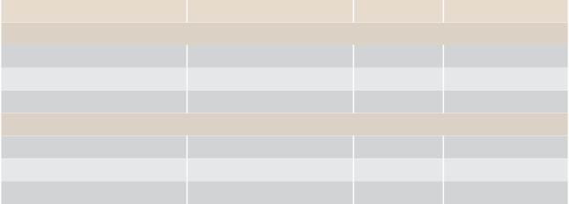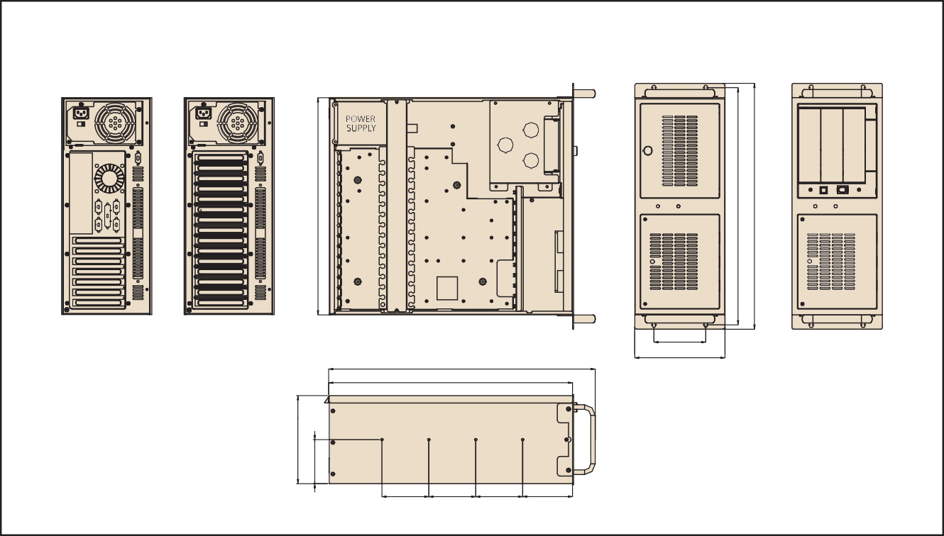Ordering Information
Part Number Backplane Version IPC-610BP-00LBE IPC-610BP-50LBE IPC-611BP-00XBE
Motherboard Version
IPC-610MB-00LBE IPC-610MB-40LBE IPC-611MB-00XBE
Power Supply
Wattage Switch type
-
PS8-500ATX-ZE
-
- 500W
-
ATX ATX ATX
-
PS8-400ATX-ZE
-
- 400W
-
ATX ATX ATX
92[3.6] 92[3.6] 92[3.6] 99.9[3.9]
101.6[4.0]
177.0[7.0]
522.9[20.6]
478.4[18.8]
Unit: mm [inch]
Dimensions
172.8 [6.8]
86.4 [3.4]

Power Supply Options
(For detailed power supply specs, please refer to Chapter 13)

Optional Accessories
Part Number Description
Mobile rack for converting dual 5.25" drive bays to three 3.5" SATA HDD trays
IPC-DT-5230E
Power cable for GPU card (Two 4-pin 12V connectors to one 6+2 pins PCIe power connector)
1700029268-01
Power cable for GPU card (Two B4P Molex connectors to one 6+2 pins PCIe power connector)
1700024754-01
** If GPU card with 2 power connectors, please use 1700029268-01*1 + 1700024754- 01*1;If GPU card with 1 power connector, please use 1700029268-01.
* Only 500W or higher wattage PSU support 1700029268-01 and 1700024754-01 for high-end GPU card.

Spare Parts

426.3[16.8]
465.6[18.3]
482.6[19.0]
Part Number

PS8-250ATX-ZE
80 Plus Grade
Bronze
Wattage
Type
250W
Single
PS8-300ATX-ZBE
Bronze 300W
Single
PS8-400ATX-ZE
Bronze 400W
Single
PS8-500ATX-ZE
Bronze 500W
RPS8-500ATX-XE
Bronze 500W
Single
1+1
Redundant
Input
AC 100 ~ 240
(full range) AC 100 ~ 240
(full range)
AC 100 ~ 240
(full range) AC 100 ~ 240
(full range)
AC 100 ~ 240
(full range)
Part Number Description
2130006149S000 Fan filter 127 x 127 x 5 mm
2130004802S000 Door filter 142 x 97 x 5 mm

Online Download www.advantech.com/products

