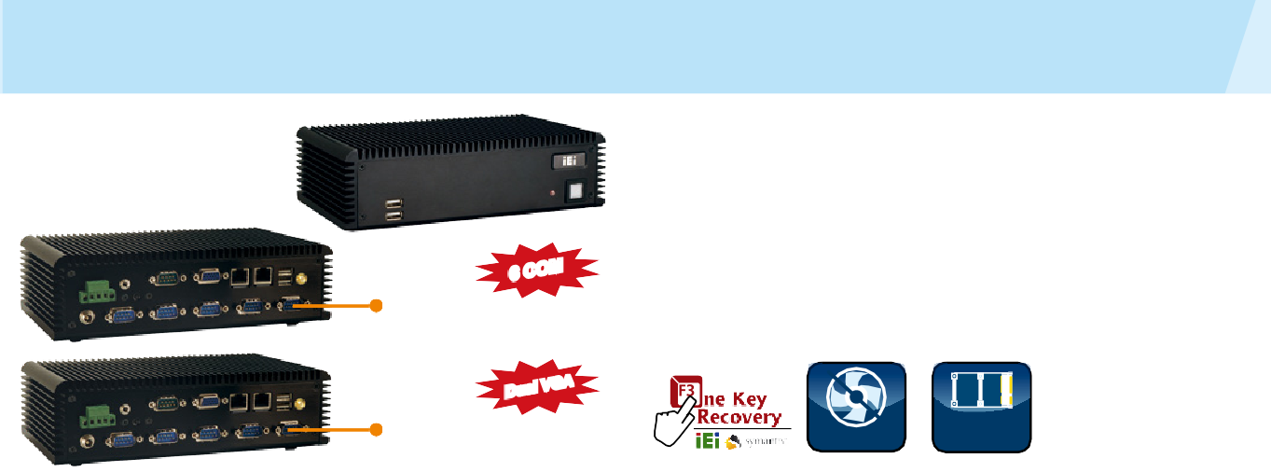
ECW-281B/B2 Series

Fanless Embedded System with
Intel® Atom™ Dual-core D525 CPU

w w w . i ei w or l d .c om

COM2 for
ECW-281B Series

Features
- Fanless system with
» 1.8 GHz Intel® Atom™ D525 dual-core CPU
- Supports four USB 2.0 ports and six COM ports
- Dual GbE LAN ideal for high-speed network applications
- Supports CompactFlash®, 2.5” SATA HDD and SSD storage devices
- 12 V DC and 9 V DC - 36 V DC power input models available
- Supports dual VGA display (B2 model only)

Specifications
2nd VGA for
ECW-281B2 Series

Fanless

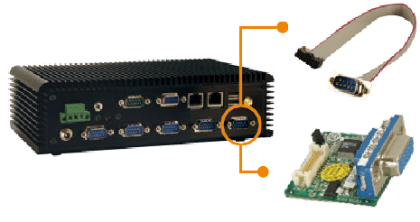Dual Display

PCIe Mini Expansion

RS-232 Cable Installed in ECW-281B series

Dimensions (Unit: mm)
Model Name |  | ECW-281B-D525 (ECW-281B2-D525)
Chassis | Color | Black
 | Dimensions  (WxDxH) (mm) | 229 x 132 x 64
 | System Fan | Fanless
 | Chassis  Construction | Aluminum alloy with heavy duty metal
Motherboard | Motherboard  Model | WAFER-PV-D5252
 | SBC Size (mm) | 3.5", 146 x 102
 | CPU | IIntel® Atom™ D525 dual-core 1.8GHz/1MB L2 cache
 | Chipset | Intel® ICH8M
 | System  Memory | 1 GB DDR3 204-pin SO-DIMM memory pre-installed
Storage | Hard Drive | 1 x 2.5" SATA HDD space
 | CF Card/CFast | 1
I/O Interfaces | USB 2.0 | 4
 | Ethernet | 2 x Realtek 8111E PCIe GbE
 | COM Port | 6 x RS-232 ports for ECW-281B-D525  (COM2: Default RS-232, RS422/485 optional) 5 x RS-232 ports for ECW-281B2-D525
 | Display | 1 (2) x VGA
 | Resolution | VGA: Up to 2048 x 1536@60Hz  (VGA: Up to 1024 x 768@60MHz)
 | Audio | 1 x Speaker out
Expansions | PCIe Mini | 1 x PCIe Mini card slot
Power | Power Input | DC jack: 12 V DC  3-pin terminal: 9 V~36 V DC
 | Power Consumption | 12V@1.79A  (Intel® Atom™ D525 1.8GHz CPU with 1GB DDR3  memory)
Reliability | Mounting | DIN mount, VESA 75 mount, wall mount
 | Operating  Temperature | -20°C ~ 65°C with CompactFlash®/SSD  -10°C ~ 50°C with HDD
 | Operating  Shock | Half-sine wave 3G, 11ms 3 shocks per axis
 | Operating  Vibration | * MIL-STD-810F 514.5C-1  MIL-STD-810F 514.5C-2
 | Weight (Net/  Gross) | 2.1 kg/3.9 kg

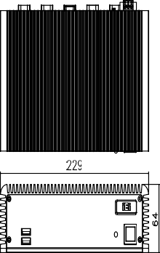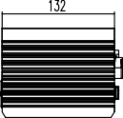

Ordering Information

LVDS-VGA-R10
Installed in ECW-281B2 series
» Provides 2nd VGA option for dual VGA display

Packing List

1 x Power cord only for 12V
1 x Screw set
1 x 12V 60W power adapter
(with PSE/ErP certified, only for 12V)
1 x Wall mount bracket
1 x HDD thermal pad
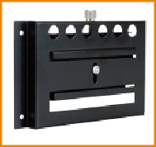
DK-84MB

ECN-281B/B2 Series-2018-V11
Industrial Computer Chassis

*Systems with hard drive meet MIL-STD-810F 514.5C-1 specifications. SSD/CF systems meet MIL-STD-810F 514.5C-2 specifications.
Part No. |  |  | Description
D525 | 12 V DC  Input | ECW-281B-R12/ D525/1GB | Fanless embedded system with WAFER-PV-D5252, with dual-core Intel® Atom™ D525 1.8GHz CPU, with 6 serial ports, with 1 GB DDR3 memory, 12  V DC in, 60W power adapter with ErP and PSE  certificates, black, RoHS
 |  | ECW-281B2-R12/ D525/1GB | Fanless embedded system with WAFER-PV-D5252, with dual-core Intel® Atom™ D525 1.8GHz CPU, with dual VGA display and 5 serial ports, with 1 GB DDR3 memory, 12 V DC in, 60W power adapter with  ErP and PSE certificates, black, RoHS
 | 9 V ~36 V  DC Input | ECW- 281BWD-R11/ D525/1GB | Fanless embedded system with WAFER-PV-D5252, with dual-core Intel® Atom™ D525 1.8GHz CPU, with 6 serial ports, with 1 GB DDR3 memory, 9 V-36  V DC in, w/o power adapter, black, RoHS
 |  | ECW- 281B2WD-R11/ D525/1GB  32205-003200-  100-RS | Fanless embedded system with WAFER-PV-D5252, with dual-core Intel® Atom™ D525 1.8GHz CPU, with dual VGA display and 5 serial ports, with 1 GB DDR3 memory, 9 V-36 V DC in, w/o power adapter, black, RoHS  Flat cable, RS-232/422/485, RS-422/485 cable, 2, 100mm, 28AWG, (A) D-sub 9-pin male, (B) DU pont 2x7P P=2.0, female, IDIOT-PROOF, 32200-074600-  RS substitute, hwalong, RoHS

Spec Comparison Table

Model | ECW-281B | ECW-281B2 | ECW-281BWD | ECW-281B2WD
Main board | WAFER-  PV-D5252 | WAFER-  PV-D5252 | WAFER-  PV-D5252 | WAFER-  PV-D5252
COM port | 6 | 5 | 6 | 5
VGA display | 1 | 2 | 1 | 2
Power input | 12 V DC in | 12 V DC in | 9 V~36 V DC in | 9 V~36 V DC in
Adapter | 60W | 60W | N/A | N/A

