w w w . i ei w or l d .c om
Tower Industrial Chassis
ECA-300

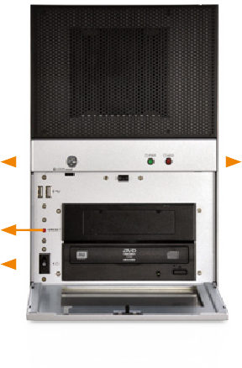Power LED

Reset Button
Power Switch
HDD LED

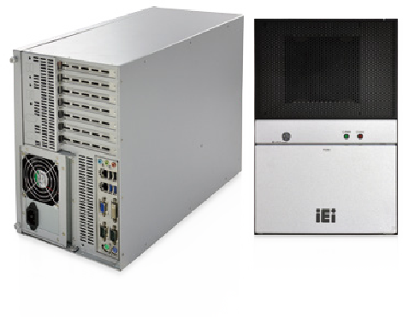
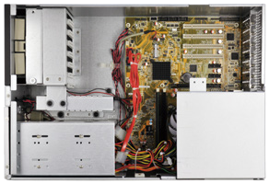
Features
- RoHS compliant design
- Supports ATX/microATX motherboard
- Two 5.25” drive bays and one 3.5”/2.5” HDD/SSD bay
- Seven expansion slots

Specifications
Construction | Heavy duty metal
SBC Form Factor | ATX/microATX
PSU | PS/2 ATX power supply
Drive Bays | 2 x 5.25”  1 x 3.5"/2.5" HDD/SSD
Cooling Fans | 1
I/O Openings | 2 x USB  4 x USB  2 x COM
Expansion Slots | 7
Indicators | 1 x Power LED, 1 x HDD LED
Buttons | 1 x Reset button, 1 x Power switch
Installation | Desktop, wall mount
Operating Temperature | -10°C ~ 50°C
Operating Humidity | 5% ~ 95%
Color | Silver
Dimensions (DxWxH) | 210 mm x 320 mm x 480.5 mm
Operating Vibration | MIL-STD-810F 514.5C-1
Operating Shock | Half-sine wave 3G, 11ms, 100 shocks per axis
Weight (Net/Gross) | TBD

Ordering Information
Dimensions (Unit: mm)

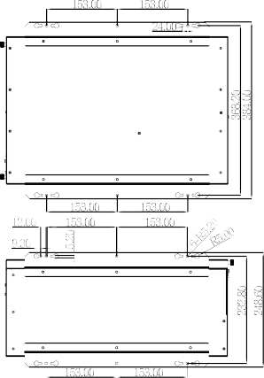

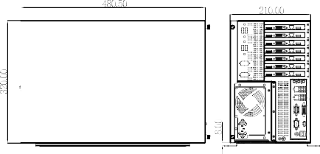Compatible SBC

Model No. | SBC Type | PCI | x1 | P  x4 | Cle  x8 | x16
IMBA-Q170-i2-R10 | ATX | 2 | 0 | 3 | 2 | 0
IMBA-H110-R10 | ATX | 6 | 0 | 0 | 0 | 1
IMBA-H810-R10 | ATX | 4 | 2 | 0 | 0 | 1
IMBA-Q870-i2-R10 | ATX | 4 | 1 | 1 | 0 | 1
IMB-Q870-i2-R10 | microATX | 1 | 1 | 1 | 0 | 1
IMB-Q770-R10 | microATX | 1 | 1 | 1 | 0 | 1
IMB-H810-i2-R10 | microATX | 2 | 1 | 0 | 0 | 1
IMB-H610A-R10 | microATX | 0 | 3 | 0 | 0 | 1
Power Supply Options

ECA-200-2019-V10
Industrial Computer Chassis
Part No.
Description
ECA-300-R10
Mini-tower chassis, supports microATX or ATX motherboard, one 3.5” HDD/2.5” SSD bay, two 5.25” CD-ROM bays, supports PS/2 ATX power supply, RoHS
Type

ATX
Model No.
ACE-A160A-R11 ACE-4840APM-RS ACE-A140A-R11 ACE-A130B-R10
Watt

600W
400W
400W
300W

