w w w . i ei w or l d .c om
Industrial Chassis
ECA-200

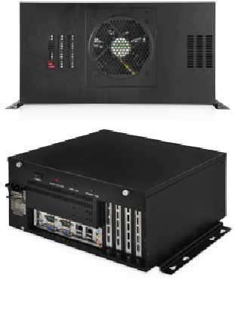
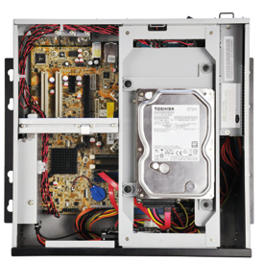
Power Reset HDD Power
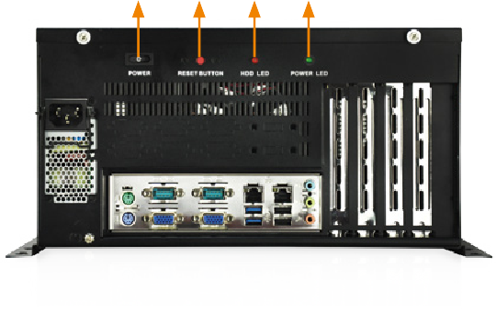
Switch Button LED LED

Features
- RoHS compliant design
- Supports microATX motherboard
- One 3.5” HDD or one 2.5” HDD/SSD bay
- Four expansion slots

Specifications
Construction | Heavy duty metal
SBC Form Factor | microATX
PSU | 1U flex power supply
Drive Bays | 1 x 3.5"/2.5" HDD/SSD  Expansion: 1 x 3.5”/2.5” HDD/SSD by the optional  ECA-HDD-KIT-R10
Cooling Fans | 1
I/O Openings | 2 x USB  6 x COM
Expansion Slots | 4
Indicators | 1 x Power LED, 1 x HDD LED
Buttons | 1 x Reset button, 1 x Power switch
Installation | Desktop, wall mount
Operating Temperature | -10°C ~ 50°C
Operation Humidity | 5% ~ 95%
Color | Black
Dimensions (DxWxH) | 310 mm x 310 mm x 162 mm
Operating Vibration | MIL-STD-810F 514.5C-1
Operating Shock | Half-sine wave 3G, 11ms, 100 shocks per axis
Weight (Net/Gross) | TBD

Ordering Information
Dimensions (Unit: mm)

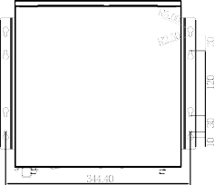

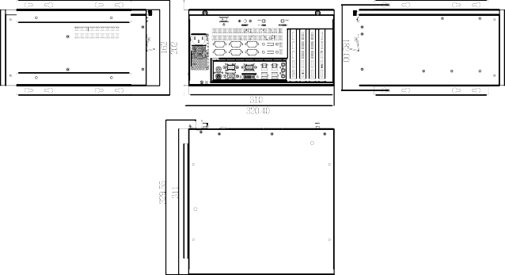

Compatible SBC

Model No. | SBC Type | PCI | x1 | P  x4 | Cle  x8 | x16
IMB-Q870-i2-R10 | microATX | 1 | 1 | 1 | 0 | 1
IMB-H810-i2-R11 | microATX | 2 | 1 | 0 | 0 | 1
IMB-Q770-R10 | microATX | 1 | 1 | 1 | 0 | 1
IMB-H810-i2-R10 | microATX | 2 | 1 | 0 | 0 | 1
IMB-H610A-R10 | microATX | 0 | 3 | 0 | 0 | 1
IMB-H110-R10 | microATX | 2 | 1 | 0 | 0 | 1
Power Supply Options

ECA-200-2019-V10
Industrial Computer Chassis
Part No.
Description
ECA-200-R20
Desktop/wall-mount industrial chassis, supports microATX motherboard and 1U ATX power supply, black, RoHS
ECA-HDD-KIT-R10
Additional 2.5”/3.5” HDD kit for ECA-100/ECA-200, R10
Type
Model No.
Watt
ATX
ACE-A615A-RS-R11 ACE-A618B-RS-R10 ACE-A622A-RS-R11 ACE-A627A-RS-R11
ACE-A630B-RS-R10
150W

180W

220W

270W

300W

