w w w . i ei w or l d .c om
Industrial Chassis
ECA-100

Power Reset HDD Switch Button LED
Power LED

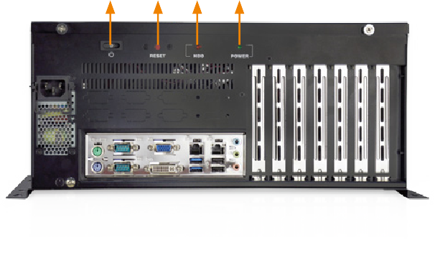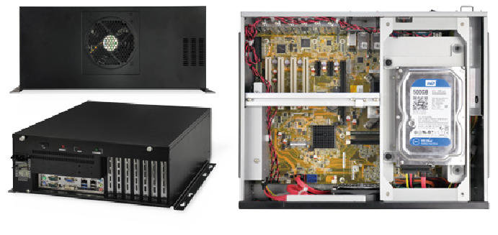

Features
- RoHS compliant design
- Supports ATX/microATX motherboard
- One 3.5” HDD or one 2.5” HDD/SSD bay
- Seven expansion slots

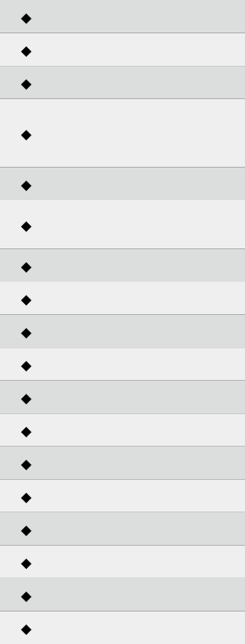
Specifications

Construction | Heavy duty metal
SBC Form Factor | ATX/microATX
PSU | 1U flex power supply
Drive Bays | 1 x 3.5”/2.5” HDD/SSD  Expansion: 1 x 3.5”/2.5” HDD/SSD by the optional  ECA-HDD-KIT-R10
Cooling Fans | 1
I/O Openings | 2 x USB  6 x COM
Expansion Slots | 7
Indicators | Power LED, HDD LED
Buttons | Power switch, reset button
Installation | Desktop, wall mount
Operating Temperature | -10°C ~ 50°C
Operating Humidity | 5% ~ 95%
Storage Temperature | -20°C ~ 60°C
Color | Black
Dimensions (DxWxH) | 365 mm x 291 mm x 162 mm
Operating Vibration | MIL-STD-810F 514.5C-1
Operating Shock | Half-sine wave 3G, 11ms, 100 shocks per axis
Weight (Net/Gross) | TBD

Ordering Information
Dimensions (Unit: mm)

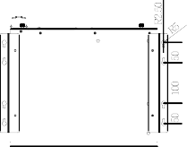

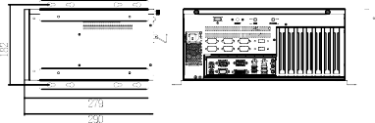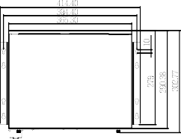Compatible SBC

Model No. | SBC Type | PCI | PCle
 |  |  | x1 | x4 | x8 | x16
IMBA-Q170-i2-R10 | ATX | 2 | 0 | 3 | 2 | 0
IMBA-H110-R10 | ATX | 6 | 0 | 0 | 0 | 1
IMBA-H810-R10 | ATX | 4 | 2 | 0 | 0 | 1
IMBA-Q870-i2-R10 | ATX | 4 | 1 | 1 | 0 | 1
IMBA-Q770-R10 | ATX | 3 | 2 | 1 | 0 | 1
IMBA-Q670-R30 | ATX | 4 | 1 | 1 | 0 | 1
IMBA-H610-R10 | ATX | 4 | 2 | 0 | 0 | 1
IMB-Q870-i2-R10 | microATX | 1 | 1 | 1 | 0 | 1
IMB-H810-i2-R11 | microATX | 2 | 1 | 0 | 0 | 1
IMB-Q770-R10 | microATX | 1 | 1 | 1 | 0 | 1
IMB-H810-i2-R10 | microATX | 2 | 1 | 0 | 0 | 1
IMB-H610A-R10 | microATX | 0 | 3 | 0 | 0 | 1

Power Supply Options

ECA-100-2019-V10
Industrial Computer Chassis
Part No. | Description
ECA-100-R20 | Desktop/wall-mount industrial chassis, supports ATX/microATX motherboard and 1U ATX power supply, black, RoHS
ECA-HDD-KIT-R10 | Additional 2.5”/3.5” HDD kit for ECA-100/ECA-200, R10

Type | Model No. | Watt
ATX | ACE-A615A-RS-R11 | 150W
 | ACE-A618B-RS-R10 | 180W
 | ACE-A622A-RS-R11 | 220W
 | ACE-A627A-RS-R11 | 270W
 | ACE-A630B-RS-R10 | 300W

