w w w . i ei w or l d .c om
Embedded Chassis for IEI Single Voltage Mini-ITX SBC
EBC-3200
Mini-ITX

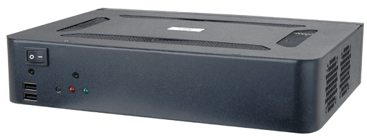
Features

Designed for Mini-ITX SBC with single voltage input
- Flexible storage with CF or 2.5" HDD (optional)
- One PCI or PCIe expansion slot (optional)

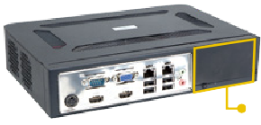Flexible design with five optional modules for storage and expansion slot
2
Optional Modules
Part No. | Description
EBCKIT-01-R10/PCI-HDD | EBC-3200 optional module with one PCI slot and one 2.5" HDD bay, RoHS
EBCKIT-02-R10/PCIe-HDD | EBC-3200 optional module with one PCIe x1 slot and one 2.5" HDD bay, RoHS (For KINO-PV-D4252/D5252  only)
EBCKIT-03-R10/PCI-CF | EBC-3200 optional module with one PCI slot and  one CompactFlash® slot, RoHS
EBCKIT-06-R10/PCIe16-HDD | EBC-3200 optional module with one PCIe x16 slot and one 2.5" HDD bay, RoHS

Flexible storage by optional modules

x Internal 2.5” HDD bays (default)

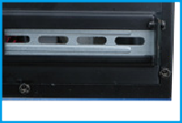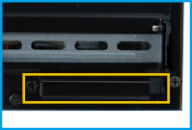

1 x Internal 2.5” HDD bay
1 x CF slot
1 x Expansion slot (PCI/PCIe)
1 x Internal 2.5” HDD bay
1 x Expansion slot (PCI/PCIe) 1 x CF slot

Specifications

Model Name |  | EBC-3200
Platform |  | Case only
Chassis | Color | Black
 | Dimensions (WxDxH) (mm) | 260 x 180 x 55
 | System Fan (WxDxH) (mm) | 2, 40 x 40 x 10
Motherboard | Motherboard Model | Refer to KINO Series
 | SBC Size (mm) | Mini-ITX (170 x 170)
Storage | Hard Drive | 2 x 2.5” HDD bays (default)  Varies by optional modules
Expansions | PCI/PCIe | 1 x Low profile PCI/PCIe (support by optional modules) Max. dimensions:  147 mm (L) x 10.5 mm (D)
Buttons |  | Power switch
 |  | Reset
Indicators |  | Power LED
 |  | Error LED
Reliability | Mounting | Desktop, wall mount, VESA mount
 | Operating Temperature | -10°C ~ 50°C with air flow*
 | Weight (Net/Gross) | 1.1 kg/2 kg
(*Ambient air speed follows IEC-68-2-2 standard)

Compatible SBC
Part No. | Expansion Type | Recommended CPU Cooler
tKINO-BW | 1 x PCIe x1 | Fanless
KINO-DQM170 | 1 x PCIe x16 | 19100-000203-00-RS
KINO-DH810 | 1 x PCIe x1 | CF-1156A-RS, CF-1156C-RS, CF-1156D-RS
KINO-DBT | 1 x PCIe x4 | Fanless
eKINO-BT | 1 x PCIe x1 | Fanless
KINO-DA750-i2 | N/A | CF-989B-RS
KINO-KBN/SE-i2 | 1 x PCIe x4 | GX-424CC & GX415GA with fan
KINO-DQM871-i1 | 1 x PCIe x16 | 19100-000203-00-RS
KINO-DH610 | 1 x PCI  1 x PCIe x1 | CF-1156A-RS, CF-1156C-RS, CF-1156D-RS
KINO-QM770 | 1 x PCIe x16 | CF-989A-RS
KINO-QM670 | 1 x PCIe x16 | CF-989A-RS
KINO-QM57A | 1 x PCIe x16 | CF-989A-RS, CF-989B-RS
KINO-HM551 | 1 x PCIe x16 | CF-989A-RS

Dimensions (Unit: mm)
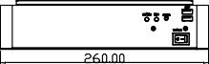

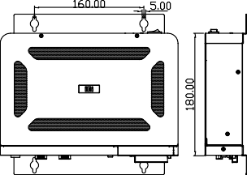
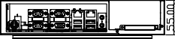
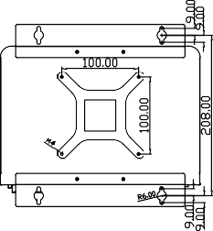
Ordering Information

Part No. | Description
EBC-3200-R10 | Mini-ITX embedded chassis, compatible two 2.5" HDD,  w/o power adapter, black, RoHS
Options

Part No. | Description
32000-000002-RS | European standard power cord, 1830mm
32000-000025-RS | American standard power cord, 1830mm
63040-010060-110-RS | Power adapter, FSP060-DIBAN2, 90 V~264 V AC, 12 V DC, 60W, Din 4-pin/lock, Erp, RoHS
19FR124010BL-000002-RS | Fan module, 40x40x10mm, CCL, RoHS
Packing List

EBC-3200-2019-V10
Industrial Computer Chassis
1 x QIG | 2 x Wall mount brackets | 1 x Screw set

