Display System
w w w . i ei w or l d .c om

10.1” Freescale™ i.MX6 Cortex™-A9 quad core 1.0 GHz 15.6” Freescale™ i.MX6 Cortex™-A9 quad core 1.0 GHz
18.5” Freescale™ i.MX6 Cortex™-A9 quad core 1.0 GHz
FIT1-W18A-IMX6
FIT1-W15A-IMX6
FIT1-W10A-IMX6

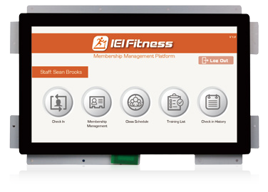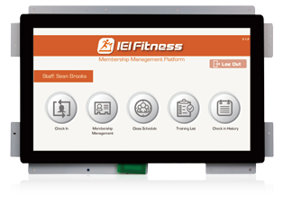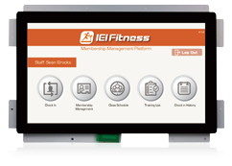Ready for ODM / OEM
Specifications
Bluetooth

Features
- Support Android 5.1 OS
- Flexible ID Design (Open Frame)
- IEI Customer Reference Board (10.1"/15.6"/18.5" share the same main board)
- Waterproof : IPX5 (For customized ID)
- Support BLE / ANT+ / NFC
- Support ATSC / DVBT TV Dongle

Wi-Fi

IPX5

Touchscreen

microSD

Model | FIT1-W10A-IMX6-R10 | FIT1-W15A-IMX6-R10 | FIT1-W18A-IMX6-R10
Size | 10.1" | 15.6" | 18.5"
Resulution | 1280 (W) x 600 (H) | 1366 (W) x 768 (H) | 1366 (W) x 768 (H)
Brightness (cd/m²) | 250 (cd/m²) | 300 (cd/m²) | 400 (cd/m²)
Contrast Ratio | 600: 1 | 500: 1 | 1000 (Typ.)
LCD Color | 16.7M | 16.7M | 16.7M
Pixel Pitch (mm) | 0.1695 x 0.1695 | 0.252 x 0.252 | 0.3 x 0.3
Backlight MTBF (hrs) | 30000 | 50000 | 50000
Touchscreen | Projected capacitive flat touch
CPU | Freescale iMX6 Cortex-A9 Quad Core 1.0 GHz
RAM | 2GB DDR3 SDRAM
Boot Flash | 8G eMMC Nand Flash
OS Support | Android 5.1
Input / Output | 1 x USB 2.0  - x LCB Connector 1 x Csafe  - x Hand Pulse Connector 1 x HDMI In  1 x Keypad Connector  1 x 10/100 Mbps Power over Ethernet 1 x SD Card Slot
Audio | 2 x 3W Audio
Wireless | BT4.0 + WiFi 802.11 b/g/n
Color | Black
Dimensions (WxHxD) (mm) | 256 x 187 x 77.3 mm | 420 x 270 x 87mm | 461 x 281 x 93mm
Operational Temperature ( °C) | 0°c~+40°c
Storage Temperature (°C) | (-10°c~+50°c)
Humidity | 5%~95%
Power Requirement | 12~36V
Power Consumption | 12V @1.5A | 12V @2.25A | 12V @ 2.6A

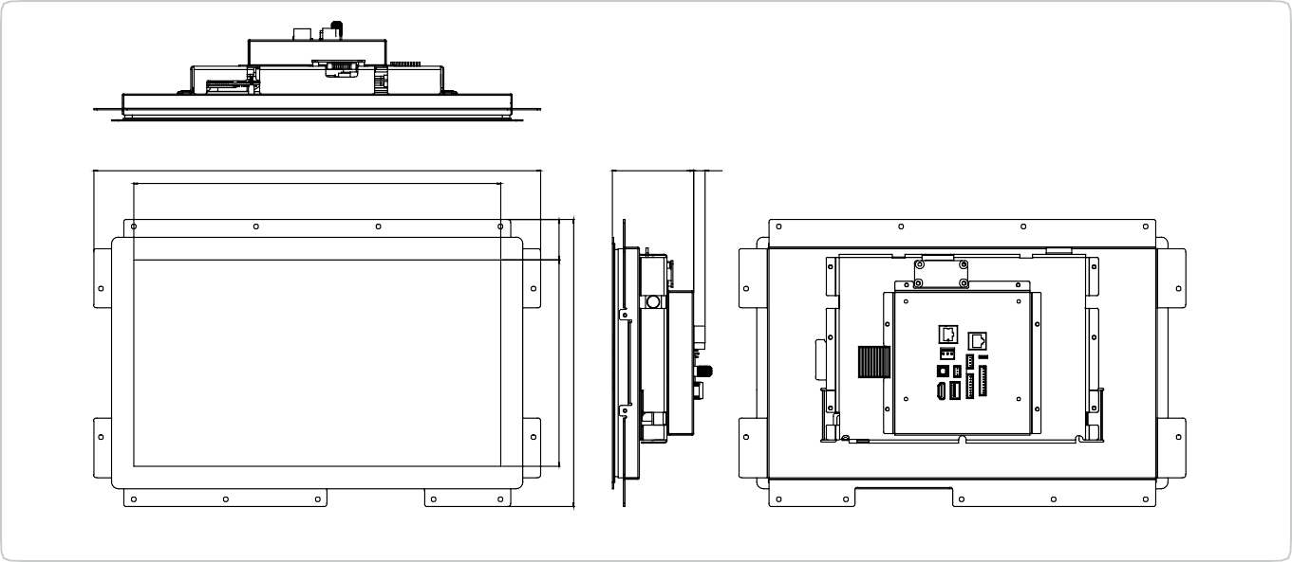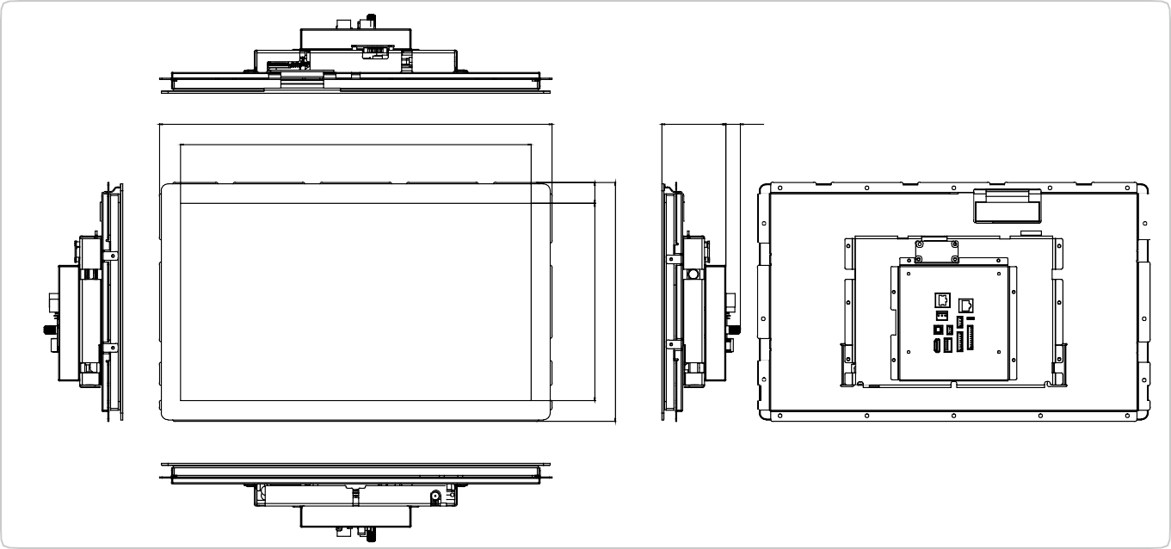
Display System
76.50 10.8
420.2
345.2
FIT1-W15A-IMX6-R10
Open Frame Dimensions (Unit: mm)
17.10
75.40
461.20
411.8
FIT1-W18A-IMX6-R10
Open Frame Dimensions (Unit: mm)
194.5
270.5
38
136.9
187
20.41
24.60
232
281.20
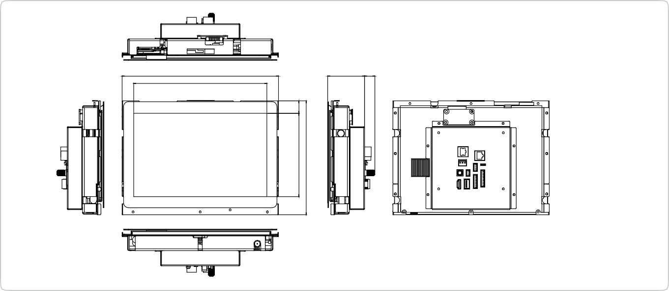w w w . i ei w or l d .c om
17.10
60.20
256
218.2
FIT1-W10A-IMX6-R10
Open Frame Dimensions (Unit: mm)

