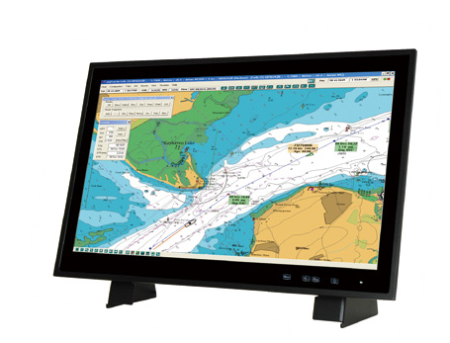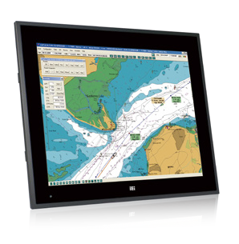
Marine Panel PC Series
Intel® Core™ i5 Dual-core Processor
Intel® Core™ i5FDeuaatl-ucroeresProcessor
(Optional Stand Kit)
- 19” and 24” Fanless Panel PC with 4th Generation Intel® Core™ i5 Dual-core Processor
- -15°C ~ +55°C Wide Temperature and IP66 Protection with Flat-bezel Projected Capacitive Touchscreen
- Excellent Visual Performance
  - Three independent displays
  - Full OSD function configuration
  - 0%~100% full range dimming
  - 178°/178° wide viewing angles
  - Optical bonding improves visibility under bright light (optional)
- Isolation Protection
  - RS-232/422/485 isolated serial ports
  - Isolated 18V ~ 36V DC input
  - 2 x Isolated CAN-bus 2.0B
- iRIS Remote Management Module
Specifications
S24A-QM87
S19A-QM87
Model |  | S19A-QM87 | S24A-QM87
LCD | LCD Size | 19” | 24”
 | Panel Type | PMVA | AMVA
 | Max. Resolution | 1280 x 1024 (5:4) | 1920 x 1080 (16:9)
 | Contrast Ratio | 2000 : 1 | 5000 : 1
 | Brightness (cd/m²) | 300 | 300
 | LCD Color | 16.7M | 16.7M
 | Pixel Pitch (um) | 294 x 294 | 276.75 x 276.75
 | Viewing Angles (H-V) | 178° / 178° | 178° / 178°
 | Backlight MTBF (HRs) | 50000 | 50000
Touchscreen & Controller |  | EEX3188 (10 point) , 6H | EEX3188 (10 point) , 6H
System | SBC Model | SMB-QM87-R10
 | Chipset | Intel® QM87
 | CPU | Intel® 22nm 4th generation Mobile Core™ i5-4400E 2.7GHz processor
 | RAM | 4GB 1600MHz DDR3 SDRAM (2GB*2)  Two 204-pin 1600/1333 MHz dual-channel DDR3 SDRAM support up to 16GB
Input Interfaces | I/O Ports & Switch | 2 x USB 2.0 1 x Isolated 18V ~ 36V DC 3-pin terminal block  2 x USB 3.1 Gen 1 (5Gb/s) 1 x Power button  1 x VGA 1 x PS2 (through Y-type cable supporting KB/MS)  1 x DVI-D 2 x CAN-bus 2.0B, 3-pin terminal block (2.5 kv isolation protection)  1 x HDMI 1 x DB-9 RS-232 (non-isolated) ,  1 x Mic-in 4 x DB-9 RS-232/422/485 (2.5 kv isolation protection)  1 x Line-out 2 x RJ-45 GbE LAN with teaming support  - x Line-in (2KV isolation protection)  - x Antenna SMA hole (reserved)
 | Expansion | 2 x Full-size PCIe Mini slot, 1 x iRIS-2400 slot (iRIS remote management module)
Ethernet Controller |  | GbE1: Intel® I217LM with Intel® AMT 9.0 support  GbE2: Intel® I210-AT PCIe controller
Sensor |  | Ambient light sensor (0% ~ 100%)
OSD |  | Menu, brightness down, brightness up, LCD on/off by cap-sensor (graphics engine: Genesis STDP6038)
Storage |  | 2 x 2.5” SSD bay with RAID 0/1 function  1 x Accessible CFast socket
LED Indicator |  | Power (power on: green; power off: orange)/storage (red, blinking)/IPMI (blue)
Power Requirement |  | Isolated 24V DC (18~31.2 V DC), screw-type 3-pin terminal block
Operating Temperature |  | -15°C ~ 55°C (5°F ~ 131°F)
Storage Temperature |  | -20°C ~ 60°C (-4°F ~ 140°F)
Humidity |  | 5% to 95% RH
Thermal Design |  | Fanless
Watchdog Timer |  | Supports 1~255 sec. system reset
Certifications |  | EMC: CE, FCC  Safety: DNV, IEC 60945 4th, IACS-E10, IEC 61174  IP rating: IP66 compliant front panel and IP22 compliant rear cover
Housing |  | Front aluminum sheet metal (Black C)
Cut-out Dimensions (L x W) |  | 442 mm x 373 mm | 576 mm x 358 mm
Dimensions (L x W x H) |  | 463 mm x 394 mm x 113 mm | 592 mm x 374 mm x 113 mm
Net Weight (kg) |  | 9.91 | 13.03
Gross Weight (kg) |  | 13.38 | 17.19
Vibration and Shock |  | IEC 60945 / DNV 2.4 compliant / IACS-E10
Power Supply (DC Input) |  | DC Input ATX Power Supply  - P/N: 041D710-00-101-RS  - 150W power supply  - Input: 24V DC, 8-4A (max.)  - Output (max.): 12V @13A
Power Consumption |  | 112W | 117W

Ordering Information

w w w . i ei w or l d .c om

P/N | Description
S19A-QM87i-i5/PC/4G-R11 | 19” 300cd/m² SXGA marine panel PC with Intel® Mobile Core™ i5-4400E 2.7GHz CPU, 2*2GB DDR3 RAM, projected capacitive  touch screen, isolated 18-36V DC, iRIS-2400 supported, R11
S24A-QM87i-i5/PC/4G-R11 | 24” 300cd/m² FHD marine panel PC with Intel® Mobile Core™ i5-4400E 2.7GHz CPU, 2*2GB DDR3 RAM, projected capacitive  touch screen, isolated 18-36V DC, iRIS-2400 supported, R11

Options

Item | Part No. | Description
Panel Mount Kit | PK-S19A-R10 | For S19A
 | PK-S24A-R10 | For S24A
Desktop Stand | STAND-S24A-R10 | For S19A & S24A
Ceiling Mount Kit | CEILMT-S24-R10 | For S19A/S24A
HDMI Lockable Kit | HDMI-LK-R10 | Universal HDMI Locking Adapter
iRIS Module | iRIS-2400-R10 | IPMI 2.0 adapter card with AST2400 BMC chip for DDR3 SO-DIMM socket interface

Packing List

Item | Q’ty | Remark
S19A-QM87 or S24A-QM87 | 1
Screw Pack | 1 | Including necessary screws
PS/2 Cable | 1 | Round cable; PS/2 cable
Wire Strain Band | 3 | Wire strain band

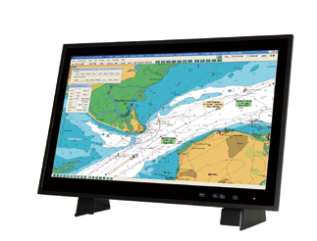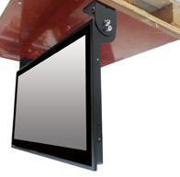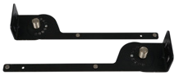
STAND-S24A-R10 CEILMT-S24-R10

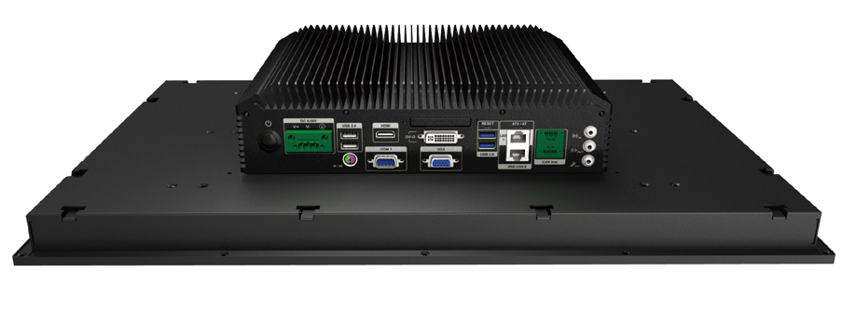CFast Slot HDMI
GbE LAN 1

Power Switch

24V DC
2 x USB 2.0

1 x PS/2
DVI-D

VGA
2 x CAN-bus 2.0B
Line-in
Line-out Mic-in

Combo RJ-45: GbE LAN 2 /IPMI

COM 1: RS-232 2 x USB 3.1 Gen 1 (5Gb/s)
Display System

Four OSD Keys by Cap-sensor
(Menu, Brightness down, Brightness up, LCD on/off)
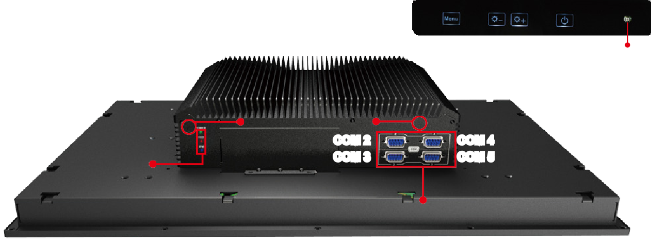
Ambient Light Sensor
LED Indicators: Power
HDD IPMI
2 x Antenna SMA hole
COM 2
COM 3
COM 4
COM 5
COM 2~COM 5: RS-232/422/485

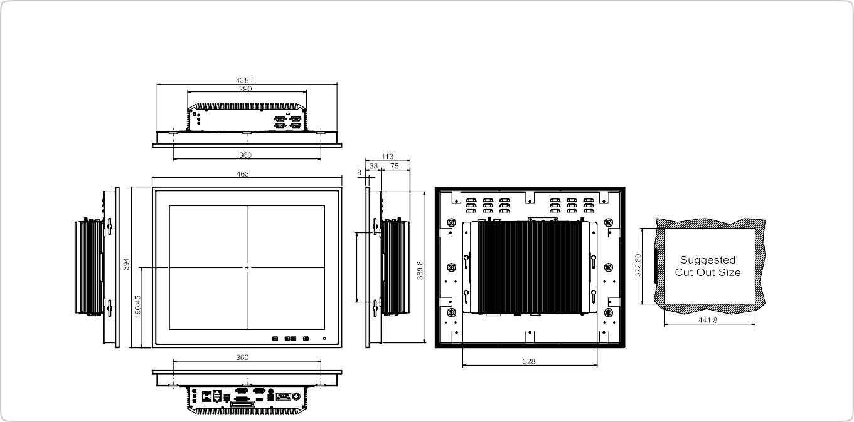
S19A-QM87 Dimensions
(Unit: mm)

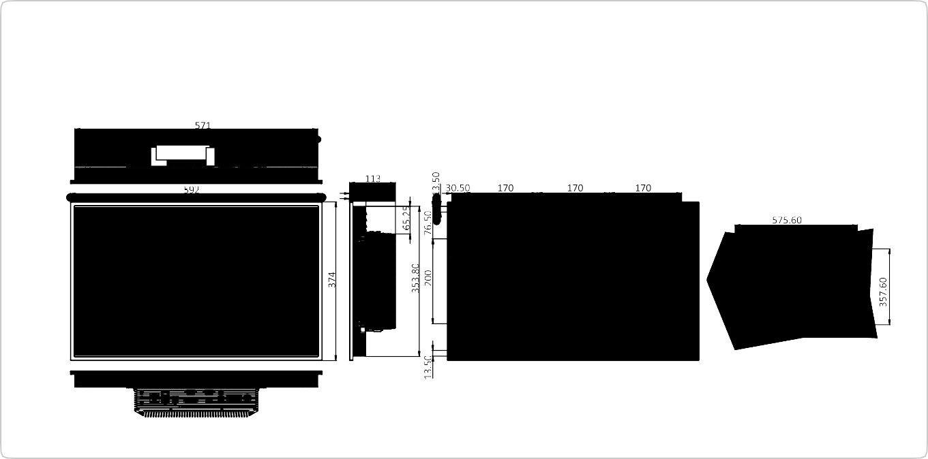
S24A-QM87 Dimensions
(Unit: mm)

