Vehicle Computer Series
AFOKAR-08A-RK39

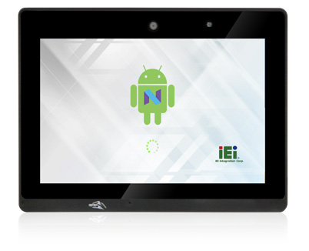Features
Android
Touchscreen
NFC
OBD-II
GPS
- 8” sunlight readable TFT LCD with projected
capacitive touchscreen
- Optional LTE module
- Built-in GPS receiver
- Built-in OBD-II/J1939
- OS: Android 7.1

Fanless

Bluetooth

Wi-Fi

High Brightness

Camera

Specifications

Model Name |  | AFOKAR-08A-RK39
Chassis | Color | Black C + Silver
 | Dimensions (WxHxD) (mm) | 210 x 154 x 33.9
 | System Fan | Fanless
 | Chassis Construction | PC + ABS plastic front, Metal rear
Display | Size | 8"
 | Resolution | 800(RGB) × 1280
 | Brightness (cd/m2) | 500 cd/m² (typ.)
 | Contrast Ratio | 800 : 1 (typ.)
 | Pixel Pitch (mm) | 0.13455(H) × 0.13455(V)
 | Viewing Angle (H/V) | 85/85/85/85 Deg.
 | Touchscreen | Projected capacitive with AG coating
Motherboard | CPU | Rockchip RK3399 (Dual-core Cortex-A72 up to 1.8GHz + Quad-core Cortex-A53 up to 1.5GHz)
 | System Memory | 2GB LPDDR3-1866
Storage | SD Card | 1 x Micro SD slot
 | Flash | 16GB eMMC NAND FLASH
Communication | WLAN | 802.11 a/b/g/n/ac
 | Bluetooth | Bluetooth V4.1
 | WWAN | PCIe Mini LTE (optional)
 | RFID | 13.56 MHz ISO4443 A/B, read-write capable,  ISO 14443A (MIFARE), ISO 14443B (FeliCa)
 | GPS | On board GPS
I/O Interfaces | 20-pin Connector | ** 1 x OBD-II/J1939  ** 1 x USB 2.0
 | 24-pin Connector | ** 1 x Audio out  ** 1 x RS-232  ** 1 x RS-485  ** 4-bit digital I/O with isolation (2-bit input, 2-bit output)
 | USB 3.1 Gen 1 | 1 x USB 3.1 Gen 1 Type A
 | Display | 1 x HDMI output
 | SIM | 1 x on board SIM card slot
 | Antenna | 1 x GPS, 1 x WWAN
Expansions | PCIe Mini | 1 x Full-size PCIe Mini (reserved for WWAN)
Multimedia | Speaker | 1 x Speaker (2 W)
 | Camera | 5-megapixel CMOS
LED Indicator & Button | Indicator | Power/BT/Wi-Fi/WWAN
 | Button | 1 x Power button
Power | Power Input | DC 9 V~30 V, 4 pin connector (with ACC Ignition)
 | Power Consumption | 12V @ 1.2A
Reliability | Mounting | VESA Mount 75mm x 75mm
 | Operating Temperature | -10°C ~ 50°C with air flow
 | Storage Temperature | -20°C ~ 60°C
 | Humidity | 10% ~ 90%, non-condensing
 | Operating Shock | Half-sine wave shock 5G, 11ms, 3 shocks per axis
 | Operating Vibration | MIL-STD-810F 514.5C-2
 | Weight (Net) | 0.77 kg
 | Safety/EMC | CE/FCC (Class A)/E-mak/IP54 front panel compliant
OS | Supported OS | Android 7.1
 | Watch dog timer | Yes

14.12
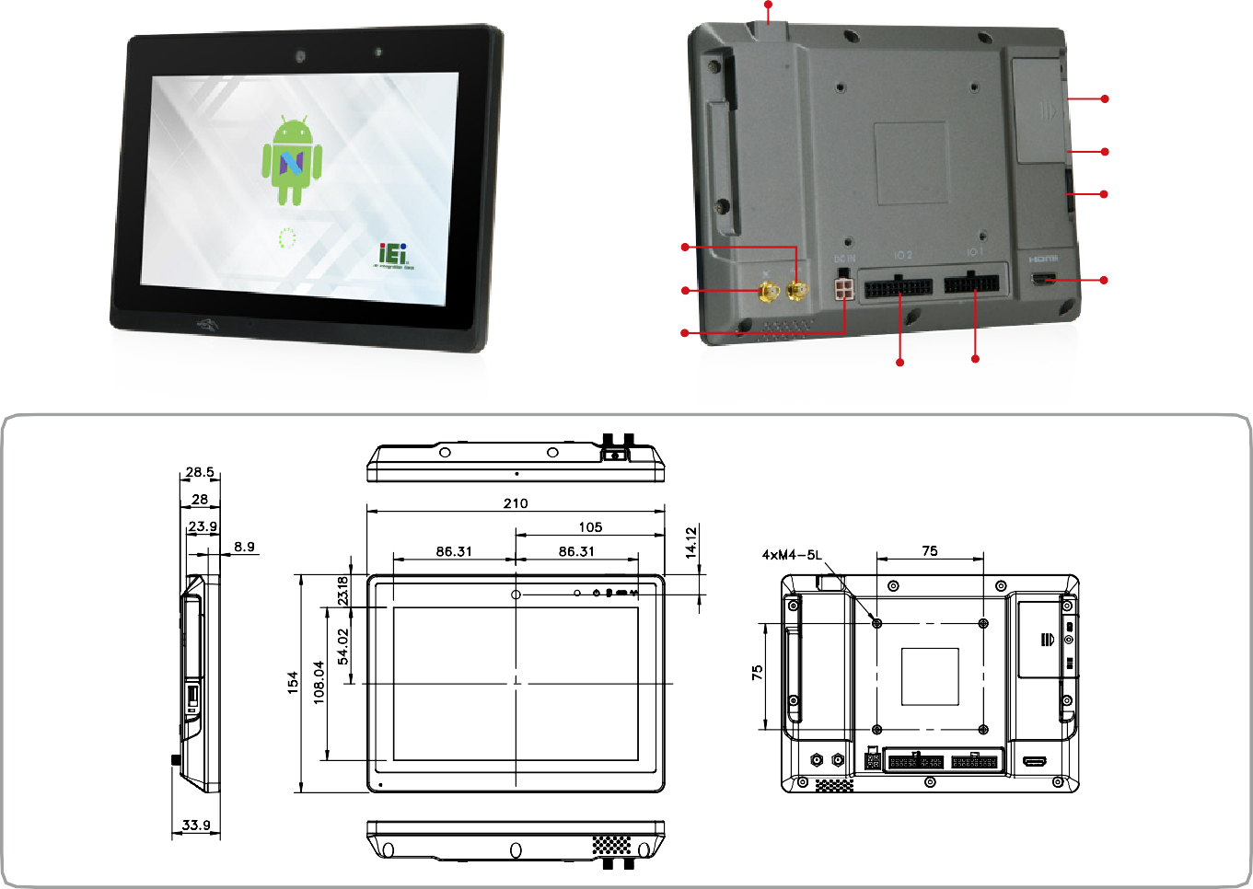Power Switch
Micro SD Card Slot Access Panel

SIM Card Slot Access Panel
USB 3.1 Gen 1
WWAN Antenna
(Optional)
GPS Antenna
HDMI Output
Power Input
Dimensions (Unit: mm)
I/O Connector 2 (24-pin) I/O Connector 1 (20-pin)
28.5
210
8.9
86.31
105
86.31
4XM4-5L
75
33.9
AFOKAR-08A-RK39
23.9
28

Ordering Information
154
108.04
54.02 23.18
75
Part No. | Description
AFOKAR-08A-RK39-R10- TW | 8” 500 cd/m², Android 7.1 In Vehicle Panel PC with Rockchip 3399 Processor, 2GB LPDDR3 , 16GB eMMC Flash, GPS, WIFI/BT, OBD II, 5M Camera, RFID Reader, TW reg, ROHS
AFOKAR-08A-RK39-R10-CN | 8” 500 cd/m², Android 7.1 In Vehicle Panel PC with Rockchip 3399 Processor, 2GB LPDDR3 , 16GB eMMC Flash, GPS, WIFI/BT, OBD II, 5M Camera, RFID Reader, CN reg, ROHS
AFOKAR-08A-RK39-R10-US | 8” 500 cd/m², Android 7.1 In Vehicle Panel PC with Rockchip 3399 Processor, 2GB LPDDR3 , 16GB eMMC Flash, GPS, WIFI/BT, OBD II, 5M Camera, RFID Reader, US reg, ROHS
AFOKAR-08A-RK39-R10-EU | 8” 500 cd/m², Android 7.1 In Vehicle Panel PC with Rockchip 3399 Processor, 2GB LPDDR3 , 16GB eMMC Flash, GPS, WIFI/BT, OBD II, 5M Camera, RFID Reader, EU reg, ROHS
Options

Item | Part No. | Description
Power Adapter | IVIPOWER-4PIN-R10 | Adapter PowerWith 4 pins transfer cable, RoHS
Cigarette Lighter Power Cable | 32002-004000-100-RS | CAR CIGARETTE LIGHTER CABLE
VESA Mount Stand | IVI-MK03-R10 | 138mm 75x75 VESA mount stand
VESA Mount Stand | IVI-MK04-R10 | 286mm 75x75 VESA mount stand
OBDII Cable | 32025-003400-100-RS | OBDII CABEL;2;2000MM;24AWG;(A)OBD2-16P MALE;(B)D-SUB 9PIN FEMALE
ACC Power Cable | 32002-001900-100-RS | Vehicle battery to device power cable;3000MM;16AWG
GPS/LTE Antenna | 32506-000500-100-RS | Magnetic Antenna Base_GPS+GLOANSS & 3G/LTE 2 In 1 Antenna;RG 174;5000MM
I/O Connector (20 pin) | 32024-003800-100-RS | 1 x DB-9 for OBD-II/J1939, 1 x USB 2.0 TYPE A
I/O Connector (24 pin) | 32124-004400-100-RS | 1 x Audio line-out (R+L), 1 x RS-232, 1 x RS-485,1 x terminal block 4 bit digital I/O
LTE module | 27552-000004-RS | WCDMA/HSPA+/LTE;SIM7500SA
 | 27552-000005-RS | GSM/LTE/WCDMA;SIM7500E
 | 27552-000006-RS | LTE/WCDMA;SIM7500A
Packing List
1 x AFOKAR Device

