Single Board Computer

Full-size

w w w . i ei w or l d .c om

WSB-H810
Full-size PICMG 1.0 CPU Card supports LGA 1150 Intel® Core™ i7/i5/i3, Pentium® and Celeron® CPU with Intel® H81, DDR3, VGA, iDP, Dual Intel® GbE, PCIe Mini, USB 3.1 Gen 1 (5Gb/s), SATA 6Gb/s, mSATA, RS-232, HD Audio and RoHS
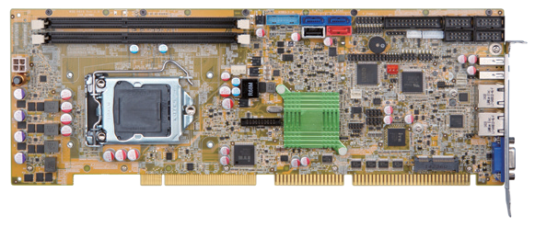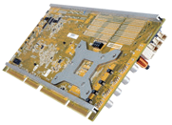1 x SATA 3Gb/s

Stiffener
bars

Dual-channel DDR3 1600/1333 MHz

LGA 1150
2 x SATA 6Gb/s
2 x USB 3.1 Gen 1 USB 2.0 Type A

Intel ®
H81
LPT 4 x RS-232
Front KB/MS panel

USB 2.0

LAN

Enhanced stability
Strengthen the mechanism Prevent PCB bending

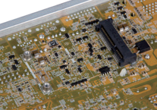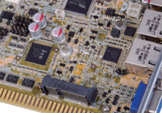PCIe Mini & mSATA connector

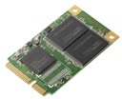Support PCIe Mini & mSATA

◄ mSATA

VGA

iDP

TPM

DIO

PCIe Mini

Specifications
DDR3
USB
1600
USB 3.1 SATA 6Gb/s Expansion
PCIe Mini
mSATA
iDP
CPU
4 x USB 2.0

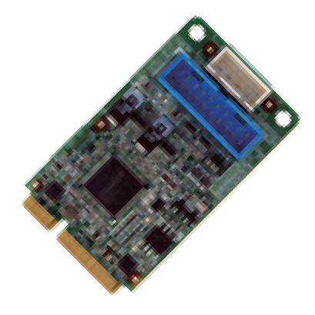
Top-side PCIe Mini connector supports PCIe signal for half-size or full-size PCIe device. Solder-side PCIe Mini connector supports SATA 3Gb/s signal for full-size mSATA.

◄ PCIe Mini

4th generation LGA 1150 Intel® Core™ i7/i5/i3, Pentium® or Celeron® processor supported Chipset
WSB-H810-2019-V10
Intel® H81
Memory
Twp 240-pin 1600/1333 MHz dual-channel DDR3 & DDR3L SDRAM unbuffered DIMMs support up to 16 GB
BIOS UEFI
Graphics Engine
Intel® HD Graphics Gen 7.5 supports DX11.1 and OpenCL 1.2, OpenGL 3.2 Full MPEG2, VC1, AVC Decode
Display Output
Dual independent display
1 x VGA (up to 1920x1200@60 Hz)
1 x iDP interface for HDMI, LVDS, VGA, DVI, DP (up to 3840x2160@60 Hz) Ethernet
LAN1: Intel® I217-LM Ethernet controller
LAN2: Intel® I211-AT Ethernet controller Audio
Supports 7.1-channel HD Audio by IEI AC-KIT-892HD-R10 kit
External I/O Interface 2 x USB 2.0
Internal I/O Interface
1 x KB/MS (1x6 pin) 2 x SATA 6Gb/s
1 x LPT (2x13 pin) 2 x USB 3.1 Gen 1 (5Gb/s) (2x10 pin) 1 x RS-422/485 (1x4 pin, P=2.0) 4 x RS-232 (2x5 pin, P=2.54)
1 x USB 2.0 (180° Type-A) 4 x USB 2.0 (2x4 pin, P=2.54)
1 x SATA 3Gb/s (AHCI supported, no RAID) Front Panel
- x Front panel (2x7 pin, power LED, HDD LED, speaker, power button, reset button)
LAN LED
- x LAN LED (1x2 pin) Digital I/O
8-bit digital I/O (2x5 pin)
TPM
1 x TPM (2x10 pin) SMBus
1 x SMBus (1x4 pin)
I²C
1 x I²C (1x4 pin) Infrared Interface
1 x Infrared Interface (1x5 pin)
Expansion
1 x Full-size PCIe Mini card slot (support mSATA) PCI and ISA signal via golden finger
Watchdog Timer
Software programmable supports 1~255 sec. system reset Fan Connector
1 x CPU smart fan (1x4 pin)
1 x System smart fan (1x3 pin)
Power Supply: 5V/12V, AT/ATX support Power Consumption
5V@3.4A, 12V@0.36A, Vcore_12V@7.48A, 3.3V@1.42A, 5VSB@0.13A
(Intel® Core™ i7-4770K 3.90 GHz CPU with 8 GB (two 4 GB) 1333 MHz DDR3 memory) Operating Temperature: -20°C ~ 60°C
Storage Temperature: -30°C ~ 70°C
Operating Humidity: 5% ~ 95%, non-condensing
Dimensions: 338 mm x 122 mm Weight: GW: 1000g / NW: 260g CE/FCC compliant

Features
- Full-size PICMG 1.0 with LGA 1150 Intel® CPU
- Two 1600/1333 MHz DDR3 SDRAM DIMM slots support up to 16 GB of memory
- Dual Intel® Gigabit Ethernet LAN controller
- SATA 6Gb/s and USB 3.1 Gen 1 (5Gb/s) supported
- IEI One Key Recovery solution for rapid OS backup and recovery
- TPM v1.2 hardware security function supported by TPM module
- Stiffener bars
- IEI jumper-less function

Packing List
1 x QIG
2 x SATA cable

1 x WSB-H810 single board computer

Ordering Information

Part No. | Description
WSB-H810-R10 | Full-size PICMG 1.0 CPU card supports LGA 1150 Intel® Core™ i7/i5/i3, Pentium® and Celeron® CPU with Intel® H81, DDR3, VGA, iDP, dual Intel® GbE, PCIe Mini, USB 3.1 Gen 1 (5Gb/s), SATA 6Gb/s, mSATA, RS-232, HD Audio and RoHS
19800-000049-RS | LPT flat cable, 240mm, P=2.54
19800-000075-RS | PS/2 KB/MS cable with bracket, 220mm, P=2.0
19800-003100-100-RS | Dual port USB 2.0 cable with bracket, 300mm, P=2.54
19800-010500-200-RS | USB 3.1 Gen 1 (5Gb/s) cable with bracket, 450mm
32102-000100-200-RS | SATA power cable, MOLEX 5264-4P to SATA15P
32200-074800-RS | RS-422/485 cable, 200mm, P=2.0
32205-000702-100-RS | RS-232 cable, 230mm, P=2.54
AC-KIT-892HD-R10 | 7.1-channel HD Audio kit with Realtek ALC892 supports dual audio streams
CF-1150SB-R11 | Special cooler kit for LGA 1150, high-performance compatible, 65W
CF-1150SC-R20 | Special cooler kit for LGA 1150, 1U chassis compatible, 65W
CF-1150SE-R11 | Special cooler kit for LGA 1150, high-performance compatible, 95W
CF-1150SF-R10 | Special cooler kit for LGA 1150, 1U chassis compatible, 54W
DP-DP-R10 | DisplayPort to DisplayPort converter board (for IEI iDP connector)
DP-DVI-R10 | DisplayPort to DVI-D converter board (for IEI iDP connector)
DP-HDMI-R10 | DisplayPort to HDMI converter board (for IEI iDP connector)
DP-LVDS-R10 | DisplayPort to LVDS converter board (for IEI iDP connector)
DP-VGA-R10 | DisplayPort to VGA converter board (for IEI iDP connector)
TPM-IN01-R20 | 20-pin Infineon TPM module, software management tool, firmware v3.17

