Single Board Computer

Full-size

w w w . i ei w or l d .c om

Full-size PICMG 1.0 CPU Card supports 32nm LGA 1155 Intel® Core™ i7/ i5/i3, Pentium® or Celeron® CPU with Intel® H61, DDR3, VGA, DVI-D, Dual Realtek PCIe GbE, USB 2.0, SATA 3Gb/s, COM, HD Audio and RoHS
WSB-H610-R11
Front panel
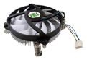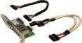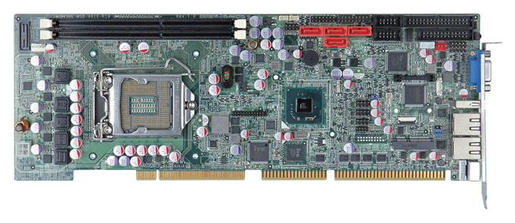4 x SATA 3Gb/s 2 x RS-232 ATXCTL

Dual-channel DDR3 1333/1066 MHz
SMBus
I²C

Intel® H61
TPM
KB/MS

FDD

LPT DIO IR
VGA USB 2.0

LAN

KB/MS

45W

DVI-D

Audio

6 x USB 2.0

PCIe Mini

Specifications
CPU

CF-115XC-R10
1U chassis compatible

Features

IO-KIT-001-R20
DVI cable included in DVI model

LGA 1155 socket supports Intel® Core™ i7/i5/i3, Pentium® or Celeron® processor Chipset
WSB-H610-2019-V11
Intel® H61
Memory
Two 240-pin 1333/1066 MHz dual-channel DDR3 & DDR3L SDRAM unbuffered DIMMs support up to 16 GB
BIOS UEFI
Graphics Engine
Intel® HD Graphics Gen 6 supports DX10.1 and OpenGL 3.0 Full MPEG2, VC1, AVC Decode
Display Output
1 x VGA (up to 2048x1536@75Hz)
1 x DVI-D (up to 1920x1200@60Hz)
(via header to IO-KIT-001-R20 DVI-D/USB module) (optional) Ethernet
LAN1: Realtek RTL8111E PCIe GbE controller with ASF 2.0 support
LAN2: Realtek RTL8111E PCIe GbE controller External I/O Interface
1 x KB/MS 1 x USB 2.0
Internal I/O Interface
- x FDD (2x17 pin) 1 x KB/MS (1x6 pin)
1 x LPT (2x13 pin) 1 x RS-422/485 (1x4 pin, P=2.0)
- x RS-232 (2x5pin, P=2.54) 4 x SATA 3Gb/s (no AHCI & RAID support) 6 x USB 2.0 (2x4 pin, P=2.54)
Audio
Supports 7.1-channel HD Audio by IEI AC-KIT-892HD-R10 kit Front Panel
1 x Front panel (2x7 pin, power LED, HDD LED, speaker, power button, reset button)
TPM
1 x TPM (2x10 pin) SMBus
1 x SMBus (1x4 pin)
I²C
1 x I²C (1x4 pin) Expansion
PCI signal and ISA signal via golden finger
Watchdog Timer
Software programmable supports 1~255 sec. system reset Digital I/O
8-bit digital I/O (2x5 pin)
Fan Connector
1 x CPU smart fan (1x4 pin)
1 x System smart fan (1x4 pin) Power Supply
5V/12V, AT/ATX support
Power Consumption
5V@4.53A, 12V@0.19A, Vcore_12V@7.81A, 5VSB@0.18A
(3.4GHz Intel® Core™ i7-2600K with two 2 GB 1333 MHz DDR3 memory) Operating Temperature
-10°C ~ 60°C
Storage Temperature
-20°C ~ 70°C
Operating Humidity
5% ~ 95%, non-condensing Dimensions
338 mm x 122 mm
Weight
GW: 1000g / NW: 260g
CE/FCC compliant
- Full-size PICMG 1.0 CPU card with LGA 1155 Intel® Core™ i7/i5/i3, Pentium® or Celeron® processor supported
- Two DDR3 & DDR3L 1333/1066 MHz DIMM SDRAM support up to 16 GB
- Embedded controller on board supports infrared and PECI 2.0 technologies
- Dual Realtek PCIe GbE and LAN1 with ASF 2.0 support
- TPM V1.2 hardware security function supported by TPM module
- IEI One Key Recovery solution allows you to create raipd OS backup and recovery

Packing List

1 x WSB-H610 single board computer
1 x Dual RS-232 cable with bracket
1 x KB/MS Y cable
1 x USB cable
2 x SATA cable
1 x Mini jumper pack
1 x QIG

Ordering Information

Part No. | Description
WSB-H610-R11 | Full-size PICMG 1.0 CPU card supports 32nm LGA 1155 Intel® Core™ i7/i5/i3, Pentium® or Celeron® CPU with Intel® H61, DDR3, VGA, dual Realtek PCIe GbE, USB 2.0, SATA 3Gb/s, COM, HD Audio and RoHS
WSB-H610-DVI-R11 | Full-size PICMG 1.0 CPU card supports 32nm LGA 1155 Intel® Core™ i7/i5/i3, Pentium® or Celeron® CPU with Intel® H61, DDR3, VGA, DVI-D, dual Realtek PCIe GbE, USB 2.0, SATA  3Gb/s, COM, HD Audio and RoHS
19800-000049-RS | LPT flat cable, 240mm, P=2.54
19800-000075-RS | PS/2 KB/MS cable with bracket, 220mm, P=2.0
32006-000300-100-RS | PS/2 KB/MS Y-cable without bracket, 140mm/120mm
32102-000100-200-RS | SATA power cable, MOLEX 5264-4P to SATA15P
32200-000017-RS | FDD cable, 520mm, P=2.54
AC-KIT-892HD-R10 | 7.1-channel HD Audio kit with Realtek ALC892 supports dual audio streams
CF-115XA-R10 | High performance LGA 1155/LGA 1156 cooler kit, 1U chassis compatible, 73W
CF-115XC-R10 | LGA 1155/LGA 1156 cooler kit, 1U chassis compatible, 45W
CF-115XD-R10 | LGA 1155/LGA 1156 cooler kit, 1U chassis compatible, 65W
CF-115XE-R10 | High performance LGA 1155/LGA 1156 cooler kit, 95W
SAIDE-KIT01-R10 | SATA to IDE/CF converter board
TPM-IN01-R20 | 20-pin Infineon TPM module, software management tool, firmware v3.17

