Single Board Computer

Full-size

w w w . i ei w or l d .c om

WSB-BT
Full-size PICMG 1.0 CPU Card supports Intel® Celeron™ on-board SoC with VGA, iDP, Dual Intel® PCIe GbE, USB 3.1 Gen 1 (5Gb/s), PCIe Mini, SATA, mSATA, COM, CF, Audio and RoHS

2 x SATA 3Gb/s

LVDS

iDP
Front Panel
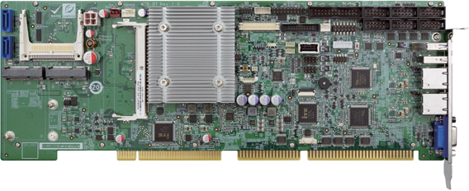RS-232/422/485

CF Type II
Audio
TPM
LPT
RS-232
Multiple Choice for Storage

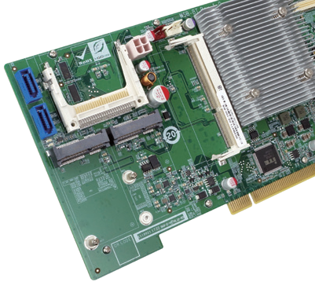CF Type II

USB 3.1 Gen 1
USB 2.0

Dual LAN

VGA

SATA 3Gb/s

mSATA

PCIe Mini
USB 2.0
KB/MS DIO

DDR4
USB
2133
USB 3.1 SATA 3Gb/s Expansion
PCIe Mini
mSATA

Specifications
WSB-BT-2019-V10
CPU
Intel® Celeron® J1900 on-board SoC (2GHz, quad-core, 2MB cache, TDP=10W) Intel® Celeron® N2807 on-board SoC (1.58GHz, dual-core, 2MB cache, TDP=4.3W) Memory
One 204-pin 1333/1066MHz dual-channel DDR3L SDRAM unbuffered DIMM supports up to 8GB (J1900) or 4GB (N2807)
BIOS
AMI UEFI BIOS
Graphics
Intel® HD Graphics Gen 7 Engines with 4 execution units, supports DX11.1, OpenGL 4.2 and OpenCL1.2
Display Output
1 x VGA (up to 1920x1200@60Hz)
1 x 18/24-bit dual-channel LVDS (up to 1920x1200@60Hz)
1 x iDP interface for HDMI, LVDS, VGA, DVI, DP (up to 2560x1600@60Hz) Ethernet
LAN1: Intel® I211-AT PCIe controller
LAN2: Intel® I211-AT PCIe controller External I/O
1 x USB 3.1 Gen 1 (5Gb/s)
1 x USB 2.0
Internal I/O
1 x CF Type II 2 x RS-232/422/485 (2x5 pin, P=2.54)
1 x KB/MS (1x6 pin) 2 x SATA 3Gb/s
1 x LPT (2x13 pin) 4 x RS-232 (2x5 pin, P=2.54)
1 x mSATA (SATA 3Gb/s) 4 x USB 2.0 (2x4 pin, P=2.54)
1 x USB 2.0 (180º Type-A)
Front Panel
1 x Front panel (Power LED, HDD LED, Speaker, Power Button, Reset Button) Digital I/O
8-bit digital I/O (2x5 pin)
TPM
1 x TPM (2x10 pin) Audio
7.1 channel HD Audio supported by IEI AC-KIT-892HD kit
SMBus
1 x SMBus (1x4 pin) I²C
1 x I²C (1x4 pin)
Expansion
1 x Full/Half-size PCIe Mini card slot PCI and ISA* signal via golden finger Watchdog Timer
Software programmable supports 1~255 sec. system reset Fan Connector
1 x CPU smart fan (1x4 pin)
1 x System smart fan (1x3 pin) Power Supply
5V/12V, AT/ATX support
Power Consumption
3.3V@0.009A, 5V@4.68A, 5Vsb@0.008A, 12V@1.143A
(Intel® Celeron® J1900 1.99 GHz 10W CPU with 8GB 1600MHz DDR3L memory) Operating Temperature
-20°C ~ 60°C
Storage Temperature
-30°C ~ 70°C
Operating Humidity
5% ~ 95%, non-condensing Dimensions
338 mm x 122 mm
Weight
GW: 1000g / NW: 260g
CE/FCC compliant

Features
- Full-size PICMG 1.0 with Intel® Celeron™ J1900 & N2807 on-board SoC
- Dual-channel 1066/1333MHz DDR3L SO-DIMM supports up to 8GB of memory
- Dual Gigabit Ethernet LAN controller
- SATA 3Gb/s, USB 3.1 Gen 1 (5Gb/s), PCIe Mini, mSATA and CF card supported
- TPM v1.2 & 2.0 hardware security function supported by TPM module
- Stiffener bars

Packing List

1 x WSB-BT single board computer
1 x Dual RS-232 cable with bracket
1 x SATA cable
1 x QIG

Ordering Information

Part No. | Description
WSB-BT-J19001-R10 | Full-size PICMG 1.0 CPU card supports Intel® Celeron™ J1900 on-board SoC with VGA, iDP, Dual Intel® PCIe GbE, PCIe Mini,  USB 3.1 Gen 1 (5Gb/s), SATA, mSATA, COM, CF, Audio and RoHS
WSB-BT-N28071-R10 | Full-size PICMG 1.0 CPU card supports Intel® Celeron™ N2807 on-board SoC with VGA, iDP, Dual Intel® PCIe GbE, PCIe Mini, USB 3.1 Gen 1 (5Gb/s), SATA, mSATA, COM, CF, Audio and RoHS
19800-000049-RS | LPT flat cable, 240mm, P=2.54
19800-000075-RS | PS/2 KB/MS cable with bracket, 220mm, P=2.0
32102-000100-200-RS | SATA power cable, MOLEX 5264-4P to SATA15P
DP-DP-R10 | DisplayPort to DisplayPort converter board (for IEI iDP connector)
DP-DVI-R10 | DisplayPort to DVI-D converter board (for IEI iDP connector)
DP-HDMI-R10 | DisplayPort to HDMI converter board (for IEI iDP connector)
DP-LVDS-R10 | DisplayPort to LVDS converter board (for IEI iDP connector)
DP-VGA-R10 | DisplayPort to VGA converter board (for IEI iDP connector)
AC-KIT-892HD-R10 | 7.1 channel HD Audio kit with Realtek ALC892 support dual audio stream
TPM-IN01-R20 | 20-pin Infineon TPM1.2 module, software management tool, firmware v3.17
TPM-IN02-R20 | 20-pin Infineon TPM2.0 module, software management tool, firmware v5.5
* ISA Limitation. Please refer to the manual for more information.

