Single Board Computer

Full-size

w w w . i ei w or l d .c om

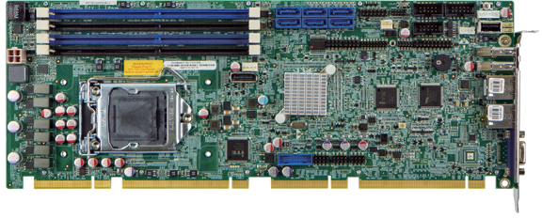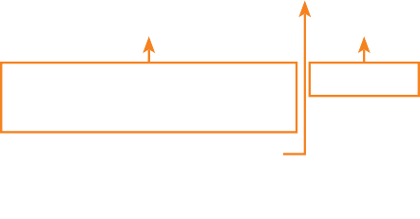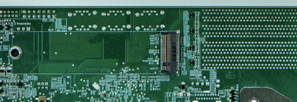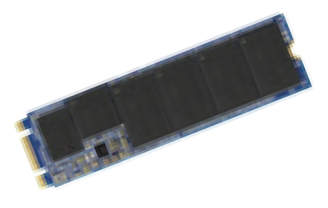PCIE-Q370
Full-size PICMG 1.3 CPU Card supports LGA1151 Intel® Core™ i7/i5/i3/ Pentium®/ Celeron® CPU per Intel® Q370, DDR4, VGA, DP, Dual Intel® PCIe GbE, SATA 6Gb/s, USB 3.1 Gen 1 (5Gb/s), M.2, HD Audio, Intel® AMT and RoHS

DisplayPort
Front Panel
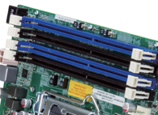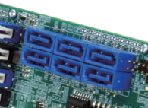Audio 3 x RS-232
Four 288-pin DDR4 SDRAM Supported
SATA 6Gb/s
RAID 0, 1, 5, 10 function compatible with six ports of SATA 6Gb/s

Dual-channel DDR4 2666MHz 6 x SATA 6Gb/s
DIO
KB/MS

LGA 1151

Intel ®
Q370
USB 2.0 RS-422/485
USB 3.1
Gen 1 LAN

VGA

Specifications
CPU
2 x USB 3.1 Gen 1 TPM
6 x USB 2.0

M.2 M Key

LGA1151 socket supports 8th generation Intel® Core® i7/i5/i3, Pentium® or Celeron® processor
Chipset Intel® Q370 Memory
Four 288-pin 2666MHz dual-channel DDR4 SDRAM unbuffered DIMMs support up to
64GB BIOS
AMI UEFI BIOS
Graphic Engine
Intel® HD Graphics Gen 9 Engines with Low power 16 execution unit, supports DX2015, OpenGL 5.X and OpenCL2.x, ES 2.0
Display Output
Dual display supported
1 x VGA (up to 1920x1200@60 Hz)
1 x DP (up to 4096 x 2304@60Hz) Ethernet
LAN1: Intel® I219LM PHY

Features
- PICMG 1.3 full-size CPU card

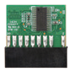
TPM 2.0 Support
AMT 11.0
Intel®
DDR4
2666
Display
Dual
DP++
M.2
Dual GbE

LAN2: Intel® I211-AT PCIe controller (Co-lay I210-AT) External I/O Interface
PCIE-Q370-2019-V11
2 x USB 3.1 Gen 1 (5Gb/s) (Rear IO type A)
- x USB 2.0 (Type A 180°)
Internal I/O Interface 1 x KB/MS (1x6 pin)
1 x RS-422/485 (1x4 pin, P=2.0)
- x USB 3.1 Gen 1 (5Gb/s) (2x10 pin) 3 x RS-232 (2x5 pin, P=2.54)
6 x SATA 6Gb/s (RAID 0/1/5/10 supported) 6 x USB 2.0 (2x4 pin, P=2.54)
Audio
Support 7.1 channel HD audio by IEI AC-KIT-892HD kit Front Panel
- x Front panel (Power LED, HDD LED, Speaker, Power Button, Reset Button)
LAN LED
- x LAN LED (1x2 pin) TPM
1 x TPM (2x10 pin)
SMBus
1 x SMBus (1x4 pin) I²C
1 x I²C (1x4 pin)
Expansion
1 x M.2 M key
1 x PCIe x16 & 4 x PCIe x1 signal via golden finger 4 x PCI signal via golden finger
Watchdog Timer
Software programmable support 1~255 sec. system reset Digital I/O
8-bit digital I/O (2x5 pin)
Fan Connector
1 x CPU smart fan (1x4 pin)
1 x System smart fan (1x3 pin) Power Supply
AT/ATX power supply
Support AT/ATX mode ErP/EuP Compliant Power Consumption
5V@3.12A, 12V@6.85A, 3.3V@1.13A, 5VSB@0.15A
(4.0 GHz Intel® Core™ i7-8700K CPU with four 16 GB 2666 MHz DDR4 memory) Operating Temperature
-20°C ~ 60°C
Operating Humidity
5% ~ 95%, non-condensing
Diemension: 338 mm x 126 mm Weight: GW: 1000g / NW: 500g CE/FCC compliant
- LGA1151 Intel® 8th Generation Core™ i7/i5/i3, Celeron® and Pemtium® processor
supported
- Dual-channel DDR4 2666MHz
- Support VGA/HDMI and DP display
- Intel® PCIe GbE with Intel® AMT 11.0 supported
- Support M.2 M key for storage (PCIe x4)
- Supports RAID 0, 1, 5, 10 function via SATA 6Gb/s

Packing List

1 x PCIE-Q370-R10 single board computer | 1 x Mini jumper pack
1 x SATA cable | 1 x QIG (Quick Installation Guide)
Ordering Information

Part No. | Description
PCIE-Q370-R11 | Full-size PICMG 1.3 CPU Card supports LGA1151 Intel® Core™ i7/i5/i3/Pentium®/Celeron® CPU per Intel® Q370, DDR4, Dual Intel® PCIe GbE, USB 3.1 Gen 1 (5Gb/s), SATA 6Gb/s, VGA, DP, M.2, HD Audio, iAMT and RoHS
PCIE-Q370-HDMI-R11** | Full-size PICMG 1.3 CPU Card supports LGA1151 Intel® Core™ i7/i5/i3/Pentium®/Celeron® CPU per Intel® Q370, DDR4, HDMI, DP, Dual Intel® PCIe GbE, USB 3.1, SATA 6Gb/s, M.2, HD  Audio, iAMT and RoHS
19800-000075-RS | PS/2 KB/MS cable with bracket, 220mm, P=2.0
32102-000100-200-RS | SATA power cable, MOLEX 5264-4P to SATA15P
AC-KIT-892HD-R10 | 7.1 channel HD Audio kit with Realtek ALC892 support dual audio streams
CF-1150SA-R10 | Special cooler kit for LGA1150, High-performance compatible, 95W
CF-1150SB-R11 | Special cooler kit for LGA1150, High-performance compatible, 65W
CF-1150SC-R20 | Special cooler kit for LGA1150, 1U chassis compatible, 65W
CF-1150SE-R11 | Special cooler kit for LGA1150, high-performance compatible, 95W
CF-1150SF-R10 | Special cooler kit for LGA1150, 1U chassis compatible, 54W
SAIDE-KIT01-R10 | SATA to IDE/CF Converter board
**By order production, MOQ: 100

