Single Board Computer

Full-size

w w w . i ei w or l d .c om

PCIE-H810
Full-size PICMG 1.3 CPU card supports LGA 1150 Intel® Core™ i7/i5/i3, Pentium® and Celeron® with Intel® H81, DDR3, VGA, iDP, Dual PCIe GbE, SATA 6Gb/s, mSATA, USB 3.1 Gen 1 (5Gb/s), RS-232, HD Audio and RoHS

Dual-channel DDR3

2 x SATA 3Gb/s LPT

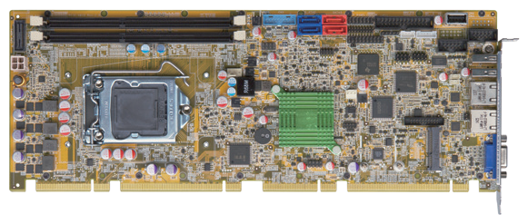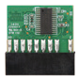USB 2.0

1600/1333 MHz
2 x SATA 6Gb/s
2 x USB 3.1 Gen 1
Front panel KB/MS

Enhanced component protection
Prevent the damage of bottom components

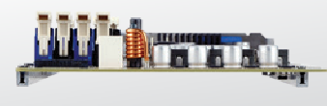2 x RS-232

USB 2.0 RS-422/485

LGA 1150

Intel® H81

DIO

TPM

PCIe Mini & mSATA colay iDP

LAN

VGA

PCIe Mini & mSATA colay
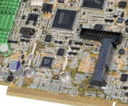The PCIe Mini interface provides PCIe x1, USB and mSATA signal for full-size or half-size PCIe Mini devices, such as SSD, mSATA and wireless LAN cards.

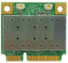
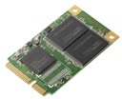2 x USB 2.0

◄ mSATA

TPM 1.2 Support

Features
DDR3

1600
USB
USB 3.1 SATA 6Gb/s PCIe GbE
mSATA
iDP
- PICMG 1.3 full-size solution
▲ Half-size wireless LAN card

Specifications
PCIE-H810-2019-V10
CPU
4th generation LGA 1150 Intel® Core™ i7/i5/i3, Pentium® or Celeron® processor supported Chipset
Intel® H81
Memory
Two 240-pin 1600/1333 MHz dual-channel unbuffered DDR3 & DDR3L SDRAM DIMMs support up to 16 GB
BIOS UEFI
Graphics Engine
Intel® HD Graphics Gen 7.5 supports DX11.1, OpenCL 1.2 and OpenGL 3.2 Full MPEG2, VC1, AVC Decode
Display Output
Dual independent display
1 x VGA (up to 1920x1200@60 Hz)
1 x iDP interface for HDMI, LVDS, VGA, DVI, DP (up to 3840x2160@60 Hz) Ethernet
Dual Realtek RTL8111E PCIe GbE controllers supported
External I/O Interface 2 x USB 2.0
Internal I/O Interface
1 x KB/MS (1x6 pin) 2 x SATA 3Gb/s (AHCI supported, no RAID)
1 x LPT (2x13 pin) 2 x SATA 6Gb/s
1 x RS-422/485 (1x4 pin, P=2.0) 2 x USB 3.1 Gen 1 (5Gb/s) (2x10 pin)
1 x USB 2.0 (180° Type-A) 4 x USB 2.0 (Golden finger)
2 x RS-232 (2x5 pin, P=2.54) 4 x USB 2.0 (2x4 pin, P=2.54)
Audio
Support 7.1-channel HD Audio by IEI AC-KIT-892HD kit Front Panel
- x Front panel (2x7 pin, power LED, HDD LED, speaker, power button, reset button)
LAN LED
- x LAN LED (1x2 pin) SMBus
1 x SMBus (1x4 pin)
I²C
1 x I²C (1x4 pin) Infrared Interface
1 x Infrared Interface (1x5 pin)
Expansion
1 x Full/Half-size PCIe Mini slot (supports mSATA) One PCIe x16 & four PCIe x1 signal via golden finger Watchdog Timer
Software programmable supports 1~255 sec. system reset
Digital I/O
8-bit digital I/O (2x5 pin) Fan Connector
1 x CPU smart fan (1x4 pin)
1 x System smart fan (1x3 pin) Power Supply
5V/12V, AT/ATX support
Power Consumption
5V@3.41A, 12V@0.35A, Vcore_12V@7.52A, 3.3V@1.41A, 5VSB@0.12A
(Intel® Core™ i7-4770K 3.90 GHz CPU with 8 GB (two 4 GB) 1333 MHz DDR3 memory) Operating Temperature: -20°C ~ 60°C
Storage Temperature: -30°C ~ 70°C
Operating Humidity: 5% ~ 95%, non-condensing
Dimensions: 338 mm x 126 mm Weight: GW: 1000g / NW: 420g CE/FCC compliant
- 4th generation LGA 1150 Intel® Core™ i7/i5/i3, Pentium® or Celeron® processor supported
- Two 1600/1333 MHz DDR3 SDRAM DIMMs support up to 16 GB
- Dual Realtek PCIe GbE supported
- TPM v1.2 hardware security function supported by TPM module
- IEI One Key Recovery solution allows you to create raipd OS backup and recovery
- Stiffener bars
- IEI jumper-less function

Packing List

1 x PCIE-H810 single board computer
2 x SATA cable
1 x QIG

Ordering Information

Part No. | Description
PCIE-H810-R10 | Full-size PICMG 1.3 CPU Card supports LGA 1150 Intel® Core™ i7/i5/i3, Pentium® and Celeron® CPU with Intel® H81, DDR3, VGA, iDP, dual PCIe GbE, SATA 6Gb/s, mSATA, RS-232,  USB 3.1 Gen 1 (5Gb/s), HD Audio and RoHS
19800-000049-RS | LPT flat cable, 240mm, P=2.54
19800-000075-RS | PS/2 KB/MS cable with bracket, 220mm, P=2.0
19800-003100-300-RS | Dual port USB 2.0 cable with bracket, 300mm, P=2.54
19800-010500-200-RS | USB 3.1 Gen 1 (5Gb/s) cable with bracket, 450mm
32102-000100-200-RS | SATA power cable, MOLEX 5264-4P to SATA15P
32205-000702-100-RS | RS-232 cable, 230mm, P=2.54
32205-003800-300-RS | RS-422/485 cable, 200mm, P=2.0
AC-KIT-892HD-R10 | 7.1-channel HD Audio kit with Realtek ALC892 supports dual audio streams
CF-1150SB-R11 | Special cooler kit for LGA 1150, high-performance compatible, 65W
CF-1150SC-R20 | Special cooler kit for LGA 1150, 1U chassis compatible, 65W
CF-1150SE-R11 | Special cooler kit for LGA 1150, high-performance compatible, 95W
CF-1150SF-R10 | Special cooler kit for LGA 1150, high-performance compatible, 54W
DP-DP-R10 | DisplayPort to DisplayPort converter board (for IEI iDP connector)
DP-DVI-R10 | DisplayPort to DVI-D converter board (for IEI iDP connector)
DP-HDMI-R10 | DisplayPort to HDMI converter board (for IEI iDP connector)
DP-LVDS-R10 | DisplayPort to LVDS converter board (for IEI iDP connector)
DP-VGA-R10 | DisplayPort to VGA converter board (for IEI iDP connector)
TPM-IN01-R20 | 20-pin Infineon TPM module, software management tool, firmware v3.17

