Display System
w w w . i ei w or l d .c om
UPC Series
Intel® Core™ i5 and Celeron® ULT Processor
UPC-F12C-ULT3

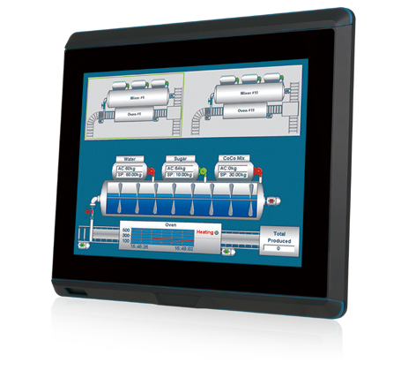Features
Specifications
- 12.1’’ fanless panel PC with Intel® Skylake ULT processor
- IP66 6-side protection with M12 connector I/O cover
- IP65 6-side protection with standard cable I/O cover
- Built-in wireless 802.11 a/b/g/n/ac and Bluetooth V4.0
- Operating temperature : -20°C ~ 60°C
- Flat glass PCAP touch with 6H hardness, resistive touch window

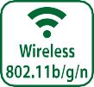

Model |  | UPC-F12CM-ULT3 | UPC-F12C-ULT3
Display | LCD Display | 12.1"
 | Max Resolution | 1024(W) x 768(H)
 | Brightness (cd/m²) | 600
 | Contrast Ratio | 700:1
 | LCD Color | 16.2M
 | Pixel Pitch (mm) | 0.24(H) x 0.24(V)
 | Viewing Angle (H-V) | 160º / 140º
 | Backlight MTBF (Hrs) | 50,000
Motherboard | CPU | 6th generation Intel® Core™ i5 and Celeron® ULT processor
 | RAM | 1 x 260-pin 2133/1867 MHz single-channel DDR4 SO-DIMMs
 | Ethernet | LAN1: PCIe GbE by Intel® I211 controller LAN2: PCIe GbE by Intel® I211 controller
Touchscreen |  | P-CAP / Resistive Touch
Input Interfaces | I/O Ports & Switch | M12 Type:  1 x 8-pin M12 connector for RS-232  1 x 8-pin M12 connector for RS-232/422/485  - x 8-pin M12 connector for GbE LAN  - x 8-pin M12 connector for two USB 2.0  1 x 5-pin M12 connector for DC jack (12V~36V DC) | Standard Type:  1 x DC jack (12V-36V DC)  1 x DC-in terminal block (12V-36V DC) 1 x HDMI  - x VGA/CAN Bus  1 x RS-232 (COM1 RJ-45)  1 x RS-232/422/485 (COM2 RJ-45)  - x LAN  2 x USB 2.0  2 x USB 3.1 Gen 1 (5Gb/s)
Expansion |  | 1 x Full-size/half-size PCIe Mini card slot (PCIe x1 and USB 2.0 signals)
Connectivity | Wi-Fi & BT | 802.11 a/b/g/n/ac + Bluetooth v4.0
 | RFID | Reserved RFID antenna area (optional)
Storage |  | 1 x 2.5" HDD bay
 |  | 1 x M.2 (B key 2242 with USB 2.0 and SATA signal)
Physical | Construction | Aluminum die-casting
 | Mounting | VESA 100mm x 100mm
 | Net/Gross Weight (kg) | 4.95 kg / 7.62 kg | 5.02 kg / 7.40 kg
 | Dimensions (W x L x D) (mm) | 316 x 279 x 67
Environment | Operating Temperature (with air  flow) | -20°C ~ 60°C (without heater solution)  -40°C ~ 60°C by project base
 | Storage Temperature | -20°C ~ 70°C
 | IP Level | Full IP65 or Full IP66 (with M12 connectors)
 | Safety | CE / FCC
Power | Power Requirement | Power 1: 12V ~ 36V (terminal block)
 |  | Power 2: 12V ~ 36V (DC jack)

w w w . i ei w or l d .c om

Ordering Information
M12 Type
Part No. | Description
UPC-F12CM-ULT3-C/R/4G-R10 | 12.1” 600cd/m² XGA fanless ultra panel PC with Intel® 14nm 6th generation mobile Celeron® 3955U (15W) on-board processor (ULT), one 4GB DDR4 RAM, 802.11a/b/g/n/ac Wi-Fi module, resistive touch, M12 I/O, R10
UPC-F12CM-ULT3-C/PC/4G-R10 | 12.1” 600cd/m² XGA fanless ultra panel PC with Intel® 14nm 6th generation mobile Celeron® 3955U (15W) on-board processor (ULT), one 4GB DDR4 RAM, 802.11a/b/g/n/ac Wi-Fi module, PCAP touch, M12 I/O, R10
UPC-F12CM-ULT3-i5/R/4G-R10 | 12.1” 600cd/m² XGA fanless ultra panel PC with Intel® 14nm 6th generation mobile Core™ i5-6300U (15W) on-board processor (ULT), one 4GB DDR4 RAM, 802.11a/b/g/n/ac Wi-Fi module, resistive touch, M12 I/O, R10
UPC-F12CM-ULT3-i5/PC/4G-R10 | 12.1” 600cd/m² XGA fanless ultra panel PC with Intel® 14nm 6th generation mobile Core™ i5-6300U (15W) on-board processor (ULT), one 4GB DDR4 RAM, 802.11a/b/g/n/ac Wi-Fi module, PCAP touch, M12 I/O, R10

Standard Type
Part No. | Description
UPC-F12C-ULT3-C/R/4G-R10 | 12.1” 600cd/m² XGA fanless ultra panel PC with Intel® 14nm 6th generation mobile Celeron® 3955U (15W) on-board processor (ULT), one 4GB DDR4 RAM, 802.11a/b/g/n/ac Wi-Fi module, resistive touch, R10
UPC-F12C-ULT3-C/PC/4G-R10 | 12.1” 600cd/m² XGA fanless ultra panel PC with Intel® 14nm 6th generation mobile Celeron® 3955U (15W) on-board processor (ULT), one 4GB DDR4 RAM, 802.11a/b/g/n/ac Wi-Fi module, PCAP touch, R10
UPC-F12C-ULT3-i5/R/4G-R10 | 12.1” 600cd/m² XGA fanless ultra panel PC with Intel® 14nm 6th generation mobile Core™ i5-6300U (15W) on-board processor (ULT), one 4GB DDR4 RAM, 802.11a/b/g/n/ac Wi-Fi module, resistive touch, R10
UPC-F12C-ULT3-i5/PC/4G-R10 | 12.1” 600cd/m² XGA fanless ultra panel PC with Intel® 14nm 6th generation mobile Core™ i5-6300U (15W) on-board processor (ULT), one 4GB DDR4 RAM, 802.11a/b/g/n/ac Wi-Fi module, PCAP touch, R10
UPC-F12C-ULT3-C/CA/PC/4G-R10 | 12.1” 600cd/m² XGA fanless ultra panel PC with Intel® 14nm 6th Generation Mobile Celeron®3955U (15W) on-board Processor (ULT), 1*4GB DDR4 RAM, 802.11a/b/g/n/ac WiFi module, with CAN bus, PCAP touch, R10
UPC-F12C-ULT3-i5/CA/PC/4G-R10 | 12.1” 600cd/m² XGA fanless ultra panel PC with Intel® 14nm 6th Generation Mobile Core™ i5-6300U (15W) on-board Processor (ULT), 1*4GB DDR4 RAM, 802.11a/b/g/n/ac WiFi module, with CAN bus, PCAP touch, R10

Optional
Item | Description
63040-010060-110-RS | Power Adapter (for standard only)
63040-030080-000-RS | Water-proof Power Adapter (for M12 only)
CB-M12USB02-R20 | USB Cable (for M12 only)
CB-M12RJ45-R20 | LAN Cable (for M12 only)
CB-M12COM-R20 | COM Port Cable (for M12 only)
Arm | ARM-11-RS
Stand | STAND-A12-RS STAND-C12-R10
MIFARE RFID Kit | UPC-F-MF-RFID-KIT01-R10 (ATO only)
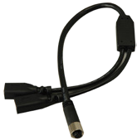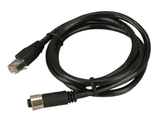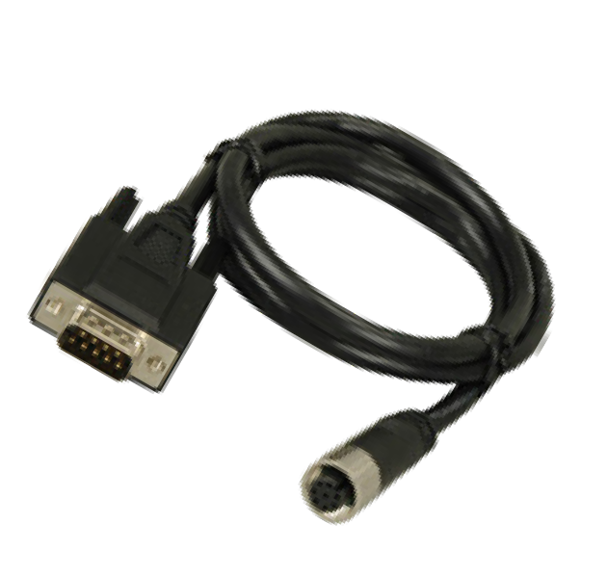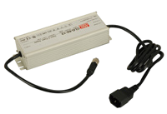

Packing List
USB cable
(CB-M12USB02-R20)
RJ-45 LAN cable (CB-M12RJ45-R10)
DB-9 COM port Cable (CB-M12COM-R20)
Water-proof Power Adapter (63040-030080-000-RS)

Display System
Item | Q'ty | Remark
Touch Pen | 1 | Resistive type only
Ferrite core | 2
D-Sub to RJ45 cable | 2 | for standard only
Waterproof plugs: Φ3 | 10 | Φ3x2, Φ4x1, Φ5x1, cover x 6 (for standard only)
M12 to USB cable | 1 | for M12 only

w w w . i ei w or l d .c om

I/O Interface

Power 2 (Terminal Block 12V~36V)

HDMI 2 x USB 2.0

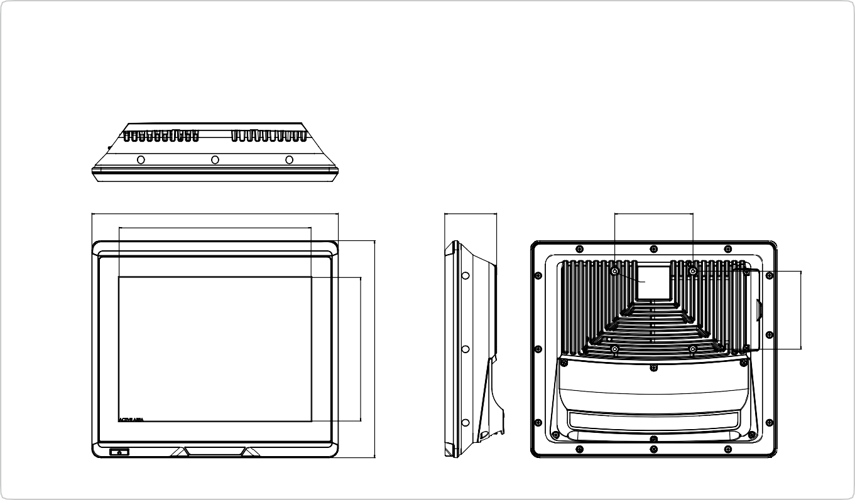
Display System
100
66.50
315.64
245.76
UPC-F12C Dimensions (Unit: mm)
184.32
278.64
100
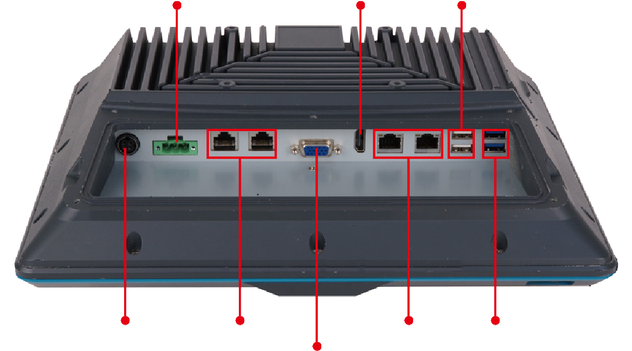
Power 1 (DC Jack 12V~36V) COM 1, COM 2
LAN 1, LAN 2 2 x USB 3.1 Gen 1 (5Gb/s)
VGA or CAN bus
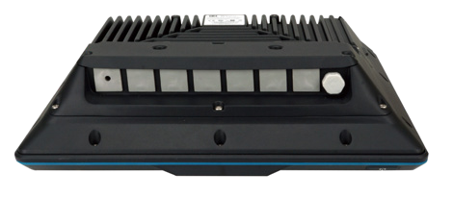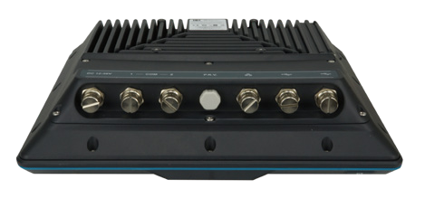
Standard IO cover
M12 IO cover

