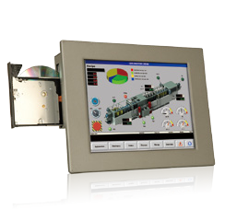
12.1" Industrial Panel PC
Intel® Atom™ N2600 Dual-Core Processor
Intel® Atom™ N270 Processor
Features
- 12.1" 500 nits high brightness TFT LCD with LED backlight
- Dual Gigabit Ethernet provides continuous network service and allows sharing among different workgroups in two different subnets
- Optional 802.11b/g/n wireless kit
- One slim type CD-ROM drive bay
- Robust aluminum front bezel and metal casing
- IP 65 compliant front panel
Specifications
Fanless
IP65
-20ºC~50ºC
PPC-3712A-N270
PPC-3712A-N26

Model |  | PPC-3712A-N26 | PPC-3712A-N270
Display | LCD Size | 12.1”
 | Max. Resolution | 1024(W) x 768(H)
 | Brightness (cd/m²) | 500
 | Contrast Ratio | 700:1
 | LCD Color | 262K
 | Pixel Pitch (mm) (HxV) | 0.3075(H) x 0.3075(V)
 | Viewing Angle (V/H) | 160°/160°
 | Backlight MTBF (hrs) | 50000 (LED backlight)
Touch | Touchscreen | 5-wire resistive type with RS-232 interface
 | Touch Controller | EETI MBMER4050CMBG
Motherboard | SBC | NANO-CV-N26001 | NANO-945GSE-N270
 | CPU | Intel® Atom™ N2600 dual-core processor 1.6GHz | Intel® Atom™ N270 1.6GHz CPU
 | Chipset | Intel® NM10 | Intel® 945GSE + ICH7M
 | RAM | One 200-pin SO-DIMM socket, supporting DDR3 800MHz  module for up to 2GB | One 200-pin SO-DIMM socket, supporting DDR2 533MHz module  for up to 2GB
 | Ethernet | Realtek RTL8111E PCIe GbE controller supporting ASF 2.0
 | Audio Codec | Realtek ALC662 HD audio codec | Realtek ALC655 AC’97 audio codec
I/O Ports and Switches |  | 2 x RS-232  1 x RS-422/485  2 x RJ-45 for LAN port 2 x USB 3.0  2 x USB 2.0  1 x HDMI  1 x VGA port  1 x Line-in, Line-out, Mic-in  1 x 9-28 V DC input power jack 1 x Power switch | 2 x RS-232  - x RS-232 (alternative to RS-422/485) 2 x RJ-45 for LAN port  - x USB 2.0  1 x VGA port  1 x Line-in, 1 x Line-out, 1 x Mic-in  1 x PS/2 mouse and keyboard interface  1 x 12 V DC power input jack  1 x Power switch
Drive Bay | HDD Drive Bay | 1 x 2.5” SATA HDD Bay
 | SSD | 1 x mSATA (SATA2 signal) | CF Type II
 | CD-ROM Drive Bay | Slim type CD ROM bay | SATA slim type CD-ROM bay
Expansion Slot |  | 1 x PCIe Mini card | 1 x PCIe Mini card
Physical | Front Panel Contruction | Aluminum die-casting
 | Chassis Construction | Heavy-duty steel (SECC)
 | Mounting | Panel, wall, rack, stand and arm (VESA 100 mm x 100 mm)
 | Front Panel Color | Silver (Pantone 8001C)
 | Dimensions (WxHxD) (mm) | 340 x 260 x 74.8 | 340 x 277 x 73.4
 | Cut Out Dimensions (WxH) (mm) | 313 x 233 | 313 x 233
 | Net/Gross Weight | 6 kg / 8 kg | 6 kg / 8 kg
System Cooling |  | Fanless | Fanless
Environment | Operating Temperature | -10°C~50°C
 | Storage Temperature | -20°C~60°C
 | Vibration | 5~17Hz, 0.1 double amplitude displacement 17~640Hz 1.5G acceleration peak to peak
 | Shock | 10G acceleration part to part (11ms)
Power Supply | Power Adapter | P/N: 63040-010060-110-RS  60W power adapter (Meets PSE) Input: 90VAC~264VAC, 50/60Hz  Output: 12VDC | P/N: 63040-010060-110-RS  60W power adapter (Meets PSE) Input: 90VAC~264VAC, 50/60Hz  Output: 12VDC

Display System

w w w . i ei w or l d .c om

Ordering Information

Part No. |  | Description
Intel® Atom™ N2600 | PPC-3712A-N26/R/2G-R12* | 12.1" 500 cd/m² XGA panel PC with Intel® Atom™ N2600 1.6GHz processor, 2GB DDR3 9 V~28 V DC RAM, and touchscreen, 9 V~28 V DC input, RoHS
Intel® Atom™ N270 | PPC-3712A-N270/R/1G-R23 | 12.1" 500 cd/m² XGA fanless panel PC, Intel® Atom™ N270 1.6GHz/ 512KB, 1GB DDR2, resistive touchscreen, sliver color, R23, RoHS
* PPC supports 9-28V DC input with 4-pin DC jack. Standard product inculdes 12V DC adapter. For terminal block solution, please contact sales team.

Packing List

Item | Part No. | Description
Screw Kit | 19600-000207-RS
SATA CD-ROM Cable | 32801-006300-100-RS | SATA 7+6P female 180°, SATA 7P female 90°+lock, DU PONT 2x4P, P=2.54, female
Power Cord | 32702-000200-100-RS | European standard, 1830 mm, plug (16A, 250V), connector (10A, 250V)
Power Adapter | 63040-010060-110-RS | 60W, 90VAC~264VAC for PPC-3712A
PS/2 Cable | 32006-000300-100-RS | 1 x mini-DIN 6-pin male; 2 x mini-DIN 6-pin female
Panel Mounting Kit | 19Z00-000024-RS | 19Z00-000024-RS x8
Wall Mounting Kit | 41014-057602-00-RS | Ultra set plate
 | 41020-016102-00-RS | Wall mount bracket
IEI One Key Recovery CD | IEI-7B000-000478-RS
Touchscreen Driver CD / Touch Pen
User Manual & Driver CD

IQ Mounting Options
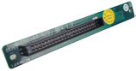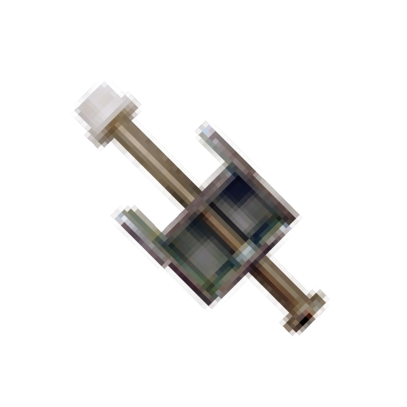
Item | Part No.
Arm | ARM-11-RS
Stand | STAND-100-RS

CD-ROM Installating Kit
19Z00-000112-RS
Panel Mount

Options

Item | Part No. | Description
RS-422/485 Cable | 32200-075202-RS | - D-sub 9-pin male  - DU PONT 2*7P, P=2.0 female
IDE CD-ROM Installation Kit | 19Z00-000112-RS | 50-pin CD-ROM connector to 44-pin IDE connector transfer board
HDD IDE Cable | 32200-000037-RS | 250 mm, IDE 44-pin
Wi-Fi Module | PPC-WL-KIT02-R10 | Wi-Fi module with RF cable and antenna, 2T2R, 802.11b/g/n for PPC-37xxA-N26 series  (Telec certified)

PPC-3712A-N26
Fully Integrated I/O
PPC-3712A-N27
Fully Integrated I/O

1 x RS-232 1 x RS-422/485
1 x Line-out
1 x Line-in
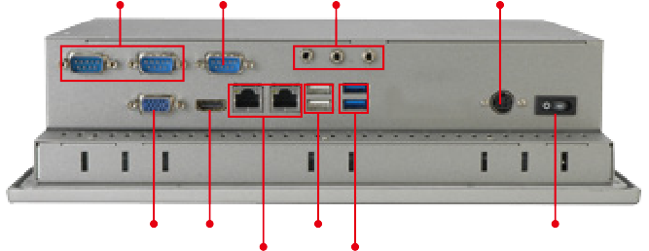
- x Mic

12V DC Input

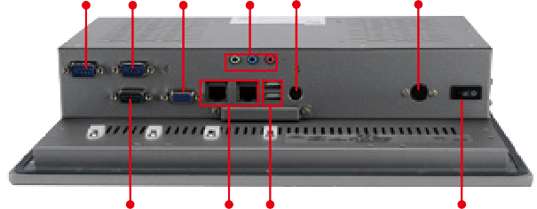
COM2 COM3 VGA Audio PS/2

12V DC Input

VGA
HDMI
2 x USB 2.0
Power Switch

COM1
- x LAN 2 x USB
Power Switch

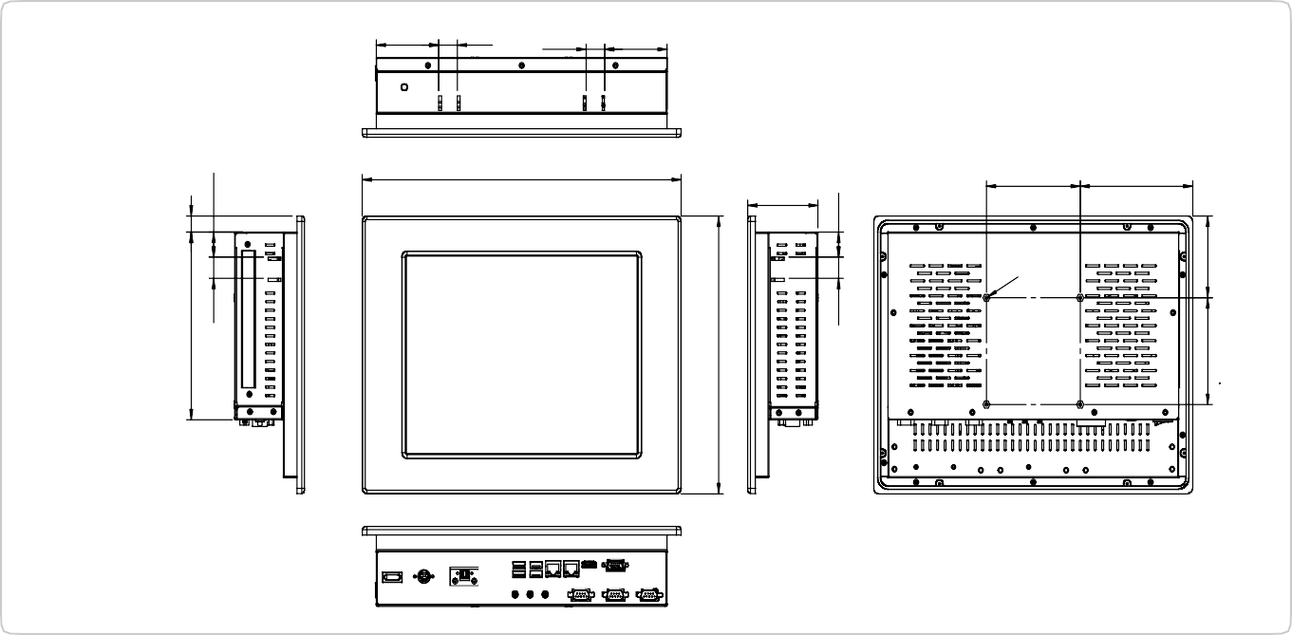2 x LAN 2 x USB 3.0
74.80
120
100
340
19.90 66.50
66.50 19.90
PPC-3712A-N26
Dimensions (Unit: mm)
175.76
19.90
15
23.40
260
19.90
23.40
100
76.51

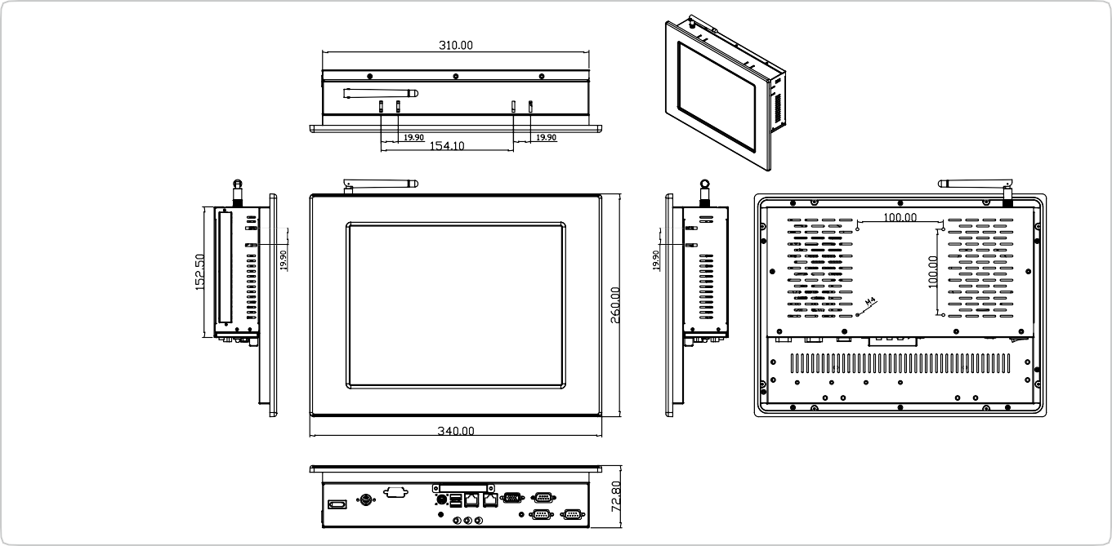
PPC-3712A-N27
Dimensions (Unit: mm)

