Display System

w w w . i ei w or l d .c om
8.4” Industrial Panel PC
Intel® Atom™ N2600 Dual-Core Processor
PPC-3708A-N26

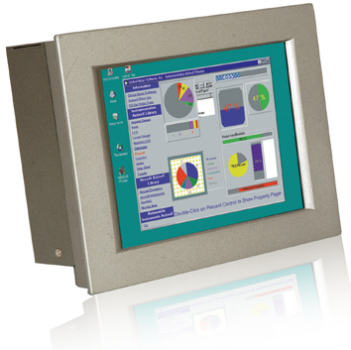Features
- 8.4" 450 nits high brightness TFT LCD with LED backlight
- Dual Ethernet provides continuous network service and allows sharing among different workgroups in two different subnets
- Robust aluminum front bezel and metal casing
- IP 66 compliant front panel
- IEI One Key Recovery solution allows you to create rapid OS backup and recovery (over 4GB storage capacity suggested)

Specifications
Model |  | PPC-3708A-N26
Display | LCD Size | 8.4”
 | Max Resolution | 800(W) x 600(H)
 | Brightness (cd/m²) | 450
 | Contrast Ratio | 600:1
 | LCD Color | 262K
 | Pixel Pitch (mm) (HxV) | 0.213(H) x 0.213(V)
 | Viewing Angle (V/H) | 140°/160°
 | Backlight MTBF (hrs) | 50000 (LED backlight)
Touch | Touchscreen | 4-wire resistive type with RS-232 interface
 | Touch Controller | EETI MBMER4040CPBG
Motherboard | SBC | NANO-CV-N26001
 | CPU | Intel® Atom™ N2600 dual-core processor 1.6GHz
 | Chipset | Intel® NM10
 | RAM | One 204-pin SO-DIMM socket, supporting DDR3 800MHz  module for up to 2GB
 | Ethernet | Realtek RTL8111E PCIe GbE controller supporting ASF 2.0
 | Audio Codec | Realtek ALC662 HD audio codec
I/O Ports and Switches |  | 2 x RS-232  1 x RS-422/485  2 x RJ-45 for LAN port 2 x USB 3.0  2 x USB 2.0  1 x HDMI  1 x VGA port  1 x Line-in, Line-out, Mic-in 1 x DC power input jack  1 x Power switch
Drive Bay | HDD Driver Bay | 1 x 2.5” SATA HDD bay
 | SSD | 1 x mSATA (SATA2 signal)
Expansion Slot |  | 1 x PCIe Mini card
Physical | Front Panel Contruction | Aluminum die-casting
 | Chassis Construction | Heavy-duty steel (SECC)
 | Mounting | Panel, wall, rack, stand and arm (VESA 100 mm x 100 mm)
 | Front Panel Color | Silver (Pantone 8001C)
 | Dimensions (WxHxD) (mm) | 244 x 175 x 86.5
 | Cut Out Dimensions (WxH) (mm) | 233 x 167
 | Net/Gross Weight | 2.2 kg / 4.4 kg
System Cooling |  | Fanless
Environment | Operating Temperature | -10°C ~ 50°C
 | Storage Temperature | -20°C ~ 60°C
 | IP Rating | IP66 compliant front panel
 | Vibration | 5~17Hz, 0.1 double amplitude displacement 17~640Hz 1.5G acceleration peak to peak
 | Shock | 10G acceleration part to part (11ms)
Power Supply | Power Input | 9-28V DC Input
 | Power Adapter | P/N: 63040-010060-110-RS  60W power adapter (Meets PSE) Input: 90VAC~264VAC, 50/60Hz  Output: 12VDC

Versatile Mounting Methods

w w w . i ei w or l d .c om

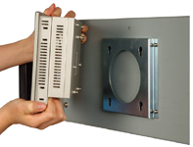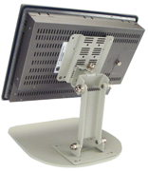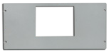
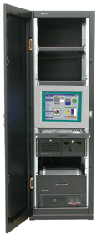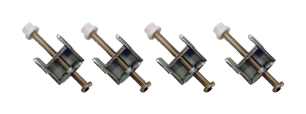 Wall Mount Stand Rack Moun
t

Panel Mount

Ordering Information

Part No. | Description
PPC-3708A-N26/R/2G-R12* | 8.4” 450 cd/m² SVGA panel PC with Intel® Atom™ N2600 1.6GHz processor, 2GB DDR3 RAM, touchscreen, 9 V~28 V DC input, RoHS
* PPC supports 9-28V DC input with 4-pin DC jack. Standard product inculdes 12V DC adapter. For terminal block solution, please contact sales team.

Packing List

Item | Part No. | Description
Screw Kit | 19600-000205-RS
Power Cord | 63040-010060-040-RS | European standard, 1830 mm, plug (16A, 250V), connector (10A, 250V)
Power Adapter | 63040-010060-110-RS | 60W, 90VAC~264VAC for PPC-3708A-N26
PS/2 Cable | 32006-000300-100-RS | 1 x MINI DIN 6-pin male; 2 x MINI DIN 6-pin female
Panel Mounting Kit | 19Z00-000026-RS | 19Z00-000026-RS x8
Wall Mounting Kit | 41014-057602-00-RS | Ultra set plate
 | 41020-016102-00-RS | Wall mount bracket
IEI One Key Recovery CD | IEI-7B000-000478-RS
Touchscreen Driver CD / Touch Pen
User Manual & Driver CD

IQ Mounting Options
Item | Part No.
Arm | ARM-11-RS
Stand | STAND-100-RS

Options

1 x RS-232

1 x RS-422/ 485

1 x Line-out
1 x Line-in
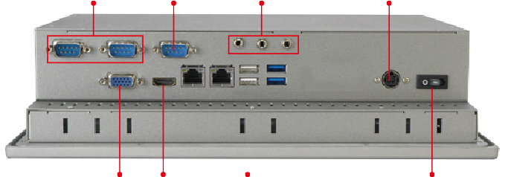
1 x Mic

DC Input

VGA
Item | Part No. | Description
RS-422/485 Cable | 32205-004900-100-RS | - D-sub 9-pin male  - DU PONT 2*7P, P=2.0, female
HDD IDE Cable | 32221-000200-100-RS | 100 mm, IDE 44-pin
Wi-Fi Module | EMB-WIFI-KIT01-R20 | 1T1R wifi module kit for embedded system, IEEE802.11a/b/g/n/ac WiFi with Bluetooth 4.0/3.0+HS, 1 x wifi module, 2 x 250mm RF cable, 2 x  Antenna, RoHS

HDMI

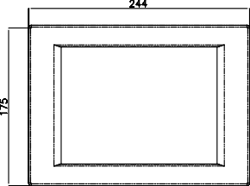
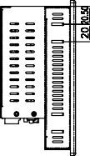
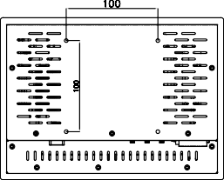
2 x LAN
2 x USB 2.0

2 x USB 3.0

Power Switch

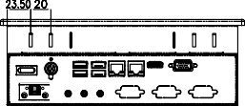
Display System

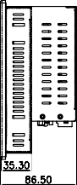
PPC-3708A-N26
Dimensions
(Unit: mm)

