Vehicle Surveillance System
IVS-300

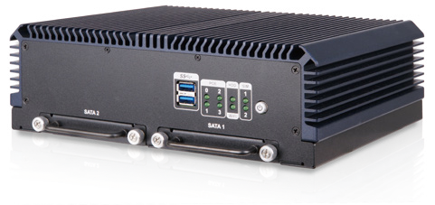Features
- Intel® Skylake ULT /Baytrail processor
- 4 x PoE IEEE802.3af
- Optional 3G/Wi-Fi
- 2 x RS-232, 1 x RS-422/485
- 4 x DI/DO
- 1 x HDMI (lockable), 1 x VGA

Fanless

PoE

Specifications

3.75G/HSUPA

GPS

Wi-Fi

OBD-II
E
E-Mark

Model Name |  | IVS-300-BT | IVS-300-ULT3
Chassis | Color | Blue C | Blue C
 | Dimensions (WxHxD) (mm) | 255 x 80 x 185 | 255 x 80 x 185
 | System Fan | Fanless | Fanless
 | Chassis Construction | Extruded aluminum alloy | Extruded aluminum alloy
Motherboard | CPU | Intel® Celeron® J1900 Processor (quad-core 2GHz, 10W TDP) | Intel® Core™ i5-6300U processor (dual-core, 2.4 GHz, 15W TDP)
 | Chipset | SoC
 | System Memory | 2 x 204-pin DDR3L SO-DIMM.  4GB pre-installed (system max. 8 GB) | 2 x 260-pin DDR4 SO-DIMM,  4GB pre-installed (system max. 32 GB)
Storage | Hard Drive | 2 x 2.5'' SATA 6Gb/s SSD removable drive bay | 2 x 2.5'' SATA 6Gb/s SSD removable drive bay
Communication | WLAN | PCIe Mini Wi-Fi 802.11 a/b/g/n/ac (optional) | PCIe Mini Wi-Fi 802.11 a/b/g/n/ac (optional)
 | Bluetooth | BT 4.0/3.0+HS (combo with WLAN optional module) | BT 4.0/3.0+HS (combo with WLAN optional module)
 | WWAN | PCIe Mini WCDMA/HSDPA/HSUPA (optional) | PCIe Mini WCDMA/HSDPA/HSUPA (optional)
 | GPS | On board GPS | On board GPS
I/O Interfaces | USB 3.1 Gen 1 | 2 | 2
 | Ethernet | 4 x RJ-45 PCIe GbE by Intel® i210-AT  Support PoE IEEE802.3af (Each port max 15.4W) | 4 x RJ-45 PCIe GbE by Intel® i210-AT  Support PoE IEEE802.3af (Each port max 15.4W)
 | COM port | 2 x DB-9 RS-232(With isolation) 1 x DB-15 RS-422/485 | 2 x DB-9 RS-232(With isolation) 1 x DB-15 RS-422/485
 | Digital I/O | 8-bit digital I/O (4-bit input, 4-bit output) | 8-bit digital I/O (4-bit input, 4-bit output)
 | CAN-Bus/OBD-II | 1 x DB9 OBD-II/J1939 | 1 x DB9 OBD-II/J1939
 | Display | 1 x VGA, 1 x HDMI | 1 x VGA, 1 x HDMI
 | Resolution | VGA : Up to 1920 x 1080 @60Hz HDMI : Up to 1920 x 1080 @60Hz | VGA : Up to 1920 x 1080 @60Hz HDMI : Up to 1920 x 1080 @60Hz
 | Audio | 1 x Mic in, 1 x Line out | 1 x Mic in, 1 x Line out
 | SIM | 2 x on board SIM card slot | 2 x on board SIM card slot
 | Antenna | 1 x 3G, 1 x GPS, 1 x BT, 1 x Wi-Fi | 1 x 3G, 1 x GPS, 1 x BT, 1 x Wi-Fi
Expansions | PCIe Mini | 1 x Half-size PCIe Mini (reserved for WLAN) 1 x Full-size PCIe Mini (reserved for WWAN) 1 x Full-size PCIe Mini (USB signal) | 1 x Half-size PCIe Mini (reserved for WLAN) 1 x Full-size PCIe Mini (reserved for WWAN) 1 x Full-size PCIe Mini (USB signal)
Led Indicator & Button | Indicator | 8 x LED (4 PoE, 1 HDD, 1 Wi-Fi, 2 SIM) | 8 x LED (4 PoE, 1 HDD, 1 Wi-Fi, 2 SIM)
 | Button | 1 x Power button | 1 x Power button
Power | Power Input | Cigarette lighter power cable: DC 9 V~30 V | Cigarette lighter power cable: DC 9 V~30 V
 | Consumption | 12 V @ 12A  (Intel® J1900 with 4 GB DDR3L memory + 4 PoE) | 12 V @ 14A  (Intel® i5-6300U with 4 GB DDR4 memory + 4 PoE)
Reliability | Mounting | Wall mount | Wall mount
 | Operating Temperature | -20°C ~ 60°C with air flow | -20°C ~ 60°C with air flow
 | Storage Temperature | -30°C ~ 70°C | -30°C ~ 70°C
 | Humidity | 10% ~ 95%, non-condensing | 10% ~ 95%, non-condensing
 | Operating Shock | Half-sine wave shock 5G, 11ms, 3 shocks per axis | Half-sine wave shock 5G, 11ms, 3 shocks per axis
 | Operating Vibration | MIL-STD-810F 514.5C-2 (with SSD) | MIL-STD-810F 514.5C-2 (with SSD)
 | Weight (Net/Gross) | 3kg/4.5kg | 3kg/4.5kg
 | Safety/EM C | CE / FCC / E-Mark | CE / FCC / E-Mark
OS | Supported OS | Microsoft® Windows® Embedded 8, Microsoft® Windows® Embedded Standard 7 E | Microsoft® Windows® Embedded 8, Microsoft® Windows® Embedded Standard 7 E

Fully Integrated I/O
Front view Rear view
LED Indicators:
PoE, HDD, Wi-Fi, SIM

2 x RS-232

Bluetooth Antenna 4 x PoE

3G Antenna

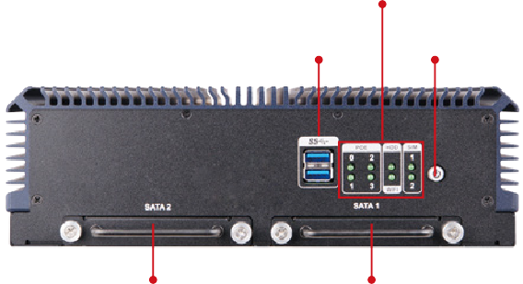
2 x USB 3.1
Gen 1
Power Switch
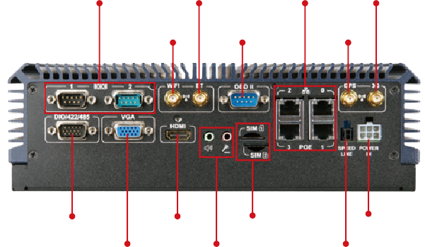2.5" HDD/SSD Drive Bay 2.5" HDD/SSD Drive Bay
Wi-Fi Antenna
OBD-II
GPS
Antenna
DIO/RS-422/485
HDMI
2 x SIM
Power In

Dimensions (Unit: mm)

VGA

Audio

Speed Line

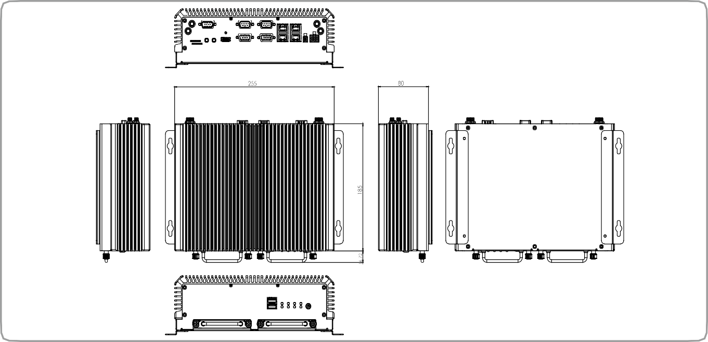
IVS-300-ULT3

Ordering Information
Part No. | Description
IVS-300-BT-J1/4G-R10 | Fanless embedded system with Intel® Celeron® Processor J1900 (10W) Processor with 4GB DDR3L pre-installed memory, PoE, on board GPS, HDMI,  VGA, two 2.5" removable SATA HDD bay, RoHs
IVS-300-ULT3-i5/4G-R10 | Fanless embedded system with 6th generation 14nm Intel® Core™ i5-6300U (15W) mobile processor (ULT) with 4GB DDR4 pre-installed memory,  PoE, on-board GPS, HDMI, VGA, two 2.5" removable SATA HDD bay, RoHs
Options
Part No. | Description
IVS-300-ULT3-WES7E64-R10 | OS Image with Windows® Embedded Standard 7 E 64-bit for IVS-300-ULT3, with DVD-ROM, RoHS
IVS-300-BT-WES7E64-R10 | OS Image with Windows® Embedded Standard 7 E 64-bit for IVS-300-BT, with DVD-ROM, RoHS
IVS-WIFI-KIT02-R10 | 1T1R Wi-Fi module kit for embedded system, IEEE802.11a/b/g/n/ac Wi-Fi with Bluetooth 4.0/3.0+HS, 1 x Wi-Fi module, 1 x Antenna, RoHS
IVS-3G-KIT02-R10 | 3G module kit for embedded system, F260, 1 x 3G module, RoHs
IVIPOWER-6PIN-R10 | Power adapter with 6-pin transfer cable, RoHS
Packing List
Item | Part No. | Qty | Description
Wall Mount Kit | 41020-0432C2-00-RS | 2 | Wall mount bracket
Power Cable | 32002-007200-101-RS | 1 | Round cable, power cable, 1, 3000mm, 18AWG, (A) MOLEX 5557-0600 P=4.2, H.S.TUBE x 2, Label: GND x 3 + VIN x 2 + ACC, RoHS
GPS/GSM Antenna | 32506-000100-100-RS | 1 | Integration antenna, GPS/GSM, RG 174, 5000mm/5000mm, PPF-5423SA5X-999, Magnetic mount:  φ55x22mm, 1575.42MHz/850MHz/900MHz/1800MHz/1900MHz, SMA plug x 2
Screw pack | 44015-030053-RS | 8 | Screw pack
 | 44005-030061-RS | 6 | Screw pack

