w w w . i ei w or l d .c om
Vehicle Fleet Management System
IVS-100-BT

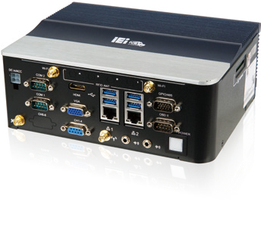Features

Intel® Atom® E3826 1.46 GHz CPU
- Powered by Windows® Embedded Standard 7
- Supports 2.5" SATA 3Gb/s SSD
- Built-in GPS function
- Built-in VGA output and HDMI output
- Dual SIM slot
- Optional 3G/Wi-Fi/UHF reader modules
- Optional software compression video capture card

Power Management

GPS

3.75G/HSUPA

Bluetooth

Wi-Fi

Video Capture

Fanless

Industrial System

Specifications

Model Name |  | IVS-100-BT
Chassis | Color | Blue C
 | Dimensions (WxHxD) (mm) | 200 x 76 x 150
 | System Fan | Fanless
 | Chassis Construction | Extruded aluminum alloy
Motherboard | CPU | Intel® Atom™ processor E3826 (dual-core, 1.46 GHz, 7W TDP)
 | Chipset | SoC
 | System Memory | 2 x 204-pin DDR3L SO-DIMM slot, 2 GB pre-installed (system max. 8GB)
Storage | Hard Drive | 1 x 2.5" SATA 3Gb/s HDD/SSD drive bay
 | SD Card | 1 (supports SD 2.0, max. 32 GB)
Communication | WLAN | PCIe Mini Wi-Fi 802.11b/g/n (optional)
 | Bluetooth | Bluetooth 2.1 (combined with WWAN optional module)
 | WWAN | PCIe Mini, WCDMA/HSDPA/HSUPA (optional)
 | RFID | UHF module, 902 MHz ~ 928 MHz operating band (optional)
 | GPS | On board GPS
I/O Interfaces | USB 3.0 | 4
 | Ethernet | 2 x 10/100/1000 Mbps RJ-45 by RTL8111E PCIe GbE
 | COM Port | 2 x DB-9 RS-232  1 x DB15 GPIO & RS-422/485
 | Digital I/O | 8-bit digital I/O (4-bit input, 4-bit output)
 | CAN-bus/OBD-II | 1 x DB-9 OBD-II/J1939
 | Display | 1 x VGA, 1 x HDMI
 | Resolution | HDMI: Up to 1920 x 1080 @60 Hz  VGA: Up to 1920 x 1080 @60 Hz
 | Audio | 1 x Line in, 1 x Line out
 | SIM | 2 x on board SIM card slot
 | Antenna | 2 x Wi-Fi/BT, 1 x WWAN, 1 x GPS, 4 x UHF
 | Other | 4-channel SC video capture card (optional)
Expansions | PCI | 1 x PCI-104
 | PCIe Mini | 1 x Full-size PCIe Mini (reserved for WWAN)  1 x Full-size PCIe Mini (reserved for capture card module) 1 x Full-size PCIe Mini (reserved for analog DIO module) 1 x Half-size PCIe Mini (reserved for WLAN)
Power | Power Input | Cigarette lighter power cable, DC 9 V~30 V
 | Consumption | 12 V @ 3.2 A (Intel® Atom™ E3826 with 2 GB DDR3 memory)
Reliability | Mounting | VESA 100
 | Operating Temperature | -20°C ~ 60°C with air flow
 | Storage Temperature | -30°C ~ 70°C
 | Humidity | 10% ~ 95%, non-condensing
 | Operating Shock | Half-sine wave shock 5G, 11ms, 3 shocks per axis
 | Operating Vibration | MIL-STD-810F 514.5C-2 (with SSD)
 | Weight (Net/Gross) | 2.1 kg/3.6 kg
 | Safety/EMC | CE/FCC/E-Mark
OS | Supported OS | Microsoft® Windows® Embedded 8, Microsoft® Windows® Embedded Standard 7 E

w w w . i ei w or l d .c om

Fully Integrated I/O
Front view
Dimensions (Unit: mm)

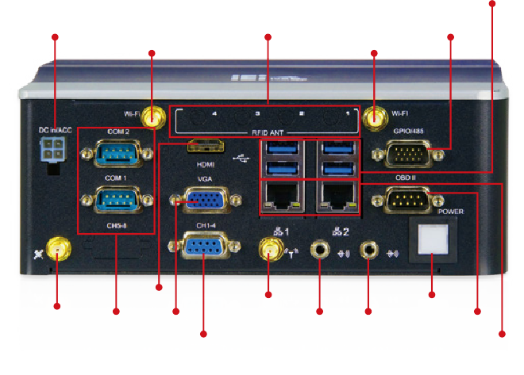
Wi-Fi &

4 x UHF RFID

Wi-Fi &

GPIO &

4 x USB 3.0

DC Input
Bluetooth Antenna
Antenna (Optional)
Bluetooth Antenna
RS-422/485

HDMI

3G Antenna

Power

GPS
Antenna
2 x RS-232
VGA
(Optional) Line-out Line-in
Switch ODB-II

Video Capture (Optional)
2 x GbE

Side view

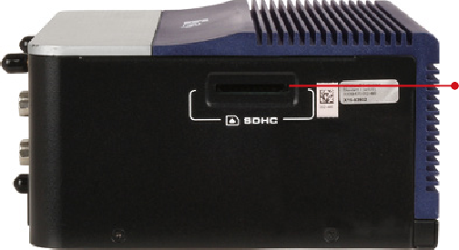

Ordering Information

SDHC
Card Slot

Part No. | Description
IVS-100-BT-E3/2G-R10 | Fanless embedded system with Intel® Atom™ E3826 1.46 GHz processor, 7W TDP, pre-installed 2 GB DDR3L memory, two GbE LAN, one HDMI, one  VGA, one 2.5” SATA HDD bay, on-board GPS, RoHS

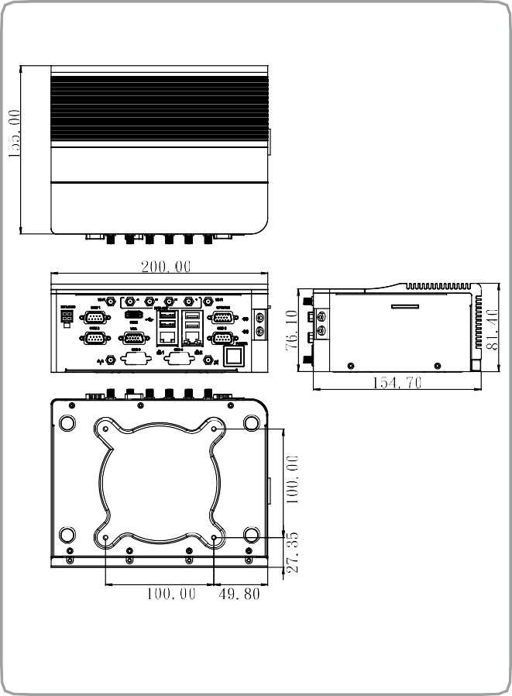Options
IVS-100-BT

Item Part No. Description
Power adapter IVIPOWER-4PIN-R10 Power adapter with 4-pin transfer cable, RoHS
Cigarette lighter power cable 32002-004000-100-RS Round cable, power cable, car cigarette lighter cable, 2000 mm, 18 AWG, (A) cigarette lighter (5 A 250 V)+ψ3
green LED, (B) MOLEX 5557-0400 P=4.2, RoHS
OBD-II cable 32025-003400-100-RS Round cable, OBD-II cable, 2000 mm, 24 AWG, (A) OBD-II 16P male, (B) D-sub 9P female, one piece package with
label, RoHS

OS: Windows Embedded 7 (DVD-ROM)
Wireless kit

WWAN kit
UHF module
UHF RFID antenna (Patch Antenna 915 MHz)
4-channel video capture card
Dead reckoning box

Packing List

IVS-100-WES7E-R10

IVS-WIFI-KIT02-R10

IVS-3G-KIT02-R10 IVS-UHF01-R10
AVL-2000PLUS-FCC01-R10

IVS-SC01-R10 IVI-DR-R10

OS image with Windows® Embedded Standard 7 E for IVS-100 Series, DVD-ROM, RoHS

1T1R Wi-Fi module kit for embedded system, IEEE802.11a/b/g/n/ac Wi-Fi with Bluetooth 4.0/3.0+HS, 1 x Wi-Fi module, 1 x Antenna, RoHS
3G module kit for embedded system, F260, 1 x 3G module, RoHs UHF RFID patch antenna, 915 MHz, only for United States
UHF RFID antenna module, patch antenna, 915 MHz, 8.5dBi, with RFID cable, LMR195, 10000 mm, SMA PLUG, RoHS

Video capture card, PCIe Mini card with 4-channel video capture, SC330N4 MC, RoHS IVI dead reckoning box, USB output

Industrial System
Item
HDD Bracket SATA Cable Power Cable
Part No.
41119-0841C0-00-RS
32801-003800-100-RS
32002-001900-100-RS
Qty
1
1
1
GPS/GSM Antenna
32506-000100-100-RS
1
Rubber pad & Screw pack
44013-030041-RS
47003-002300-RS
44403-030041-RS
44043-030063-RS
4
4
4
2
Description
HDD bracket, holder, RoHS
SATA cable, 3, 150mm/300mm, 26AWG, RoHS round cable, power cable, 3000mm, RoHS
Integration antenna, GPS/GSM, RG 174, 5000mm/5000mm, PPF-5423SA5X-999, Magnetic mount:
φ55x22mm, 1575.42MHz/850MHz/900MHz/1800MHz/1900MHz, SMA plug x 2 Rubber pad & screw pack
Rubber pad & screw pack
Rubber pad & screw pack Rubber pad & screw pack

