Railway Surveillance System
IRS-100-ULT3

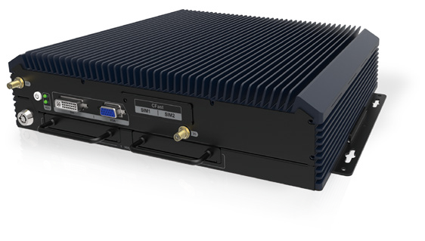Features
-40°C~70°C
- Intel® Skylake ULT processor
- Dual M12 LAN port
- VGA / DVI dual display
- Dual SIM card design
- 24V and 110V DC input (±40%) DC input
- 2 x 2.5" hot-swappable SATA SSD drive bay
- EN 50155

EN 50155

Dual SIM

Dual LAN

Dual HDD

Specifications

Model Name |  | IRS-100-ULT3
Chassis | Color | Blue C
 | Dimensions (WxHxD) (mm) | 290 x 69 x 225
 | System Fan | Fanless
 | Chassis Construction | Extruded aluminum alloy
Motherboard | CPU | Intel® Core™ i5-6300U processor (dual-core, 2.4 GHz, 15W TDP)
 | Chipset | SoC
 | System Memory | 2 x 260-pin DDR4 SO-DIMM 4GB pre-installed (system max. 32 GB)
Storage | Hard Drive | 2 x 2.5'' SATA 6Gb/s SSD drive bay
 | CFast/CF Card | 1 x CFast (SATA 6Gb/s)
 | mSATA | 1 x mSATA (SATA 6Gb/s)
Communication | WLAN | PCIe Mini Wi-Fi 802.11 a/b/g/n/ac (optional)
 | Bluetooth | BT 4.0/3.0+HS (combo with WLAN optional module)
 | WWAN | PCIe Mini WCDMA/HSDPA/HSUPA (optional)
I/O Interfaces | USB 3.1 Gen 1 | 2
 | USB 2.0 | 1 (M12 connector)
 | Ethernet | 2 x M12 connector PCIe GbE by Intel® I211
 | COM Port | 2 x DB-9 RS-232/422/485 (with 1.5 kV isolation)
 | Digital I/O | 1 x Terminal block for 8-bit digital I/O (4-bit input/4-bit output, 1.5 kV isolation)
 | Display | 1 x VGA, 1 x DVI-D
 | Resolution | VGA : Up to 1920 x 1200 @60Hz DVI-D : Up to 1920 x 1200 @60Hz
 | Audio | 1 x Line-out, 1 x Mic-in
 | SIM | 2 x SIM card slot
Expansions | PCIe Mini | 2 x Full-size PCIe Mini (for WWAN / WLAN module)
Power | Power Input | M12 Connector: 24V and 110V DC input
 | Consumption | 24V @ 2A (Intel® i5-6300U with 4 GB DDR4 memory)
Reliability | Mounting | Wall mount
 | Operating Temperature | -40°C ~ 70°C with air flow (with industrial SSD/CF), compliant with EN 50155
 | Storage Temperature | -40°C ~ 85°C
 | Humidity | 10% ~ 95%, non-condensing
 | Operating Shock | Compliant with EN 61373 Category 1 Class B
 | Operating Vibration | Compliant with EN 61373 Category 1 Class B
 | Weight (Net/Gross) | 3.9 kg / 5.1 kg
 | Safety/EM C | CE/FCC, compliant with EN 50155, EN 50121-3-2
OS | Supported OS | Microsoft® Windows® Embedded 8, Microsoft® Windows® Embedded Standard 7 E

Fully Integrated I/O
Front view Rear view

LED Indicators: HDD
VGA
2 x SIM
DC Input
AT/ATX Mode DIO

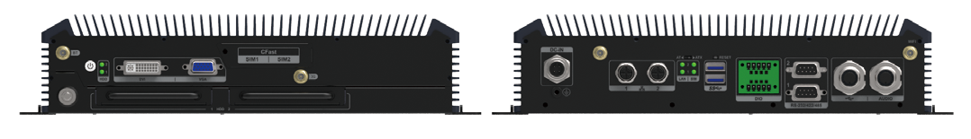
Bluetooth
DVI
CFast
3G
Wi-Fi
Reset
M12 USB
Wi-Fi
Ground
2 x M12 LAN
Power Switch 2 x 2.5" HDD/SSD Drive Bay
2 x USB 3.1
Gen 1
Audio

Dimensions (Unit: mm)
LED Indicators: LAN, SIM 2 x RS-232/422/485

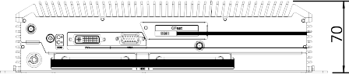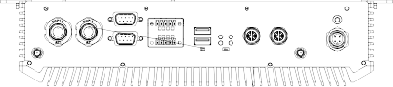
IRS-100-ULT3

Ordering Information
Part No. | Description
IRS-100-ULT3-i5/4G-R10 | Fanless railway system with Intel® Core™ i5-6300U processor (15W), 4GB DDR4 pre-installed memory, two 2.5” SATA SSD bays, VGA, DVI, two M12 GbE LAN
Options
Item | Part No. | Description
OS | IRS-100-ULT3-WES7E64-R10 | OS Image with Windows® Embedded Standard 7 E 64-bit for IRS-100-ULT3, DVD-ROM, RoHS
DC cable | 32002-009000-100-RS | Power cable, 2000 mm, 16AWG, M12 5-pin female; label: V+, V-, GND; RoHS
USB cable | 32001-022700-200-RS | USB cable, 2000 mm, 24AWG; (A) Amphenol LTW: M12 5-pin male IP68 (12-05BMMA-SL8001), (B) USB Type A 4-pin female; RoHS
LAN cable | 32013-003400-100-RS | LAN cable, 1000 mm, 26AWG; (A) METZ: M12 plug 8-pin (MNF881A315-001), (B) RJ-45 8P8C plug; RoHS
Audio cable | 32007-005400-100-RS | Audio cable, 1200 mm, 28AWG; A) Amphenol LTW: M12 5-pin male (12-05BMMA-SL8001), (B) DC stereo jack: 3.5mm*2; RoHS
Wireless Kit | IRS-100-WIFI-KIT02-R10 | 1T1R Wi-Fi module kit for embedded system, IEEE802.11a/b/g/n/ac Wi-Fi with Bluetooth 4.0/3.0+HS, 1 x Wi-Fi module, 2 x antennas, 2 x cables RoHS
WWAN Kit | IRS-100-3G-KIT02-R10 | 3G module kit for embedded system, F260, 1 x 3G module, 1 x antenna , 2 x cables, RoHs
Packing List
Item | Part No. | Qty | Description
Wall Mount Kit | 41020-0474C2-00-RS | 2 | Wall mount bracket
Screw Pack | 44015-030061-RS | 16 | Screw pack

