Single Board Computer

Industrial Motherboard

w w w . i ei w or l d .c om

tKINO-ULT3
2 x SO-DIMM DDR4 2133 MHz
Thin Mini-ITX SBC supports Intel® Skylake-U Proccessor, 9~36V DC input, Dual HDMI, LVDS, SATA 6Gb/s, Dual Intel® GbE, USB 3.1 Gen 1 (5Gb/s), PCIe Mini, eMMC 5.0, HD audio and RoHS

Multiple expansion with COM port,

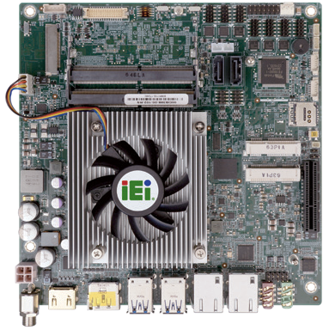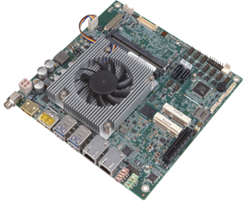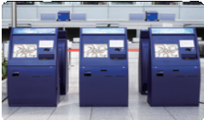system maximun up to 32 GB LVDS
4 x RS-232
2 x RS-232/422/485

PCIe x4, and PCIe Mini.

2 x SATA 6Gb/s

COM port

Full size PCIe Mini

SIM holder

9~36V Wide range DC input

PCIe x4 slot

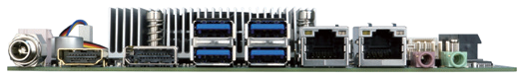Full size PCIe Mini (support mSATA)

PCIe x4 PCIe Mini

Ticketing Machine

tKINO-ULT3-2019-V10

Specifications
CPU
6th generation Intel® mobile ULT on-board processor
Intel® Core™ i7-6600U (up to 3.4GHz, dual-core, 4M Cache, TDP=15W) Intel® Core™ i5-6300U (up to 3.0GHz, dual-core, 3M Cache, TDP=15W) Intel® Core™ i3-6100U (up to 2.3GHz, dual-core, 3M Cache, TDP=15W) Intel® Celeron® 3955U (up to 2.0GHz, dual-core, 2M Cache, TDP=15W) Intel® Celeron® 3855U (up to 1.6GHz, dual-core, 2M Cache, TDP=15W) BIOS
UEFI BIOS
Memory
2 x SO-DIMM DDR4 2133MHz, system maximun up to 32GB Graphics Engine
Intel® HD graphic
Display Output
1 x HDMI 1.4 (up to 4096x2160@24Hz)
1 x HDMI/DP (up to 4096x2160@24Hz) 1 x LVDS/eDP (select by switch) Ethernet
LAN1: Intel® I219LM (with Intel® AMT11.0 support)
LAN2: Intel® I211AT PCIe controller with NCSI support External I/O Interface
4 x USB 3.1 Gen 1 (5Gb/s)
Intelnal I/O Interface
- x eMMC 5.0 (optional, up to 32G) 4 x RS-232 (2x5 pin, P=2.0) 2 x RS-232/422/485 (2x5 pin, P=2.0) 4 x USB 2.0 (2x4 pin, P=2.0)
- x SATA with 5V output Audio
Realtek ALC662 HD Audio Codec support 5.1 Channel
2 x Audio jacks (line-out, mic-in) on rear IO 1 x Front audio (2x5-pin)
Front Panel
- x Front panel (2x7 pin, power LED, HDD LED,power button, reset button) LAN LED
- x LAN LED(1x2 pin)
SMBUS: 1 x SMBus (1x4 pin) I²C: 1 x I²C (1x4 pin)
Digital I/O: 8-bit digital I/O (2x5 pin) Expansion
1 x PCIe x4 slot
1 x Full-size PCIe Mini card slot (support mSATA, colay SATA2) 1 x Full-size PCIe Mini card slot (with SIM holder)
*3855U belongs to Skylake ULT Base series CPU, PCIe signal support only PCIe Gen 2
Watchdog Timer
Software programmable, supports 1~255 sec. system reset by Super I/O Power Supply
9~36V DC input
1 x Internal power connector (2x2 pin) 1 x External DC power Jackc (Ø5.5mm) Support AT/ATX mode
Fan Connector
1 x CPU smart fan (1x4 pin) 1 x System fan (1x3 pin)
Chassis Intrusion Detection: 1 x Chassis intrusion connector (1x2 pin) Power Consumption
12V@4.68A (Intel® Core™ i7-6600U up to3.4GHz CPU with 16GB (8GB x 2) DDR4-
2133 memory running in 3.2GHz) Operating Temperature: -20°C ~ 60°C
Operating Humidity: 5% ~ 95%, non-condensing Dimensions: 170mm x 170 mm
Weight: GW: 900g / NW: 375g CE/FCC compliant

HDMI HDMI+DP 4 x USB 3.1 Gen 1 Dual LAN Audio

Thin Type
DDR4
2133
DV Input
9~36V
Display
Triple
Expansion
PCIe Mini

Features
- Mini ITX form fator with Intel® Skylake-U processor support DDR4-2133 memory
- Wide range 9~36V DC Input
- Support dual HDMI (one HDMI/DP combo support), LVDS/eDP
- Intel® GbE LAN with Intel® AMT 11.0 supported
- SATA 6Gb/s, mSATA and eMMC 5.0 (option) supported
- High speed I/O for USB 3.1 Gen 1 (5Gb/s), PCIe x4, full-size PCIe Mini support

Packing List

1 x tKINO-ULT3 single board computer with CPU cooler
2 x SATA cable
1 x I/O shielding
1 x QIG

Ordering Information

Part No. | Description
tKINO-ULT3-i7-R10 | Thin Mini-ITX SBC supports Intel® 6th Generation Mobile Core™ i7-6600U (15W) on-board Processor (ULT), 9~36V DC input, Dual HDMI, LVDS, eDP, SATA 6 Gb/s, Dual Intel® GbE, PCIe Mini, USB 3.1 Gen 1 (5Gb/s), eMMC 5.0, HD audio and RoHS
tKINO-ULT3-i5-R10 | Thin Mini-ITX SBC supports Intel® 6th Generation Mobile Core™ i5-6300U (15W) on-board processor (ULT), 9~36V DC input, Dual HDMI, LVDS, eDP,SATA 6 Gb/s, Dual Intel® GbE, PCIe Mini, USB 3.1 Gen 1 (5Gb/s), eMMC 5.0, HD audio and RoHS
tKINO-ULT3-i3-R10 | Thin Mini-ITX SBC supports Intel® 6th Generation Mobile Core™ i3-6100U (15W) on-board processor (ULT), 9~36V DC input, Dual HDMI, LVDS, eDP, SATA 6 Gb/s, Dual Intel® GbE, PCIe Mini, USB 3.1 Gen 1 (5Gb/s), eMMC 5.0, HD audio and RoHS
tKINO-ULT3-C-R10 | Thin Mini-ITX SBC supports Intel® 6th Generation Mobile Celeron® 3955U (15W) on-board processor (ULT), 9~36V DC input, Dual HDMI, LVDS, eDP, SATA 6 Gb/s, Dual Intel® GbE, PCIe Mini, USB 3.1 Gen 1 (5Gb/s), eMMC 5.0, HD audio and RoHS
tKINO-ULT3-CE-R10 | Thin Mini-ITX SBC supports Intel® 6th Generation Mobile Celeron® 3855U (15W) on-board processor (ULT), 9~36V DC input, Dual HDMI, LVDS, eDP, SATA 6 Gb/s, Dual Intel® GbE, PCIe Mini, USB 3.1 Gen 1 (5Gb/s), eMMC 5.0, HD audio and RoHS
32205-002700-200-RS | RS-232/422/485, 200mm, P=2.0
34000-000645-RS | Fanless heatsink module, 93.5 x 84 x 30mm

