Single Board Computer

Industrial Motherboard

w w w . i ei w or l d .c om

tKINO-BW
Thin Mini-ITX SBC supports 14nm Intel® Pentium®/Celeron® on-board SoC, 9~30V DC input, VGA/LVDS/DP+HDMI, SATA 6Gb/s, dual GbE, USB 3.1 Gen 1 (5Gb/s), HD Audio and RoHS

2 x DDR3L SO-DIMM mSATA

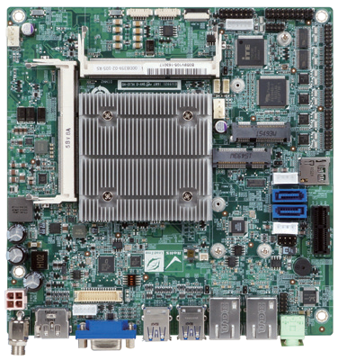TPM
Three Digital Display Interfaces
3 independent displays under Window® 7 OS and up

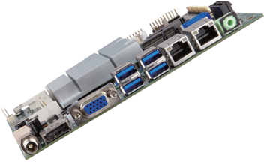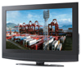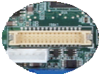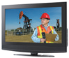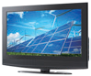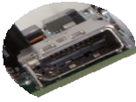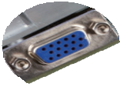RS-232/422/485
LVDS
VGA
HDMI/DP

RS-232

microSD slot

2 x SATA 6Gb/s 1 x PCIe x1

LVDS
Power input

PCIe Mini

Specifications
SoC
Intel® Pentium® N3710 on-board SoC (up to 2.56GHz, quad-core, 2MB cache, TDP=6W) Intel® Celeron® N3160 on-board SoC (up to 2.24GHz, quad-core, 2MB cache, TDP=6W)

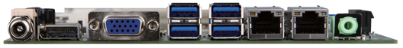DC Power

VGA

USB 3.1 Gen 1

Dual LAN

Audio

Intel® Celeron® N3060 on-board SoC (up to 2.48GHz, dual-core, 2MB cache, TDP=6W) Intel® Celeron® N3010 on-board SoC (up to 2.24GHz, dual-core, 2MB cache, TDP=4W) BIOS
UEFI BIOS
Memory
Two 204-pin 1333/1600 MHz single-channel DDR3L SDRAM unbuffered SO-DIMM slots support up to 8 GB
DDR3L
1.35V
USB
USB 3.1
mSATA Expansion Thin Type
PCIe Mini
Display
Triple
Graphics Engine
Intel® HD Graphics Gen 8 Engines with 16 low-power execution units, supporting DX11.1, OpenGL 4.2 and OpenCL1.2
Display Output
Triple independent display
1 x HDMI/DP (up to 3840x2160@30Hz)
Jack
HDMI+DP

1 x 18/24-bit dual-channel LVDS (up to 1920x1200@60Hz) 1 x VGA (up to 1920x1200@60Hz)
tKINO-BW-2019-V10
Ethernet
Dual Realtek RTL8111E PCIe GbE controller External I/O Interface
4 x USB 3.1 Gen 1 (5Gb/s)
Internal I/O Interface
1 x KB/MS (1x6 pin) 2 x SATA 6Gb/s with 5V output
1 x MicroSD card slot 2 x USB 2.0 (2x4 pin, P=2.54) 1 x mSATA (colay SATA2) 4 x RS-232 (2x5 pin, P=2.0)
2 x RS-232/422/485 (2x5 pin, P=2.0)
Front Panel
- x Front panel (2x7 pin, power LED, HDD LED, speaker, power button, reset button) LAN LED
- x LAN LED (1x2 pin)
SMBus
1 x SMBus (1x4 pin) TPM
1 x TPM (2x10 pin)
I²C
1 x I²C (1x4 pin) Digital I/O
8-bit digital I/O (2x5 pin)
Expansion 1 x PCIe x1
1 x Full-size PCIe Mini card slot Audio
Realtek ALC662 HD codec
1 x Audio jacks (line-out) on rear IO 1 x Front audio (2x5 pin)
Watchdog Timer: Software programmable supports 1~255 sec. system reset Power Supply
1 x External DC power jack (ø5.5 mm)
1 x Internal power connector (2x2 pin) Input Voltage Range: 9V ~ 30V Support AT/ATX mode
Fan Connector
1 x CPU smart fan (1x4 pin)
1 x System smart fan (1x4 pin) Power Consumption
12V@1.61A (Intel® Celeron® N3710 CPU with two 4 GB 1600 MHz DDR3L memory)
Operating Temperature: -20°C ~ 60°C Storage Temperature: -30°C ~ 70°C
Operating Humidity: 5% ~ 95%, non-condensing Weight: GW: 900g / NW: 400g
CE/FCC compliant

Features
- Thin Mini-ITX form factor with 14nm Intel® Pentium®/Celeron® on-board SoC processor supports DDR3L memory
- Supports USB 3.1 Gen 1 (5Gb/s), two SATA 6Gb/s
- Triple independent display, supporting 4K resolution
- Supports IEI jumperless function

Packing List

1 x tKINO-BW single board computer with heatsink
1 x I/O shielding
1 x SATA cable
1 x QIG

Ordering Information

Part No. | Description
tKINO-BW-N4-R20 | Thin Mini-ITX SBC supports Intel® Pentium® quad-core processor N3710 up to 2.56GHz (6W), VGA/LVDS/DP+HDMI, SATA, dual GbE, USB 3.1 Gen 1 (5Gb/s), HD Audio and RoHS
tKINO-BW-N3-R20 | Thin Mini-ITX SBC supports Intel® Celeron® quad-core processor N3160 up to 2.24GHz (6W), VGA/LVDS/DP+HDMI, SATA, dual GbE, USB 3.1 Gen 1 (5Gb/s), HD Audio and RoHS
tKINO-BW-N2-R20 | Thin Mini-ITX SBC supports Intel® Celeron® dual-core processor N3060 up to 2.48GHz (6W), VGA/LVDS/DP+HDMI, SATA, dual GbE, USB 3.1 Gen 1 (5Gb/s), HD Audio and RoHS
tKINO-BW-N1-R20** | Thin Mini-ITX SBC supports Intel® Celeron® dual-core processor N3010 up to 2.24GHz (4W), VGA/LVDS/DP+HDMI, SATA, dual GbE, USB 3.1 Gen 1 (5Gb/s), HD Audio and RoHS
32205-002700-200-RS | RS-232/422/485 cable, 200mm, P=2.0
TPM-IN01-R20 | 20-pin Infineon TPM module, software management tool, firmware v3.17
**By order production, MOQ: 100

