Single Board Computer

Industrial Motherboard

w w w . i ei w or l d .c om

KINO-QM770
Mini-ITX SBC with Socket G2 for Intel® 22nm mobile CPU, DVI-I, dual HDMI, LVDS, dual PCIe GbE, USB 3.1 Gen 1 (5Gb/s), PCIe Mini, SATA 6Gb/s and audio
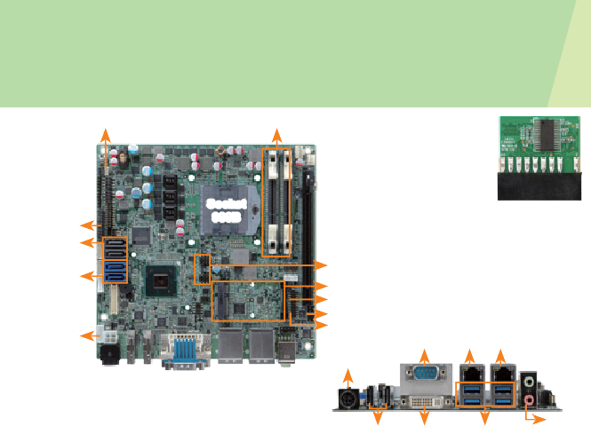
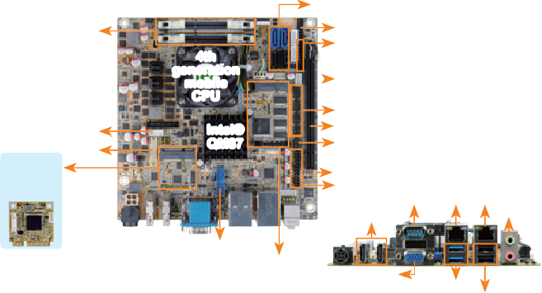SMBus 2 x DDR3 SO-DIMM
2 x SATA 6Gb/s
2 x SATA 3Gb/s
Dual-channel DDR3 1600/1333 MHz
Front panel TPM
4th generation mobile CPU

RS-422/485
Intel® QM87
4 x RS-232 PCIe x16 DIO
Slot for iRIS-1010
module in the bottom side
iDP
LVDS
SMBus
6 x USB 2.0
Combo RJ-45:
Dual HDMI
RS-232 GbE1 GbE2 / IPMI
Audio
USB 3.1 Gen 1
PCIe Mini (supports mSATA)
VGA
2 x USB 3.1 Gen 1
KINO-DQM871-i1
Mini-ITX SBC supports 4th generation 22nm Intel® mobile processors, HDMI/ VGA/LVDS/DP, dual Intel® PCIe GbE, USB 3.1 Gen 1 (5Gb/s), SATA 6Gb/s, iRIS-1010, audio and RoHS

TPM
SATA 3Gb/s SATA 6Gb/s

KB/MS

Socket 988B

4 x USB 2.0
PCIe Mini card RS-232
IR DIO

12V DC-in

COM

TPM 1.2 Support

LAN2 LAN1

HDMI DVI-I 4 x USB 3.1

Audio

Specifications
CPU

External I/O Interface
2 x USB 2.0

Specifications

CPU: Socket G2 for 3rd generation Intel® 22nm
(DVI+VGA)

External I/O Interface
Gen 1

Intel® mobile Core™ i7-4700EQ on-board processor with Intel® AMT 9.0 support (2.4GHz, quad-core, 6MB cache, TDP=47W)
Intel® mobile Core™ i5-4402E on-board processor with Intel® AMT 9.0 support (1.6GHz, dual-core, 3MB cache, TDP=25W)
Intel® mobile Core™ i5-4400E on-board processor with Intel® AMT 9.0 support (2.7GHz, dual-core, 3MB cache, TDP=37W) (by request) Chipset: Intel® QM87
Memory: Two 204-pin 1600/1333 MHz dual- channel DDR3 SDRAM unbuffered DIMMs support up to 16 GB
BIOS: UEFI BIOS
Ethernet
LAN1: Intel® I217LM with Intel® AMT 9.0 support LAN2: Intel® I210-AT PCIe controller
Graphics Engine
Intel® HD Graphics Gen 7.5 supports DX11.1 and OpenCL 1.2, OpenGL 3.2
Full MPEG2, VC1, AVC Decode Audio
Realtek ALC662 HD codec supports 5.1-channel 2 x Audio jacks (line-out, mic-in) on rear IO
iRIS Remote Management Module 1 x iRIS-1010 slot
LAN LED: 2 x LAN LED (1x2 pin)
Display Output
1 x VGA (up to 1920x1200@60Hz)
1 x 18/24-bit dual-channel LVDS (up to 1920x1200@60Hz)
2 x HDMI (up to 2500x1600@60Hz)
1 x iDP interface for HDMI, LVDS, VGA, DVI, DP (up to 3840x2160@60Hz)

Packing List
1 x KINO-DQM871-i1 motherboard | 2 x SATA with power output cable
1 x CPU cooler | 1 x Mini jumper pack
1 x I/O shielding | 1 x QIG

Ordering Information
1 x RS-232 2 x USB 2.0
2 x USB 3.1 Gen 1 (5Gb/s) Internal I/O Interface
- x KB/MS (1x6 pin)
1 x RS-422/485 (1x4 pin, P=2.0)
- x SATA 3Gb/s
2 x SATA 6Gb/s (RAID 0/1/5/10 supported)
2 x USB 3.1 Gen 1 (5Gb/s) (2x10 pin, P=2.0)
4 x RS-232 (2x5 pin, P=2.0)
6 x USB 2.0 (2x4 pin, P=2.54)
Front Panel: 1 x Front panel (2x7 pin, power LED, HDD LED, speaker, power button, reset button)
SMBus: 1 x SMBus (1x4 pin) TPM: 1 x TPM (2x10 pin)
Expansion: 1 x PCIe x16 slot
1 x Full-size PCIe Mini card slot (support mSATA)
Watchdog Timer: Software programmable, support 1~255 sec. system reset
Digital I/O: 8-bit digital I/O (2x5 pin)
Fan Connector: 1 x CPU smart fan (1x4 pin) 1 x System smart fan (1x4 pin)
Power Supply: 12V DC input
1 x Internal power connector (2x2 pin) 1 x External DC jack (4-pin DIN) Support AT/ATX mode
Power Consumption: 12V@6.03A (Intel® Core™ i7-4770EQ, 2.4GHz CPU with 8 GB (two 4 GB)
1333 MHz DDR3 memory)
Operating Temperature: -20°C ~ 60°C Operating Humidity: 5% ~ 95%, non-condensing Dimensions: 170mm x 170mm
Weight: GW: 900g / NW: 450g CE/FCC compliant

mobile processor Chipset: Intel® QM77
Memory: Two 240-pin 1600/1333 MHz dual- channel DDR3 SDRAM unbuffered DIMMs support up to 16 GB
BIOS: UEFI BIOS
Ethernet
LAN1:Intel® 82579 PHY with Intel® AMT 8.0 support
LAN2:Intel® 82583V PCIe controller Graphics Engine
Supports DX11 and OpenGL 3.1 Full MPEG2, VC1, AVC Decode Display Output
1 x DVI-I (up to 1920x1200@60Hz)
- x 18/24-bit dual-channel LVDS (up to 1920x1200@60Hz)
2 x HDMI (up to 1920x1200@60Hz) Audio
Realtek ALC892 HD codec
- x Audio jacks (line-out, mic-in) on rear IO 1 x Front Audio (2x5 pin)
SMBus: 1 x SMBus (1x4 pin) TPM: 1 x TPM (2x10 pin)
Expansion
1 x PCIe x16 slot 1 x PCIe Mini card slot Digital I/O: 8-bit digital I/O (2x5 pin)

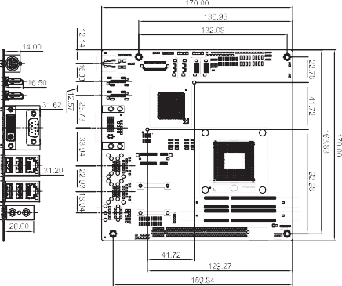
Dimensions (Unit: mm)

x RS-232 4 x USB 3.1 Gen 1 (5Gb/s)
Internal I/O Interface 1 x KB/MS (1x6 pin) 2 x SATA 3Gb/s
1 x RS-232 (2x5 pin, P=2.0)
- x SATA 6Gb/s (RAID 0/1/5/10 supported) 1 x RS-422/485 (1x4 pin, P=2.0)
4 x USB 2.0 (2x4 pin, P=2.54)
Watchdog Timer: Software programmable supports 1~255 sec. system reset
Infrared Interface: 1 x Infrared interface (1x5 pin) Fan Connector
1 x CPU smart fan (1x4 pin) 1 x System fan (1x3 pin) Power Supply
12V DC input
1 x Internal power connector (2x2 pin) 1 x External DC jack (4-pin DIN) Support AT/ATX mode
Power Consumption
12V@6.08A (2.3GHz Intel® Core™ i7-3610QE with two 1333 MHz 4 GB DDR3 memory running 3DMark06 burn in)
Operating Temperature: -10°C ~ 60°C Storage Temperature: -20°C ~ 70°C
Operating Humidity: 5% ~ 95%, non-condensing
Dimensions: 170 mm x 170 mm Weight: GW: 900g / NW: 450g CE/FCC compliant

KINO-DQM871-i1-2019-V10

Packing List
Part No. | Description
KINO-DQM871-i1-i7-R10 | Mini-ITX SBC supports Intel® 22nm mobile Core™ i7- 4700EQ on-board processor, HDMI/VGA/LVDS/DP, AMT 9.0, dual Intel® PCIe GbE, USB 3.1 Gen 1 (5Gb/s), SATA 6Gb/s, iRIS-1010, audio and RoHS
KINO-DQM871-i1-i5E-R10 | Mini-ITX SBC supports Intel® 22nm mobile Core™ i5-4402E on-board processor, HDMI / VGA / LVDS / DP, dual Intel® PCIe GbE, AMT 9.0, USB 3.1 Gen 1 (5Gb/s), SATA 6Gb/s,  iRIS-1010, audio and RoHS
iRIS-1010-R10 | IPMI 2.0 adapter card with AST1010 BMC chip (W/O KVM over IP function) for PCIe Mini socket interface
19800-000300-100-RS | RS-232 cable with bracket, 300mm, P=2.0
19800-003100-100-RS | Dual port USB 2.0 cable with bracket, 300mm, P=2.54
19800-010500-200-RS | USB 3.1 Gen 1 (5Gb/s) cable with bracket, 450mm
32000-023800-RS | PS/2 KB/MS cable, 135mm/110mm, P=2.0
32205-003800-200-RS | RS-422/485 cable, 200mm, P=2.0
DP-DP-R10 | DisplayPort converter board (for IEI iDP connector)
DP-DVI-R10 | DisplayPort to DVI-D converter board (for IEI iDP connector)
DP-HDMI-R10 | DisplayPort to HDMI converter board (for IEI iDP connector)
DP-LVDS-R10 | DisplayPort to 24-bit dual-channel LVDS converter board (for IEI iDP connector)
DP-VGA-R10 | DisplayPort to VGA converter board (for IEI iDP connector)
TPM-IN01-R20 | 20-pin Infineon TPM module, software management tool, firmware v3.17

1 x KINO-QM770 single board computer | 2 x SATA with power output cable
1 x I/O shielding | 1 x Mini jumper pack
1 x RS-232 cable with bracket | 1 x QIG
Ordering Information
Part No. | Description
KINO-QM770-R10 | Mini-ITX SBC with Socket G2 for Intel® 22nm mobile CPU,  DVI-I/dual HDMI/LVDS, dual PCIe GbE, USB 3.1 Gen 1 (5Gb/s), PCIe Mini, SATA 6Gb/s and Audio
19800-003100-100-RS | Dual port USB 2.0 cable with bracket, 300mm, P=2.54
32000-023800-RS | PS/2 KB/MS cable, 135mm/110mm, P=2.0
32205-003800-300-RS | RS-422/485 cable, 200mm, P=2.0
33Z00-000031-RS | DVI-I to VGA adapter connector
CF-989A-RS-R12 | CPU cooler for mobile socket-G (PGA988) up to 55W processor, copper, 60 x 60 x 27.6mm, RoHS
SACF-KIT01-R10 | SATA to CF converter board
TPM-IN01-R20 | 20-pin Infineon TPM module, software management tool, firmware v3.17

