Single Board Computer

Industrial Motherboard

w w w . i ei w or l d .c om

KINO-DAL
Mini-ITX SBC supports Intel® 14nm Atom™, Pentium® or Celeron® on-board SoC with HDMI/LVDS/VGA, Dual PCIe GbE, USB 3.1 Gen 1 (5Gb/s), PCIe Mini, M.2, SATA 6Gb/s, COM, Audio and RoHS

MicroSD (optional)

2 x DDR3L SO-DIMM

Front Panel TPM LVDS KB/MS
Triple Independent Displays

USB 2.0

USB 2.0 B Key M.2

RS-232

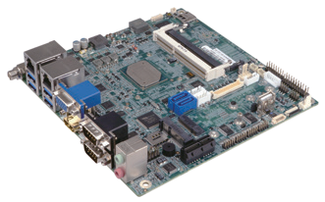Full/Half size
VGA
HDMI
LVDS
PCIe Mini card slot
Dual LAN VGA

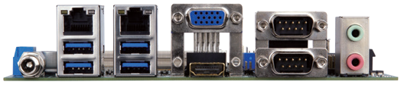PCIe x1

MicroSIM (optional) Front Audio

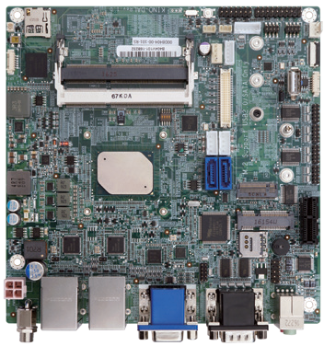Specifications
SoC

DIO

2 x SATA 6Gb/s
12V
power input

USB 3.1 Gen 1 HDMI COM 1/2 Line-out/ Mic

DDR3L

Intel® Atom® x7-E3950 on-board SoC (up to 2.0GHz, quad-core, 2M Cache, TDP=12W)
KINO-DAL-2019-V10
Intel® Atom® x5-E3940 on-board SoC (up to 1.8GHz, quad-core, 2M Cache, TDP=9W) Intel® Atom® x5-E3930 on-board SoC (up to 1.8GHz, dual-core, 2M Cache, TDP=6W) Intel® Pentium® N4200 on-board SoC (up to 2.5GHz, quad-core, 2M Cache, TDP=6W) Intel® Celeron® N3350 on-board SoC (up to 2.4GHz, dual-core, 2M Cache, TDP=6W) BIOS
UEFI BIOS
Memory
Two 204-pin 1866/1600MHz Dual-channel DDR3L SO-DIMMs support up to 8GB Graphics Engine
Intel® HD Graphics Gen9 Low Power; 18 Execution Units
4K Codec Decode & Encode for HEVC 4 , H.264, VP8, SVC, MVC Display Output
Triple independent display
1 x 18/24-bit dual-channel LVDS (up to 1920x1200@60Hz) 1 x VGA (up to 1920x1200@60Hz)
1 x HDMI (up to 3840x2160@30Hz)
Ethernet: 2 x PCIe GbE LAN Intel® i211 AT controller External I/O Interface
4 x USB 3.1 Gen 1 (5Gb/s)
2 x RS-232/422/485
Internal I/O Interface
1 x eMMC 5.0 (optional, up to 32G) 1 x KB/MS (1x6 pin)
- x MicroSD card slot (optional) 4 x RS-232 (2x5 pin, P=2.0) 1 x USB 2.0 (180° Type-A) 4 x USB 2.0 (2x4 pin, P=2.0)
- x SATA 6Gb/s with 12/5V SATA power connector SMBus: 1 x SMBus (1x4 pin)
I²C: 1 x I²C (1x4 pin) TPM: 1 x TPM (2x10 pin)
Audio
Realtek ALC662 HD codec
2 x Audio jacks (line-out, mic-in) on rear IO 1 x Front audio (2x5 pin)
Front Panel
1 x Front panel (2x7 pin, power LED, HDD LED, speaker, power button, reset button) LAN LED: 2 x LAN LED (1x2 pin)
Expansion
1 x PCIe x1 card slot
1 x Full/Half-size PCIe Mini card slot
1 x M.2 B key (2242/2260/2280, USB 2.0 & colay SATA2)
Digital I/O: 8-bit digital I/O (2x5 pin) Fan Connector
1 x CPU smart fan (1x4 pin)
1 x System smart fan (1x3 pin) Power Supply
12V only DC input as Default/ 9V~30V DC input (optional)
1 x Internal power connector (2x2 pin) 1 x External DC power Jackc (Ø5.5mm) Support AT/ATX mode
Watchdog Timer
Software programmable, supports 1~255 sec. system reset Power Consumption
12V@3.64A (Intel® Pentium® N4200 CPU with two 8GB 1600MHz DDR3L memory)
Operating Temperature: -20°C ~ 70°C / -40°C ~ 85°C (KINO-DAL-ExW2) Storage Temperature: -40°C ~ 85°C
Operating Humidity: 5% ~ 95%, non-condensing Dimensions: 170mm x 170mm
Weight: GW: 1100g / NW: 700g CE/FCC compliant

USB
Fanless Jumper-less M.2/NGFF USB 3.1 SATA 6Gb/s PCIe GbE

Features
- Mini-ITX SBC supports Intel® 14nm Atom®, Pentium® or Celeron® on-board SoC
supports dual-channel DDR3L SO-DIMMs
- Triple independent display support
- Optional wide range 9V~30V DC input design
- Full size PCIe Mini slot for 3G/LTE expansion
- COM, USB 3.1 Gen 1 (5Gb/s), SATA 6Gb/s, M.2, eMMC 5.0 and audio support
- IEI one key recovery solution allows you to create rapid OS backup and recovery

Packing List

1 x KINO-DAL single board computer with heatsink | 1 x I/O Shielding
1 x SATA with power cable kit | 1 x QIG
Ordering Information

Part No. | Description
KINO-DAL-N2-R10** | Mini-ITX SBC supports Intel® 14nm quad-core Pentium® N4200 2.5GHz on-board SoC with HDMI/LVDS/VGA, Dual PCIe GbE, USB 3.1 Gen 1 (5Gb/s), PCIe Mini, M.2, SATA 6Gb/s, COM,  Audio and RoHS
KINO-DAL-N1-R10 | Mini-ITX SBC supports Intel® 14nm dual-core Celeron® N3350 2.3GHz on-board SoC with HDMI/LVDS/VGA, Dual PCIe GbE, USB 3.1 Gen 1 (5Gb/s), PCIe Mini, M.2, SATA 6Gb/s, COM,  Audio and RoHS
KINO-DAL-J2-R10 | Mini-ITX SBC supports Intel® 14nm quad-core Celeron® J3455 2.3GHz on-board SoC with HDMI/LVDS/VGA, Dual PCIe GbE, USB 3.1 Gen 1 (5Gb/s), PCIe Mini, M.2, SATA 6Gb/s, COM,  Audio and RoHS
KINO-DAL-E3W2-R10** | Mini-ITX SBC supports Intel® 14nm quad-core Atom® x7-E3950 2.0GHz on-board SoC with HDMI/LVDS/VGA, Dual PCIe GbE, USB 3.1 Gen 1 (5Gb/s), PCIe Mini, M.2, SATA 6Gb/s, COM,  Audio and RoHS, -40°C ~ 85°C
KINO-DAL-E2W2-R10** | Mini-ITX SBC supports Intel® 14nm quad-core Atom® x5-E3940 1.8GHz on-board SoC with HDMI/LVDS/VGA, Dual PCIe GbE, USB 3.1 Gen 1 (5Gb/s), PCIe Mini, M.2, SATA 6Gb/s, COM,  Audio and RoHS, -40°C ~ 85°C
KINO-DAL-E1W2-R10** | Mini-ITX SBC supports Intel® 14nm dual-core Atom® x5-E3930 1.8GHz on-board SoC with HDMI/LVDS/VGA, Dual PCIe GbE, USB 3.1 Gen 1 (5Gb/s), PCIe Mini, M.2, SATA 6Gb/s, COM,  Audio and RoHS, -40°C ~ 85°C
32000-070301-RS | Dual-port USB cable, 210mm, P=2.0
32000-023800-RS | PS/2 KB/MS cable, 135mm, P=2.0
32205-002700-200-RS | RS-232 cable, 200mm, P=2.0
TPM-IN02-R20 | 20-pin Infineon TPM 2.0 module, software management tool, firmware v5.5
**By order production, MOQ: 100

