Single Board Computer

Industrial Motherboard

w w w . i ei w or l d .c om

KINO-AQ170
Mini-ITX SBC supports LGA 1151 Intel® Core™ i7/i5/i3, Pentium® or Celeron® CPU with Intel® Q170, HDMI 2.0/HDMI+DP/VGA, Dual Intel® GbE, SATA 6Gb/s, USB 3.1 Gen 1 (5Gb/s), PCIe Mini, HD Audio and RoHS

Dual-channel DDR4 2133 MHz

Front panel
HDMI 2.0 Ultra HD (4,096x2,160@60Hz)

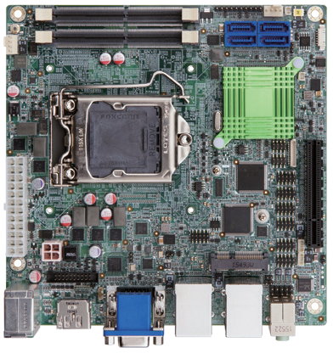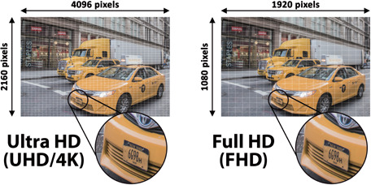SATA 6Gb/s

USB 2.0
4 x RS-232

PCIe x8

2 x RS-232/422/485
 | HDMI 1.4 | HDMI 2.0
Bandwidth | 10.2Gbps | 18Gbps
4K@30hz | Yes | Yes
4K@60hz | No | Yes
Up to 32 Audio Channels | No | Yes

iDP

Specifications
CPU

DIO PCIe Mini (mSATA support)
VGA LAN 1 LAN 2

LGA 1151 socket supports Intel® 6th/7th generation Core™ i7/i5/i3, Pentium® or Celeron® processor
Chipset Intel® Q170 BIOS
UEFI BIOS
Memory
Two 260-pin 2133 MHz dual-channel DDR4 SDRAM SO-DIMM support up to 64GB Graphics Engine
Intel® HD Graphics Gen 9 support for DX11/12, OCL 2.x, OGL 4.3/4.4, ES 2.0
Decode/Encode for HEVC, VP8, VP9 2, VDENC Display Output
Triple independent display
1 x HDMI 2.0 (up to 4096x2160@60Hz)
1 x HDMI/DP (up to 3840x2160@60Hz) 1 x VGA (up to 1920x1200)

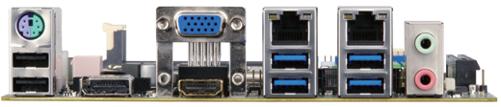2 x USB 2.0 HDMI+DP HDMI 2.0

DDR4

2133

Features

ULTRAHD

4 x USB 3.1 Gen 1
USB
USB 3.1

Audio
Expansion
PCIe Mini

- x iDP interface for HDMI, LVDS, VGA, DVI, DP (up to 3840x2160@60Hz) Ethernet
KINO-AQ170-2019-V10
LAN1: Intel® I219LM with (Intel® AMT 11.0 support)
LAN2: Intel® I211 PCIe controller with NCSI support External I/O Interface
- x USB 2.0
4 x USB 3.1 Gen 1 (5Gb/s) Internal I/O Interface
2 x RS-232/422/485 (2x5 pin, P=2.0)
4 x RS-232 (2x5 pin, P=2.0)
4 x SATA 6Gb/s (RAID 0/1/5/10 supported) 4 x USB 2.0 (2x4 pin, P=2.0)
Audio
Realtek ALC662 HD Audio codec
2 x Audio jacks (line-out, mic-in) on rear IO 1 x Front audio (2x5-pin)
Front Panel
1 x Front panel (1x10 pin, power LED, HDD LED, power button, reset button) LAN LED: 2 x LAN LED (1x2 pin)
SMBus: 1 x SMBus (1x4 pin) I²C: 1 x I²C (1x4 pin)
Digital I/O: 8-bit digital I/O (2x5 pin) Expansion
1 x PCIe x8 slot
1 x Full-size PCIe Mini card slot (support mSATA)
Chassis Intrusion Detection: 1 x Chassis intrusion connector (1x2 pin) Watchdog Timer
Software programmable supports 1~255 sec. system reset by super I/O
Power Supply ATX power supply Fan Connector
1 x CPU smart fan (1x4 pin)
1 x System smart fan (1x4 pin) Power Consumption
3.3V@0.62A, 5V@3.3A, 12V@7.51A, 5VSB@0.23A
(Intel® Core™ i7 6700K 4.0GHz CPU with 16 GB (two 8 GB) 2133 MHz DDR4 memory) Operating Temperature: -20°C ~ 60°C
Operating Humidity: 5% ~ 95%, non-condensing Dimensions: 170mm x 170mm
Weight: GW: 900g / NW: 450g CE/FCC compliant
- LGA 1151 Intel® 6th/7th generation Core™ i7/i5/i3, Pentium® or Celeron® processor
and DDR4 2133MHz memory support
- Support HDMI 2.0 (4096x2160@60Hz)
- Dual Intel® GbE support Intel® AMT 11.0
- Triple display via HDMI 2.0/HDMI/DP 1.2/VGA/iDP
- High speed I/O interface for USB 3.1 Gen 1 (5Gb/s), SATA 6Gb/s and mSATA support
- Support IEI jumpless

Packing List

1 x KINO-AQ170 single board computer | 2 x SATA cable
1 x I/O shielding | 1 x QIG

Ordering Information

Part No. | Description
KINO-AQ170-R10 | Mini-ITX SBC supports 6th generation Intel® Core™ i7/i5/i3, Pentium® and Celeron® processor, HDMI 2.0/HDMI/DP/VGA, SATA 6Gb/s, dual Intel® GbE, USB 3.1 Gen 1 (5Gb/s), PCIe Mini, HD Audio and RoHS
32001-008600-200-RS | Dual-port USB cable, 210mm, P=2.0
32205-002700-200-RS | RS-232/422/485 cable, 230mm, P=2.0
CF-1156C-R20 | LGA1155/LGA1156 cooler kit, 1U chassis compatible, 45W
CF-1156D-R20 | LGA1155/LGA1156 cooler kit, 1U chassis compatible, 65W
CF-115XE-R10 | High performance LGA1155/LGA1156 cooler kit, 95W
DP-DP-R10 | DisplayPort to DP converter board (for IEI connector)
DP-DVI-R10 | DisplayPort to DVI-D converter board (for IEI connector)
DP-HDMI-R10 | DisplayPort to HDMI converter board (for IEI connector)
DP-LVDS-R10 | DisplayPort to 24-bit dual-channel LVDS converter board (for IEI connector)
DP-VGA-R10 | DisplayPort to VGA converter board (for IEI connector)

