Single Board Computer

Industrial Motherboard

w w w . i ei w or l d .c om

IMBA-Q170-i2
ATX motherboard supports 14nm LGA1151 Intel® CPU, Intel® Q170, DDR4, triple independent display VGA/ DVI-D/ HDMI 2.0, dual Intel® PCIe GbE, USB 3.1 Gen 1 (5Gb/s), SATA 6Gb/s, HD Audio, IPMI 2.0 and RoHS

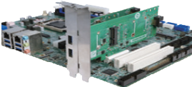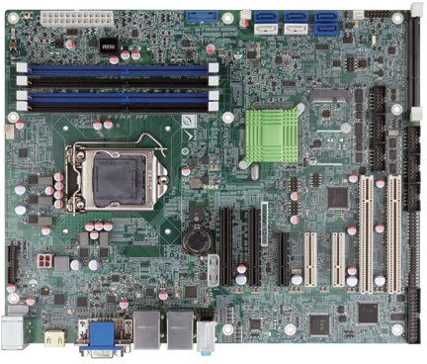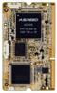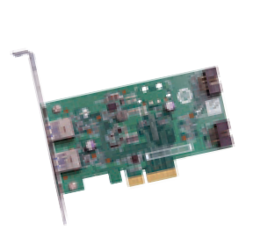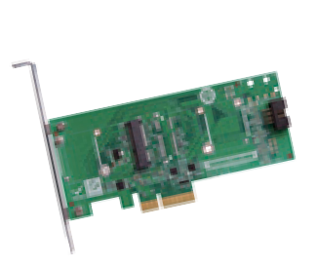Dual-channel DDR4
2133 MHz USB 3.1 Gen 1
6 x SATA 6Gb/s

Front panel

Slot for iRIS-2400 module (optional)
Flexible I/O support
IEI USB 3.1 Gen 1 (5Gb/s) & mSATA/PCIe Mini expansion card
The expansion card can provide more choices to meet users demand

Intel® Q170
RS-232/422/485

RS-232

PCIE-USB3S

Combo RJ-45 LAN2/IPMI

PCIE-2PIMSATA

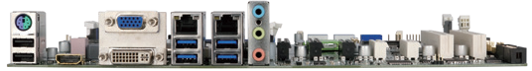KB/MS VGA LAN 1
TPM

iDP

KB/MS

PCIe x 4
DDR4
2133
Display
Triple
USB
USB 3.1 SATA 6Gb/s PCIe GbE

PCIe Mini

LPT

2 x USB 2.0
HDMI 2.0

DVI-D

Audio 4 x USB 3.1 Gen 1
Intel®
AMT 11

USB 2.0

Specifications
CPU
2 x PCIe x8
2 x PCIe x4
flexible I/O
2 x PCI

LGA 1151 socket supports Intel® 6th/7th generation Core™ i7/i5/i3, Pentium® or Celeron® processor
IMBA-Q170-i2-2019-V11
Chipset Intel® Q170 Memory
Four 288-pin 2133 MHz dual-channel DDR4 SDRAM unbuffered DIMMs support up to 64 GB
BIOS: UEFI BIOS
Graphics Engine
Intel® HD Graphics Gen 9 engine with 16 low-power execution units, supports DX11/12, OpenGL 4.3/4.4 and OpenCL2.x, ES 2.0
Display Output
Triple independent display
1 x VGA (up to 1920x1200@60 Hz)
1 x DVI-D (up to 1920x1200@60Hz)
1 x HDMI 2.0 (up to 4096x2160@60Hz)
- x iDP interface for HDMI, LVDS, VGA, DVI, DP (up to 3840x2160@60Hz) Ethernet
LAN1: Intel® I219LM with Intel® AMT 11.0 support
LAN2: Intel® I210AT PCIe controller with NCSI support External I/O Interface
- x USB 2.0
4 x USB 3.1 Gen 1 (5Gb/s) Internal I/O Interface
1 x KB/MS (1x6 pin) 4 x RS-232 (2x5 pin, P=2.54)
1 x LPT (2x13 pin, P=2.54) 4 x USB 2.0 (2x4 pin, P=2.0)
2 x USB 3.1 Gen 1 (5Gb/s) (2x10 pin, P=2.0) 6 x SATA 6Gb/s (RAID 0/1/5/10 supported) 2 x RS-232/422/485 (2x5 pin, P=2.54)
SMBus: 1 x SMBus (1x4 pin) I²C: 1 x I²C (1x4 pin)
TPM: 1 x TPM (2x10 pin)
Audio
Realtek ALC662 HD codec supports 5.1-channel 3 x Audio jacks (line-out, line-in, mic-in) on rear IO 1 x Front audio (2x5 pin)
Front Panel
1 x Front panel (2x7 pin, power LED, HDD LED, speaker, power button, reset button) LAN LED: 2 x LAN LED (1x2 pin)
Expansion
- x Full-size PCIe Mini card slot (support mSATA) 2 x PCI slot
- x PCIe x 8 slot (Gen3) 3 x PCIe x 4 slot (Gen3)
iRIS Remote Management Module: 1 x iRIS-2400 slot
Watchdog Timer: Software programmable supports 1~255 sec. system reset Digital I/O: 8-bit digital I/O (2x5 pin)
Fan Connector
- x CPU smart fan (1x4 pin)
- x System smart fan (1x3 pin)
Chassis Open: 1 x Chassis intrusion (1x2 pin) Power Supply: ATX/AT power supply
Power Consumption
3.3V@1.65A, 5V@3.4A, 12V@8.58A, 5VSB@3.4A
(Intel® Core™ i7 6700K 4.0GHz CPU with 32 GB (four 4 GB) 2133 MHz DDR4 memory) Operating Temperature: -20°C ~ 60°C
Storage Temperature: -30°C ~ 70°C
Operating Humidity: 5% ~ 95%, non-condensing Dimensions: 244mm x 305mm
Weight: GW: 1200g / NW: 700g CE/FCC compliant

Features
- LGA 1151 Intel® 6th/7th generation Core™ i7/i5/i3, Pentium® or Celeron® processor
supported
- Dual-channel DDR4 2133 MHz
- Support triple display with HDMI, DVI and VGA
- Support USB 3.1 Gen 1 (5Gb/s), SATA 6Gb/s and PCI Express Gen3
- Support IPMI 2.0 via iRIS-2400 module
- IEI One Key Recovery solution allows you to create rapid OS backup and recovery

Packing List

1 x IMBA-Q170-i2 single board computer | 2 x SATA cable
1 x I/O shielding | 1 x QIG
Ordering Information

Part No. | Description
IMBA-Q170-i2-R10 | ATX motherboard supports 14nm LGA1151 Intel® CPU, Intel® Q170, DDR4, triple independent display VGA/ DVI-D/ HDMI 2.0, dual Intel® PCIe GbE, USB 3.1 Gen 1 (5Gb/s), SATA 6Gb/s, HD Audio, IPMI 2.0 and RoHS
IMBA-Q170-ECO-R10 | ATX motherboard supports 14nm LGA1151 Intel® CPU, Intel® Q170, DDR4, triple independent display VGA/ DVI-D/ HDMI 2.0, dual Intel® PCIe GbE, USB 3.1 Gen 1 (5Gb/s), SATA 6Gb/s, HD Audio, ECO packing and RoHS
iRIS-2400-R10 | IPMI 2.0 adapter card with AST2400 BMC chip for DDR3 SO- DIMM socket interface
PCIES-2PIMSATA-R10 | Peripheral card for flexible I/O, 1 x PCIe Mini, 2 x mSATA  expansion
PCIES-USB3-R10 | Peripheral card for flexible I/O, USB 3.1 Gen 1 (5Gb/s) expansion
19800-000049-RS | LPT flat cable, 240mm, P=2.54
19800-000075-RS | PS/2 KB/MS cable with bracket, 220mm, P=2.0
19800-003100-100-RS | Dual port USB cable with bracket, 30mm, P=2.54
19800-010500-200-RS | USB 3.1 Gen 1 (5Gb/s) cable 457mm with bracket
32102-000100-200-RS | SATA power cable, MOLEX 5264-4P to SATA15P
32205-000702-100-RS | RS-232 cable, 230mm, P=2.54
CF-115XC-R10 | LGA1155/LGA1156 cooler kit, 1U chassis compatible, 45W
CF-115XD-R10 | LGA1155/LGA1156 cooler kit, 1U chassis compatible, 65W
CF-115XE-R10 | High-performance LGA1155/1156 cooler kit, 95W
DP-DP-R10 | DisplayPort to DisplayPort converter board (for IEI iDP connector)
DP-DVI-R10 | DisplayPort to DVI-D converter board (for IEI iDP connector)
DP-HDMI-R10 | DisplayPort to HDMI converter board (for IEI iDP connector)
DP-LVDS-R10 | DisplayPort to 24-bit dual-channel LVDS converter board (for IEI iDP connector)
DP-VGA-R10 | DisplayPort to VGA converter board (for IEI iDP connector)
TPM-IN02-R20 | 20-pin Infineon TPM 2.0 module, software management tool, firmware v5.5

