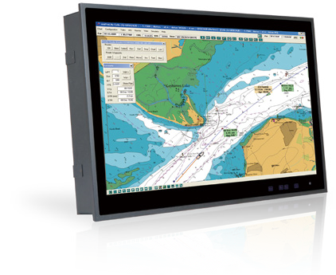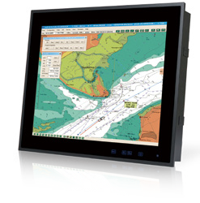
Display System
Specifications
w w w . i ei w or l d .c om
Marine Monitor Series
19” IP66 Marine Monitors
24” IP66 Marine Monitors
S24M
S19M

Features
- IP66 Front / IP22 Rear
- -15°C ~ +55°C Wide Temperature and Flat-bezel Projected Capacitive Touchscreen
- Excellent Visual Performance
  - Full OSD function configuration
  - 0%~100% full range dimming
  - 178°/178° wide viewing angles
- Multiple Video Input
  - Two VGA, two DVI, and one BNC
- Multiple Video Output
  - One VGA and one BNC
- Dual Isolated AC/DC Input with Redundant Power Protection
- Remote OSD Settings through LAN, RS-232, RS-422 and RS-485

Model |  | S19M | S24M
LCD | LCD Size | 19” | 24”
 | Panel Type | PMVA | AMVA
 | Max. Resolution | 1280 x 1024 (5:4) | 1920 x 1080 (16:9)
 | Contrast Ratio | 2000 : 1 | 5000 : 1
 | Brightness (cd/m²) | 300 | 300
 | LCD Color | 16.7M | 16.7M
 | Pixel Pitch (um) | 294 x 294 | 276.75 x 276.75
 | Viewing Angles (H-V) | 178° / 178° | 178° / 178°
 | Backlight MTBF (HRs) | 50000 | 50000
Touchscreen & Controller |  | EXC7920 (10-point), 6H | EXC7200 (2-point), 6H
Scalar Chip |  | STDP8028
I/O Ports |  | - DVI-D Signal Input: 2 x DVI (24-pin, female)  - VGA Signal Input: 2 x D-sub (15-pin, female)  - VGA Signal Output: 1 x D-sub (15-pin, female) - Clone of VGA IN*  - Composite Video Input: 1 x BNC connector (female) Composite Video Output: 1 x BNC connector (female)  - RS-232/422/485 for Remote control (non-isolated)  - Touchscreen: 1 x USB Type A connector (female)  - Ethernet: 1 x RJ-45 connector for remote control  - Isolated AC Power Inlet: 100V~240V AC  - Isolated DC Terminal Block: 18V~36V DC  - 1 x Buzzer
PIP |  | Yes
OSD Button |  | P-CAP button (LCD on/off, Menu, Auto, Up, Down, Left, Right)
LED/Sensor |  | Ambient light sensor (0%~100%)
Power Requirement |  | Multi-power Supply:  Isolated AC Power: 100-240V, 2-1A, 50-60Hz Isolated DC Power: 18-36V, 8-4A
Operating Temperature |  | -15°C ~ 55°C
Storage Temperature |  | -20°C ~ 60°C
Humidity |  | 5% to 95% RH
Thermal Design |  | Fanless
Housing |  | Aluminum front , sheet metal back (Black C)
Cut-out Dimensions (W x L) |  | 442 mm x 373 mm | 576 mm x 358 mm
Dimensions (W x L x D) |  | 463 mm x 394 mm x 113 mm | 592 mm x 374 mm x 113 mm
Mounting |  | VESA 100mm x 100mm | VESA 100mm x 100mm
Net Weight (kg) |  | 7.74 | 11.48
Gross Weight (kg) |  | 11.54 | 15.97
Approvals |  | EMC: CE, FCC
 |  | Safety: DNV, IEC 60945 4th, IACS-E10
 |  | IP Rating: IP66 front, IP22 rear

Ordering Information
w w w . i ei w or l d .c om

PN | Description
S19M-AD/PC-R11 | 19” SXGA 300cd/m² Marine Display with AC and DC redundant power, PCAP touch screen, R11
S24M-AD/PC-R11 | 24” FHD 300cd/m2 Marine Display with AC and DC redundant power, PCAP touch screen, R11

Options

Item | Part No. | Description
Panel Mount Kit | PK-S19M-R10 | For S19M
 | PK-S24M-R10 | For S24M
Desktop Stand | STAND-A21-R10 | For S19M & S24M

RJ-45 Network

Packing List

Item | Q'ty | Remark
VGA | 1 | VGA signal cable
DVI | 1 | DVI signal cable
USB | 1 | USB touchscreen cable
Power Cord | 1 | Power cord
S19M or S24M | 1

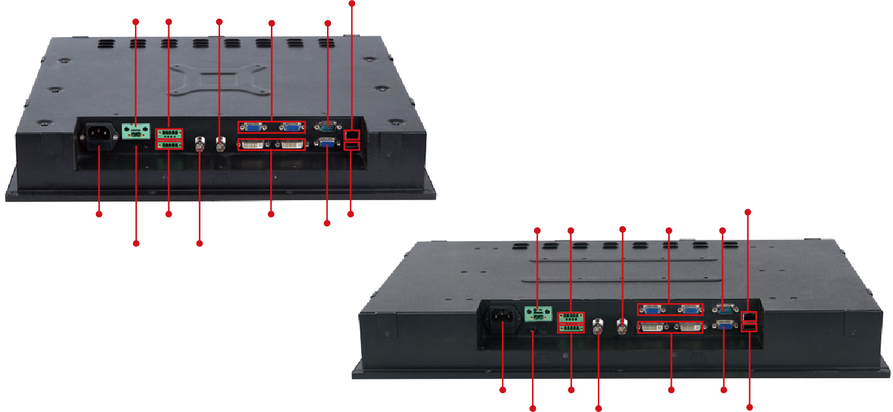
18V~36V DC Input Buzzer BNC Out 2 x VGA RS-232
S19M
Fully Integrated I/O
100V~240V AC Input RS-422/485
2 x DVI In
USB Touch
VGA Out
RJ-45 Network
18V~36V DC Input Buzzer BNC Out 2 x VGA RS-232
Grounding Screw BNC In
S24M
Fully Integrated I/O
100V~240V AC Input
RS-422/485
2 x DVI In VGA Out

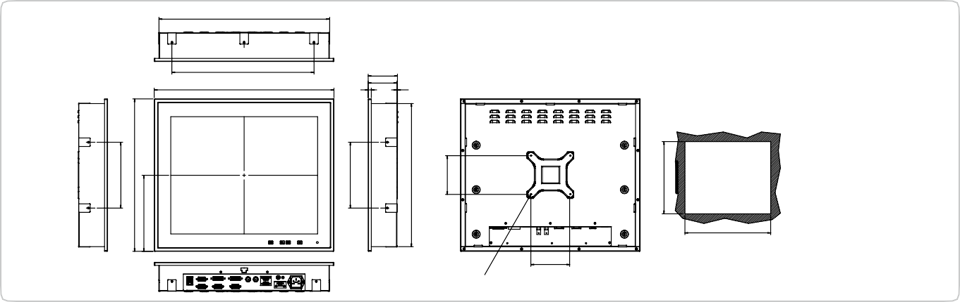Grounding Screw
100
VESA MOUNT M4 SCREW
441.80
Suggested Cut Out Size
74
75.50
8 1.50
S19M Dimensions
(Unit: mm)
366
463
438.80
170
394
170
369.80
100
372.80
BNC In
USB Touch

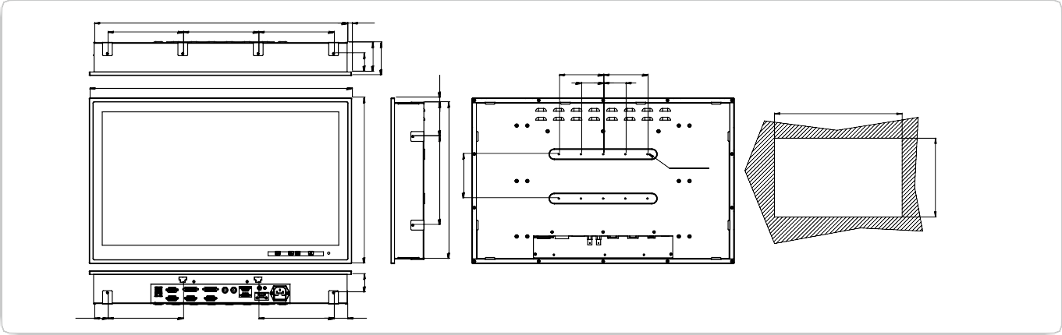
Display System
170
571
170
10.50
170
100
100
S24M Dimensions
(Unit: mm)
592
50 50
575.60
10-M4-KFE-L8
Suggested Cut out Size
1:4
30.50
169.85
169.85
30.50
196.45
41.30
374
41.30
66
74
200
353
100
76.50
10.50
356

