Single Board Computer

Half-size

w w w . i ei w or l d .c om

PICOe-HM650
Half-size PCIe CPU Card supports Socket 988B Intel® Mobile Core™ i7/ i5/i3 or Celeron® CPU with Intel® HM65, DDR3, VGA, LVDS, Dual PCIe GbE, SATA 6Gb/s, HD Audio and RoHS

RS-422/485 Dual-channel DDR3

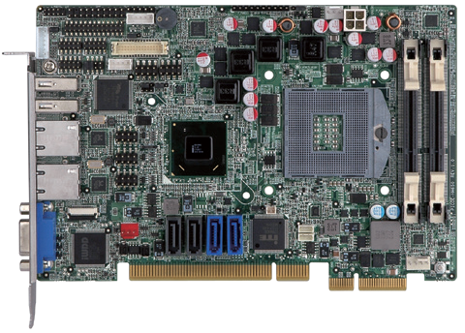Audio
TPM
IR Inverter LVDS
Front audio
1333/1066 MHz

LPT
KB/MS DIO

2 x USB 2.0
2 x RS-232

Dual LAN

LAN1

Intel HM65

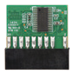
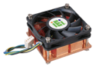VGA

CPU cooler

6 x USB 2.0
2 x SATA 6Gb/s
I²C SMBus

2 x SATA 3Gb/s
P/N: CF-989A-RS-R12 TPM 2.0 Support

Specifications
PICOe-HM650-2019-V11
CPU
LGA 1155 socket supports Intel® Core™ i7/i5/i3, Pentium® or Celeron® processor Chipset
Intel® B65
Memory
One 240-pin 1333/1066 MHz dual-channel DDR3 & DDR3L SDRAM unbuffered DIMMs support up to 8 GB
BIOS UEFI
Graphics Engine
Intel® HD Graphics Gen 6 supports DX10.1 and OpenGL 3.0 Full MPEG2, VC1, AVC decoding
Display Output
1 x VGA (up to 2048x1536@75Hz) Ethernet
LAN1: Realtek RTL8111E PCIe GbE controller with ASF 2.0 support
LAN2: Realtek RTL8111E PCIe GbE controller External I/O Interface
2 x USB 2.0
Internal I/O Interface
1 x KB/MS (1x6 pin) 1 x SATA 6Gb/s
1 x LPT (2x13 pin) 2 x RS-232 (2x5pin, P=2.0)
1 x SATA 3Gb/s 2 x USB 2.0 (2x4 pin, P=2.0)
Audio
Supports 7.1-channel HD Audio by IEI AC-KIT-892HD-R10 kit Front Panel
1 x Front panel connector (1x10 pin, power LED, HDD LED, speaker, power button,
reset button) TPM
1 x TPM (2x10 pin)
SMBus
1 x SMBus (1x4 pin) I²C
1 x I²C (1x4 pin)
Expansion
PCIe signal and PCI signal via golden finger Watchdog Timer
Software programmable supports 1~255 sec. system reset
Digital I/O
8-bit digital I/O (2x5 pin) Fan Connector
1 x CPU smart fan (1x4 pin)
1 x System smart fan (1x4 pin) Power Supply
5V/12V, AT/ATX support
Power Consumption
5V@3.17A, 12V@0.46A, Vcore_12V@7.26A, 5VSB@0.18A
(3.4GHz Intel® Core™ i7-2600K with two 2 GB 1333 MHz DDR3 memory) Operating Temperature
-10°C ~ 60°C
Storage Temperature
-20°C ~ 70°C
Operating Humidity
5% ~ 95%, non-condensing Dimensions
185 mm x 122 mm
Weight
GW: 1000g / NW: 260g
CE/FCC compliant

Features

SATA 3Gb/s

PCIe GbE
DDR3
1333
- Half-size PCIe CPU card supports Socket G2 32nm Intel® Core™ i7/i5/i3 or Celeron® processor
- Up to 16 GB 1333/1066 MHz dual-channel DDR3 SDRAM
- Supports 18/24-bit dual-channel LVDS and analog CRT output
- High-speed I/O interface provided through the 2nd gen PCIe add-on card and SATA 6Gb/s connectors
- Rich media acceleration for hardware encoding and decoding
- TPM V1.2 hardware security provided by the TPM module
- IEI One Key Recovery solution allows you to create raipd OS backup and recovery

Packing List

1 x PICOe-B650 single board computer
1 x Dual RS-232 cable with bracket
1 x USB cable | 1 x Mini jumper pack
2 x SATA cable | 1 x QIG

Ordering Information

Part No. | Description
PICOe-B650-R10 | Half-size PCIe CPU card supports 32nm LGA 1155 Intel® Core™ i7/i5/i3, Pentium® or Celeron® CPU with Intel® B65, DDR3, VGA, dual Realtek PCIe GbE, USB 2.0, SATA 6Gb/s, HD Audio and RoHS
19800-000075-RS | PS/2 KB/MS cable with bracket, 220mm, P=2.0
32102-000100-200-RS | SATA power cable, MOLEX 5264-4P to SATA15P
AC-KIT-892HD-R10 | 7.1-channel HD Audio kit with Realtek ALC892 supports dual audio streams
CF-115XA-R10 | High-performance LGA 1155/LGA 1156 cooler kit, 1U chassis compatible, 73W
CPU-DT-C-G440 | Intel® Celeron® G440 processor, LGA -1155, single core 1.6GHz, 1M cache, 35W, compatible with CF-115XC-R10 CPU cooler
CPU-DT-i3-2120T | Intel® Core™ i3-2120T processor, LGA 1155, dual core 2.6GHz, 3M cache, 35W, compatible with CF-115XC-R10 CPU cooler
CPU-DT-i5-2390T | Intel® Core™ i5-2390T processor, LGA -1155, dual core 2.7GHz, 3M cache, 35W, AMT, compatible with CF-115XC-R10 CPU cooler
CPU-DT-i5-2500T | Intel® Core™ i5-2500T processor, LGA -1155, quad core 2.3GHz, 6M cache, 45W, compatible with CF-115XC-R10 CPU cooler
CPU-DT-P-G630T | Intel® Pentium® G630T processor, LGA 1155, dual core 2.3GHz, 3M cache, 35W, compatible with CF-115XC-R10 CPU cooler
SAIDE-KIT01-R10 | SATA to IDE/CF converter board
TPM-IN01-R20 | 20-pin Infineon TPM module, software management tool, firmware v3.17

