Single Board Computer

Half-size

w w w . i ei w or l d .c om

IOWA-LX
Half-size Pure ISA CPU Card with On-board AMD Geode™ LX600 Processor (366 MHz), 128KB L2 cache, On-board 128MB Memory, VGA, LAN, USB 2.0, CF, COM, LPT, Audio and RoHS

Inverter
SMBus
IDE
Infrared
RS-232/422/485

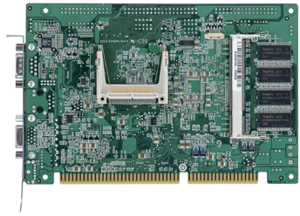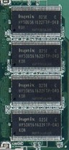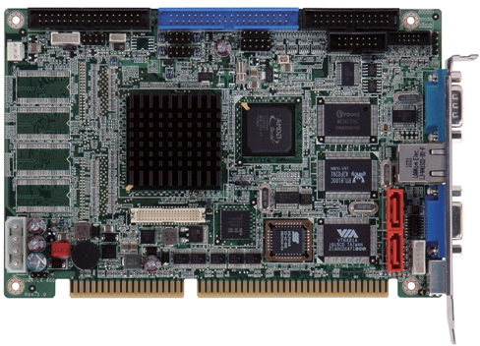RS-232
On-board 128MB memory
FDD 4 x USB 2.0
DIO
LPT
Audio
AMD LX600
24-bit TTL
KB/MS

LAN

Specifications
CPU

2 x SATA

VGA

KB/MS
CF Type II DDR SO-DIMM
up to 512 MB

Performance Comparison Chart
ZD CPU MARK 99
IOWA-LX platform can easily replace the IOWA-GX platform without any impact to the system for increased levels of performance.
14.1
28.4

30

25

20

15

10

On-board AMD Geode™ LX600 processor (366 MHz), 128KB L2 cache Chipset
IOWA-LX-2019-V10
AMD Geode™ CS5536
BIOS
Award BIOS Memory
One 200-pin 266/200 MHz DDR SDRAM SO-DIMMs supports up to 512MB
On-board 128MB DDR 266/200 MHz memory Graphics Engine
VGA integrated in the AMD Geode™ LX600
Display Output
Single HD VOP 2.0 output 1 x VGA (up to 1920x1440) 1 x TFT (up to 1600x1200) External I/O Interface
1 x KB/MS 1 x RS-232
Internal I/O Interface
1 x CF Type II 1 x RS-232/422/485 (2x7 pin, P=2.54)
- x FDD (2x17 pin) 1 x LPT (2x13 pin)
1 x IDE (2x10 pin) 4 x USB 2.0 (2x4 pin, P=2.54)
- x SATA (RAID 0/1 supported on IOWA-LX-600S-R10) Ethernet
10/100Mbps Realtek RTL8100C Ethernet controller
Audio
Realtek ALC203 with AC’97 codec 1 x Front audio (2x5 pin) Expansion
ISA bus supported via golden finger Digital I/O
8-bit digital I/O (2x5 pin)
Infrared Interface
1 x Infrared Interface (1x5 pin) Watchdog Timer
Software programmable supports 1~255 sec. system reset
FAN connctor
1 x Smart fan (1x3 pin) Power supply
5V/12V, AT/ATX support
Power Consumption 5V@1.51A, 5VSb@0.09A
(On-board AMD Geode™ LX 600 CPU 366 MHz with 128MB 200 MHz on- board DDR memory and 512MB 333 MHz DDR memory)
Operating Temperature
-10ºC ~ 60ºC Storage Temperature
-20°C ~ 70°C
Operating Humidity
5% ~ 95%, non-condensing Weight
GW: 1000g / NW: 250g
CE/FCC compliant
5

0
IOWA-LX IOWA-GX

Geode™
AMD

Fanless
CERTIFIED USB
USB 2.0
Hi-Speed

Features
- ISA CPU card with on-board AMD Geode™ LX600 processor (366 MHz), 128KB L2 cache
- Flexible on-board DDR SDRAM and one SO-DIMM slot
- Enchanced TTL, RS-232, RS-422/485 and USB 2.0 interfaces for extened connectivities
- IEI One Key Recovery solution allows you to create rapid OS backup and recovery

Packing List

1 x IOWA-LX-600 single board computer
1 x Audio cable
1 x IDE flat cable
1 x KB/MS Y cable
1 x USB cable
1 x Mini jumper pack
1 x QIG
Ordering Information

Part No. | Description
IOWA-LX-600-R10 | Half-size pure ISA CPU card with on-board AMD Geode™ LX600 processor (366 MHz), 128KB L2 cache, on-board 128MB memory VGA, LAN, USB 2.0, COM, CF, LPT, audio and RoHS
IOWA-LX-600S-R10 | Half-size pure ISA CPU card with on-board AMD Geode™ LX600 processor (366 MHz), 128KB L2 cache, on-board 128MB memory VGA, LAN, USB 2.0, SATA, CF, COM, LPT, Audio and RoHS
19800-000049-RS | LPT flat cable, 240mm, P=2.54
19800-004400-200-RS | RS-232 & RS-422/485 cable with bracket, 14-pin to two DB-9, 255mm, P=2.54
32801-000703-500-RS | SATA (7-pin to 7-pin) cable, 500mm
32200-000017-RS | FDD Cable, 520mm, P=2.54

