Single Board Computer

Full-size

w w w . i ei w or l d .c om

Half-size PICMG 1.3 CPU Card supports LGA 1151 Intel® Xeon® E3, Core™ i3/Pentium®/ Celeron® CPU with Intel® C236, ECC & non-ECC DDR4 SO-DIMM, VGA, iDP, Dual Intel® PCIe GbE, USB 3.1 Gen 1 (5Gb/s), SATA 6Gb/s, mSATA, HD Audio, Intel® AMT and RoHS
HPCIE-C236

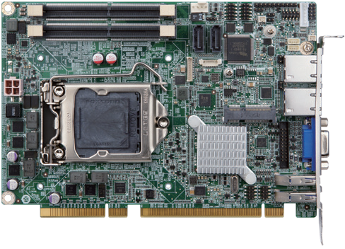Dual-channel DDR4
2 x RS-232/422/485

PCIe Mini slot provides mSATA and USB signal for full-size or

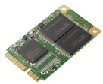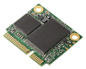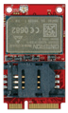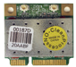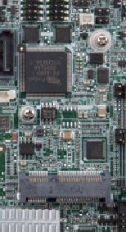1600/2133 MHz 2 x SATA 6Gb/s Front panel
USB Type
mSATA
3G/Wi-Fi/USB devices

HD Audio KB/MS

LAN

half-size mSATA SSD and wireless LAN card.

LGA 1151

Intel ®
C236

VGA

USB 3.1 Gen 1
AMT 11.0
Intel®

Specifications
CPU

4 x USB 2.0
DDR4

2133
USB
USB 3.1 SATA 6Gb/s Dual GbE
mSATA
iDP

LGA 1151 socket supports Intel® Xeon® E3 v5/v6, 6th/7th generation Core™ i3, Pentium® or Celeron® processor
HPCIE-C236-2019-V11
Chipset Intel® C236 Memory
Two 260-pin 1866/2133 MHz dual-channel DDR4 ECC and non-ECC unbuffered SO-
DIMMs support up to 32 GB BIOS
UEFI BIOS
Graphics Engine
Intel® HD Graphics Gen 9 supports DX11/12, OpenCL 2.x and OpenGL 4.3/4.4 Decode/Encode for HEVC, VP8, VP9, VDENC
Display Output
1 x VGA (up to 1920x1200@60 Hz)
- x iDP interface for HDMI, LVDS, VGA, DVI, DP (up to 3840x2160@60 Hz) Ethernet
LAN1: Intel® I219LM Clarkville-V with Intel® AMT 11.0 support
LAN2: Intel® I210 PCIe controller External I/O Interface
- x USB 3.1 Gen 1
Internal I/O Interface
1 x KB/MS (1x6 pin) 2 x SATA 6Gb/s (RAID 0, 1 supported) 1 x mSATA (SATA & USB signal) 4 x USB 2.0 (2x4 pin, P=2.0)
2 x RS-232/422/485 (2x5 pin, P=2.0)
Front Panel
- x Front panel (1x10 pin, power LED, HDD LED, speaker, power button, reset button) LAN LED
- x LAN LED (1x2 pin)
Audio
Support 7.1-channel HD Audio by IEI AC-KIT-892HD kit SMBus
1 x SMBus (1x4 pin)
I²C
1 x I²C (1x4 pin) Expansion
16-lane PCIe signal from CPU via golden finger
(supports x16, or x8 + x8, or x4 + x4 + x8)
4-lane PCIe signal from Q170 via golden finger
1 x Full/Half-size PCIe Mini card slot (supports mSATA) Watchdog Timer
Software programmable supports 1~255 sec. system reset
Digital I/O
8-bit digital I/O (2x5 pin) Fan Connector
1 x CPU smart fan (1x4 pin)
Power Supply
5V/12V, AT/ATX support Power Consumption
5V@0.13A, 12V@7.89A, 3.3V@0.10A, 5VSB@0.20A
(Intel® Xeon® E3-1275 v5 3.60 GHz with two 16 GB 2133 MHz DDR4 memory) Operating Temperature
-20°C ~ 60°C
Operating Humidity
5% ~ 95%, non-condensing Dimensions
169 mm x 126 mm
Weight
GW: 1000g / NW: 420g
CE/FCC compliant

Features
- PICMG 1.3 full-size CPU card
- LGA1151 Intel® 8th Generation Xeon® E3, Core™ i7/i5/i3, Celeron® and Pentium® processor supported
- Dual-channel DDR4 2666MHz
- Support HDMI and DP display
- Intel® PCIe GbE with Intel® AMT 11.0 supported
- Support M.2 M key for storage (PCIe x4)
- Supports RAID 0, 1, 5, 10 function via SATA 6Gb/s

Packing List

1 x HPCIE-C236 single board computer
1 x SATA cable
1 x QIG

Ordering Information

Part No. | Description
HPCIE-C236-R10 | Half-size PICMG 1.3 CPU card supports LGA 1151 Intel® Xeon® E3, Core™ i3/Pentium®/Celeron® CPU with Intel® C236, ECC & non-ECC DDR4 SO-DIMM, VGA, iDP, dual Intel® PCIe GbE, USB 3.1 Gen 1 (5Gb/s), SATA 6Gb/s, mSATA, HD Audio, Intel® AMT and RoHS
19800-000075-RS | PS/2 KB/MS cable with bracket, 220mm, P=2.0
32102-000100-200-RS | SATA power cable, MOLEX 5264-4P to SATA15P
32205-002700-200-RS | RS-232/422/485 cable, 200mm, P=2.0
AC-KIT-892HD-R10 | 7.1-channel HD Audio kit with Realtek ALC892 supports dual audio streams
CF-115XA-R10 | High-performance LGA 1155/LGA 1156 cooler kit, 1U chassis compatible, 73W
CF-115XC-R10 | LGA 1155/LGA 1156 cooler kit, 1U chassis compatible, 45W
CF-115XD-R10 | LGA 1155/LGA 1156 cooler kit, 1U chassis compatible, 65W
DP-DP-R10 | DisplayPort to DisplayPort converter board (for IEI iDP connector)
DP-DVI-R10 | DisplayPort to DVI-D converter board (for IEI iDP connector)
DP-HDMI-R10 | DisplayPort to HDMI converter board (for IEI iDP connector)
DP-LVDS-R10 | DisplayPort to LVDS converter board (for IEI iDP connector)
DP-VGA-R10 | DisplayPort to VGA converter board (for IEI iDP connector)
SAIDE-KIT01-R10 | SATA to IDE/CF converter board

