w w w . i ei w or l d .c om
GRAND-BDE
Powered by an advanced 14nm Intel® Xeon® D 64-bit SoC processor, up to 128GB DDR4 ECC RDIMM RAM / 64GB DDR4 non-ECC UDIMM RAM, and the 12Gb/ s SAS-enabled GRAND-BDE delivers outstanding performance for data transmission and applications. With a thermal design power of only 20-65W, the GRAND- BDE fulfills demands for both performance and energy saving.

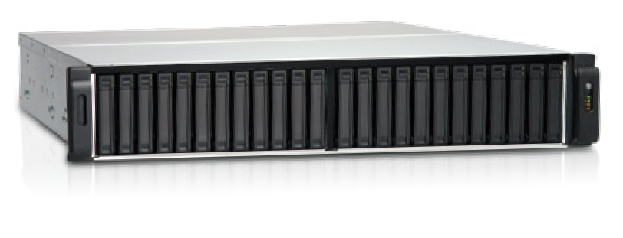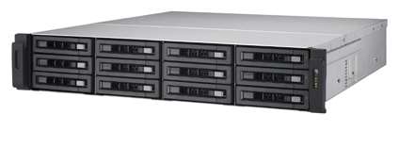Features
- Intel® Xeon® D processor optimizes performance and efficiency
- 4 x DIMM Slots, up to 128 GB memory with 4 x 32GB DIMMs
- 4 x PCIe slot can support 40GbE network card
- Storage expandable, up to 1PB
- 10GbE network card support ready
SAS
Storage
Expansion

Ready

DDR4
up to 128GB RAM
ECC RAM
support

SAS
12Gb/s

Excellent Hardware
Immensely, Durable & Compact
The GRAND-BDE supports SAS 12Gb/s 2.5” drives, allowing for SAS 12Gb/ s and SATA 6Gb/s hard drives and SSDs. Businesses can create the most powerful storage by implementing suitable drives based on their needs.

Expansion Capability
GRAND-BDE provide Five built-in PCIe 3.0 expansion slots provide great expandability options for 10GbE/40GbE network adapters, USB 3.1 Gen 2 (10Gb/s) and 12Gb/s SAS expansion cards, PCIe NVMe SSD - or even a graphics card.

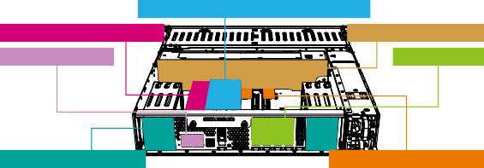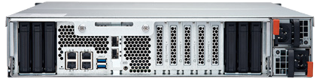
Intel® Xeon® multi-core processor
DDR4 2133 MHz menory Hot swappable fans Gigabit port x 4 PCIe slot x 4
2.5” SATA SSD slot x 6
12Gb/s SAS controllers
4 3 2 1
6 x SATA SSD drive bays
4 x PCIe expansion slots
Optional

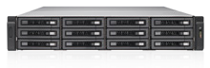
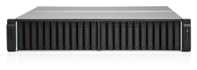
Specifications

Model Name | GRAND-BDE-18B | GRAND-BDE-30B
CPU | Intel® Xeon® Processor D-1521, 4 core 2.4 GHz Intel® Xeon® Processor D-1531, 6 core 2.2 GHz  Intel® Xeon® Processor D-1548, 8 core 2.0 GHz (for GRAND-BDE-30B only)
Memory | Total DIMM slots: 4  Maximum memory: DDR4 128GB (32GB RDIMM x 4)
Drive Tray SSD drive bay x 6 | Front: 2.5” / 3.5” x 12 Rear: 2.5” SSD drive bay x 6 | Front: 2.5” x 24 Rear: 2.5” Rear: 2.5” SSD drive bay x 6
Hard Drive | Front: SAS 12Gb/s, SAS 6Gb/s, SATA 6Gb/s and SSD Rear: SATA 6Gb/s and SSD
Network port | 4 x Gigabit ports
LEDs | 10 GbE network, system status, network, drive LED
Buttons | Power button, Reset button
Form Factor | 2U rack mount
Dimensions (H x W x D) | 88 x 442.5 x 530.5 mm 3.46 x 17.42 x 20.89 inch | 88.3 x 439 x 484.5 mm 3.47 x 17.28 x 19.07 inch
Operating Temperature | 0ºC ~ 40ºC
Relative Humidity | 5 to 95% non-condensing, wet bulb: 27ºC
Power Supply | Redundant power: input 90 to 264VAC: 450W x 2
PCIe Expansion Slots | Quantity: 4  Slot 1: PCIe 3.0 x8 Slot 3: PCIe 3.0 x4  Slot 2: PCIe 2.0 x4 Slot 4: PCIe 3.0 x4 or PCIe 3.0 x8*  Note: Slot 4 provides the bandwidth of PCIe 3.0 x8 when Slot 3 is not in use. Slot 4 then provides the bandwidth of PCIe 3.0 x4 only when an expansion board is installed in Slot 3.
Fan | 4 x 6 cm High efficiency fan
10GbE PCIe Card Slot | Support specific 10GbE network card (P/N: LAN-10G2F-PHY-CS4227)

Ordering Information

Part No. | Description
GRAND-BDE-18B- D1521-R10 | 2U 12Bay front 3.5”, 6bay rear 2.5” HDD or SSD support, rackmount storage server system (Barebone) with Intel® Xeon® D-1521, 450W redundant PSU, RoHS
GRAND-BDE-18B- D1531-R10 | 2U 12Bay front 3.5”, 6bay rear 2.5” HDD or SSD support, rackmount storage server system (Barebone) with Intel®  Xeon® D-1531, 450W redundant PSU, RoHS
GRAND-BDE-30B- D1521-R10 | 2U 24Bay front 2.5”, 6bay rear 2.5” HDD or SSD support, rackmount storage server system (Barebone) wth Intel® Xeon® D-1521, with 450W redundant PSU, RoHS
GRAND-BDE-30B- D1531-R10 | 2U 24Bay front 2.5”, 6bay rear 2.5” HDD or SSD support, rackmount storage server system (Barebone) wth Intel®  Xeon® D-1531, with 450W redundant PSU, RoHS
GRAND-BDE-30B- D1548-R10 | 2U 24Bay front 2.5”, 6bay rear 2.5” HDD or SSD support, rackmount storage serversystem (Barebone) wth Intel® Xeon® D-1548, with 450W redundant PSU, RoHS
*Pre-install Memory by Request

Packing List
Options

Item | Item | Description
Network card | LAN-40G2SF-MLX | Dual-port 40GbE QSFP+ network expansion card
Network card | LAN-10G2SF-MLX | Dual-port 10GbE SFP+ network expansion card
Network card | LAN-10G2T-X550 | Dual-port 10GBASE-T network expansion card
USB card | USB-U31A2P01 | USB 3.1 Gen 2 10Gbps Type-A dual-port PCIe card
SAS Card | SAS-12G2E | Dual port storage expansion, SAS 12Gbps
Rail kit | RAIL-A03-57 | A03 series (Chassis) slide, Maxmium load 57 kg
Cable | CAB-SAS10M-8644 | MiniSAS Cable (SFF-8644 to SFF-8644), 1.0m
 | CAB-SAS05M-8644 | MiniSAS Cable (SFF-8644 to SFF-8644), 0.5m

GRAND-BDE-2019-V10
Data Storage
Ethernet cable x 4 | Flat head screws (for 2.5” HDD)
Power cord x 2 | Flat head screws (for 3.5” HDD, GRAND-BDE-180B only)

