w w w . i ei w or l d .c om
GRAND-AL
The GRAND-AL is a rackmount storage server that easily fits into a standard 19-inch rack, providing an ideal storage solution in the server room for small and medium businesses. The GRAND-AL also provides a wide range of value-added features: 4K video playback and real-time transcoding; and web automation services with IFTTT.

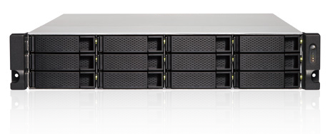
Features
- Intel® Celeron® J3455 quad-core 1.5GHz CPU with AES-NI Encryption
- 2 x SODIMM Slots, up to 8GB memory with 2 x 4GB DIMMs
- Storage expandable via USB 3.1 Gen 1 (5Gb/s), up to 200TB
Intel® Celeron® J3455 quad-core 1.5GHz CPU with AES-NI Encryption
Powered by the latest 14 nm Intel® Celeron® J3455 quad-core 1.5GHz processor (burst up to 2.3 GHz), up to 8GB DDR3L RAM, four Gigabit LAN ports, and SATA 6Gb/s, the GRAND-AL runs tasks smoothly and quickly with up to 415 MB/s read/ write speeds. The GRAND-AL features Intel® AES-NI accelerated encryption to drive transfer speeds of up to 416 MB/s with AES 256- bit encryption for both full storage server volumes and shared folders, boosting system performance while ensuring the confidentiality of sensitive business data stored in the storage server.
File Transfer with Encryption (4 x 1GbE)
Windows Download Windows Upload
416
300
File Transfer (4 x 1GbE)
Windows Download Windows Upload
415
390

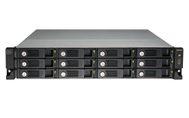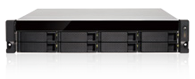Low-cost, Flexible Storage Expansion
Can be connected to 1 UX-800U-RP/ UX-1200U-RP expansion unit
USB 3.1 Gen 1 (5Gb/s)
UX-1200U-RP
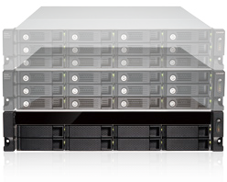

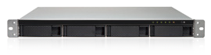
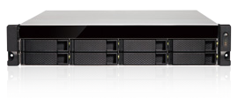
Specifications

MB/s 0

100

200 300

400

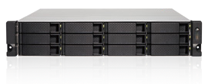
GRAND-AL-2019-V10
Data Storage
Model Name | GRAND-AL-04A | GRAND-AL-04A- RP | GRAND-AL-08B | GRAND-AL-08B- RP | GRAND-AL-12B | GRAND-AL-12B- RP
CPU | Intel® Celeron® J3455 4-core 1.5GHz (burst up to 2.3GHz)
System memory | Total memory slots: 2 SODIMM; Memory expandable up to 8GB DDR3L (4GB x 2)
Drive Trays | 4 |  | 8 |  | 12
Drive Types | SATA 6Gb/s, 3Gb/s HDD or SSD; Hot-swappable
USB | 4 x USB 3.1 Gen 1 (5Gb/s) (Rear)
LAN Ports | 4 x GbE
HDMI Output | 1 x HDMI 1.4b
LED Indicators | System Status, HDD, Expansion, LAN
Buttons | Power, Reset
Form Factor | 1U, rack mountable |  | 2U, rack mountable |  | 2U, rack mountable
Dimensions (H x W x D) | 44 x 439 x 499 mm  1.73 x 17.28 x 19.65 inch |  | 89 x 482 x 534 mm  3.5 x 18.98 x 21.02 inch |  | 89 x 482 x 534 mm  3.5 x 18.98 x 21.02 inch
Net Weight | 7.63 kg (16.82 lbs.) |  | 11.02 kg (24.29 lbs.) |  | 16.14 kg (35.58 lbs.)
Temperature | 0-40ºC
Relative Humidity | 0~95% R.H.
Power Supply | ATX 250W (single) ATX 250W (redundant x 2) |  | ATX 250W (single) ATX 250W (redundant x 2) |  | ATX 350W (single) ATX 250W (Redundant x2)
Fan | 2 x 40mm, 12V |  | DC 2 x 70mm, 12V |  | DC 2 x 70mm, 12V DC

Ordering Information
Part No. | Description
GRAND-AL-04A-R10 | 1U 4Bay front 3.5” HDD or SSD support, rackmount storage server system (Barebone) with Intel® Celeron® J3455, 250W single PSU, RoHS
GRAND-AL-04A-RP-R10 | 1U 4Bay front 3.5” HDD or SSD support, rackmount storage server system (Barebone) with Intel® Celeron® J3455, 250W redundant PSU, RoHS
GRAND-AL-08B-R10 | 2U 8Bay front 3.5” HDD or SSD support, rackmount storage server system (Barebone) with Intel® Celeron® J3455, 250W single PSU, RoHS
GRAND-AL-08B-RP-R10 | 2U 8Bay front 3.5” HDD or SSD support, rackmount storage server system (Barebone) with Intel® Celeron® J3455, 250W redundant PSU, RoHS
GRAND-AL-12B-R10 | 2U 12Bay front 3.5” HDD or SSD support, rackmount storage server system (Barebone) with Intel® Celeron® J3455, 350W single PSU, RoHS
GRAND-AL-12B-RP-R10 | 2U 12Bay front 3.5” HDD or SSD support, rackmount storage server system (Barebone) with Intel® Celeron® J3455, 250W redundant PSU, RoHS
Options Packing List
Item | Order P/N | Description
Rail kit | RAIL-B02 | B02 series slide for 1U, 2U chassis

Ethernet cable x 2 | Flat head screw (for 2.5” HDD)
Power cord x2 (non RP model only one  power cord) | Flat head screw (for 3.5” HDD)

