**PCI-1741U PCI-1742U**

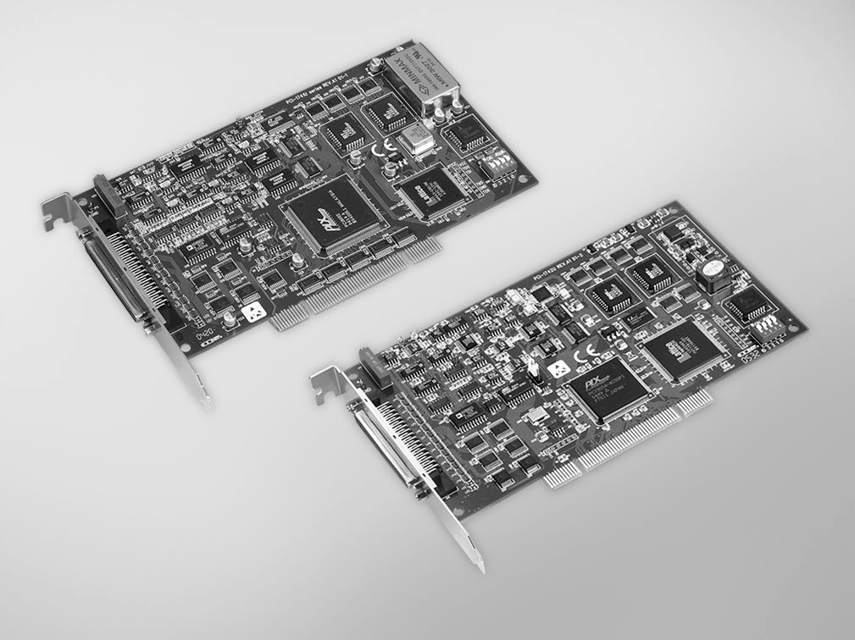

**PCI-1741U**

**PCI-1742U**

RoHS

**COMPLIANT**

2002/95/EC

# Specifications

## Analog Input

* **Channels** 16 single-ended/8 differential (software programmable)
* **Resolution** 16 bits
* **Max. Sampling Rate** PCI-1741U: 200 kS/s

PCI-1742U: single-channel - 1 MS/s

multi-channel - 800 kS/s unipolar bipolar mixed - 250 kS/s

* **FIFO Size** 1,024 samples
* **Overvoltage Protection** 30 Vp-p
* **Input Impedance** 100 M/10pF (Off); 100 M/100pF (On)
* **Sampling Mode** Software, onboard programmable pacer and external
* **Input Range\*** (V, software programmable)

|  |  |  |  |  |  |
| --- | --- | --- | --- | --- | --- |
| **Unipolar** | N/A | 0 ~ 10 | 0 ~ 5 | 0 ~ 2.5 | 0 ~ 1.25 |
| **Bipolar** | ±10 | ±5 | ±2.5 | ±1.25 | ±0.625 |
| **Accuracy (% of FSR ±1LSB)** | 0.02 | 0.02 | 0.02 | 0.03 | 0.04 |

* **Note:** All channels should be set to the same range

# 200 kS/s, 16-bit, 16-ch Universal PCI Multifunction Card

**1 MS/s, 16-bit, 16-ch Universal PCI Multifunction Card**

**Features**

* 16-ch single-ended or 8-ch differential analog input
* PCI-1741U: 16-bit A/D converter, with up to 200 kHz sampling rate PCI-1742U: 16-bit A/D converter, with up to 1 MHz sampling rate
* Onboard FIFO memory (1,024 samples)
* Auto calibration
* PCI-1741U: 1 x 16-bit analog output channel PCI-1742U: 2 x 16-bit analog output channels
* 16-ch digital input and 16-ch digital output
* Universal PCI bus (support 3.3 V or 5 V PCI bus signal)
* Onboard programmable counter
* BoardID™ switch

## Digital Output

### Channels 16

* **Compatibility** 5 V/TTL
* **Output Voltage** Logic 0: 0.8 V max. Logic 1: 2.0 V min.
* **Output Capability** Sink: 24 mA @ 0.8 V

Source: -15 mA @ 2.0 V

## Counter/Timer

### Channels 1

* **Compatibility** 5 V/TTL
* **Resolution** 16 bits
* **Max. Input Frequency** 10 MHz
* **Reference Clock** Internal: 10 MHz

External Clock Frequency: 10 MHz

## Analog Output

* **Channels** PCI-1741U: 1 PCI-1742U: 2
* **Resolution** 16 bits
* **Output Rate** Static update
* **Output Range** (V, software programmable)

|  |  |  |
| --- | --- | --- |
| **Internal Reference** | **Bipolar** | ±5, ±10 |
| **Unipolar** | 0 ~ 5, 0 ~ 10 |
| **External Reference** | | 0 ~ +xV @ +xV (-10  x  10)  -x ~ +xV @ +xV (-10  x  10) |

* **Slew Rate** PCI-1741U: 20 V/us PCI-1742U: 40 V/us
* **Driving Capability** ±20 mA
* **Output Impedance** 0.1 W max.
* **Operation Mode** Software polling
* **Accuracy** INLE: ±2LSB

## Digital Input

### Channels 16

* **Compatibility** 5 V/TTL
* **Input Voltage** Logic 0: 0.8 V max. Logic 1: 2.0 V min.

## General

* **Bus Type** Universal PCI V2.2
* **I/O Connector Type** 1 x 68-pin SCSI female connector

 **Dimensions (L x H)** 175 x 100 mm (6.9" x 3.9")

* **Power Consumption** Typical: 5 V @ 850 mA, 12 V @ 600 mA

Max.: 5 V @ 1 A, 12 V @ 700 m A

* **Operating Temperature** 0 ~ 60° C (32 ~ 140° F) (refer to IEC 68-2-1, 2)
* **Storage Temperature** -20 ~ 70° C (-4 ~ 158° F)
* **Storage Humidity** 5 ~ 95% RH, non-condensing (refer to IEC 68-2-3)

# Ordering Information

* **PCI-1741U** 200 kS/s, 16-bit, 16-ch Univ. PCI Multi. Card
* **PCI-1742U** 1 MS/s, 16-bit, 16-ch Univ. PCI Multi. Card

## Accessories

* **PCL-10168-1** 68-pin SCSI Shielded Cable, 1 m
* **PCL-10168-2** 68-pin SCSI Shielded Cable, 2 m
* **ADAM-3968** 68-pin DIN-rail SCSI Wiring Board
* **PCLD-8710** DIN-rail Wiring Board w/ CJC

**Online Download** [www.advantech.com/product](http://www.advantech.com/product)

s

All product specifications are subject to change without notice Last updated : 5-May-2015