Single Board Computer

Full-size

w w w . i ei w or l d .c om

PICMG 1.3 Passive Backplane for Half-Size CPU Card

Selection Guide

PAC series wall-mount chassis 4U rack-mount chassis

PICMG 1.3 (PCIe+PCI) | Model | HPXE2-5S1 | HPXE2-6S1 | HPXE2-7S1 | HPXE2-8S1
Total Slot |  | 5 | 6 | 7 | 8
Expansion Slots | PCIe x16 | 1 | 1
 | PCIe x8 |  |  | 2 | 2
 | PCIe x4
 | PCIe x1
 | PCI-X
 | PCI | 2 | 3 | 3 | 4
PSU Type |  | 24+4-pin ATX | 24+4-pin ATX | 24+4-pin ATX | 24+4-pin ATX
Chassis Option |  | PR-1500G | PAC-1000 PAC-106G | PAC-700G PAC-1700G | PAC-125G
 |  | RACK-500G |  |  | RACK-3000G RACK-360G
Note |  | ATX power | ATX power | ATX power | ATX power

HPXE2-5S1-R10
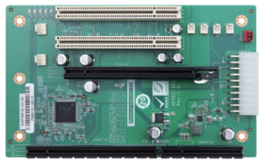
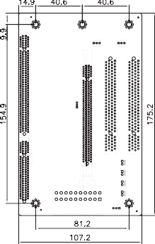

Ordering Information
HPXE2-5S1-R10 | 5-slot PICMG 1.3 backplane for half-size SBC, with two PCI  slots and one PCIe x16 slot (x16 signal)
PR-1500G | 5-slot half-size compact chassis
RACK-500G | 5U 5-slot full-size rackmount chassis
HPXE2-6S1-R10
HPXE2-7S1-R10
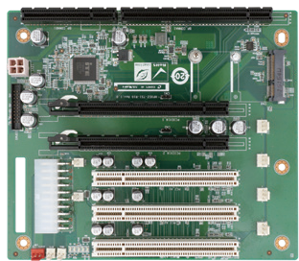
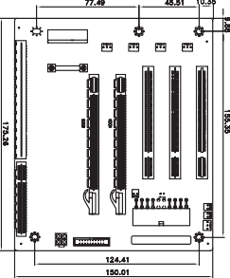

Ordering Information
HPXE2-7S1-R10 | 7-slot PICMG 1.3 backplane for half-size SBC, with three PCI  slots and two PCIe x16 slots (x8 signal)
PAC-700G | 7-slot half-size compact chassis
PAC-1700G | 7-slot full-size compact chassis
HPXE2-8S1-R10

PICMG 1.3-Half-Size-BP-2019-V10
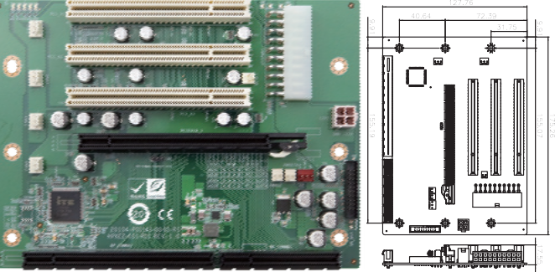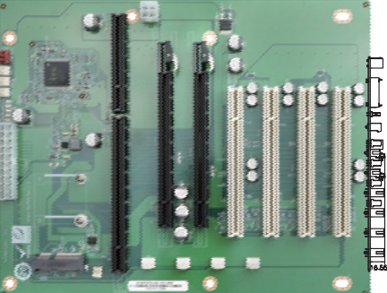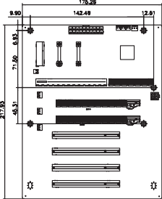
Ordering Information
HPXE2-6S1-R10 | 6-slot PICMG 1.3 backplane for half-size SBC, with three PCI  slots and one PCIe x16 slot (x16 signal)
PAC-1000G | 6-slot full-size compact chassis
PAC-106G | 6-slot full-size compact chassis

Ordering Information
HPXE2-8S1-R10 | 8-slot PICMG 1.3 backplane for half-size SBC, with four PCI  slots and two PCIe x 16 slot (x8 signal)
PAC-125G | 10-slot full-size compact chassis
RACK-3000G | 4U 14-slot full-size rack-mount chassis
RACK-360G | 4U 14-slot full-size rack-mount chassis

