PICMG 1.3 Backplane
Selection Guide PAC series wall-mount chassis 4U rack-mount chassis

Backplane |  | SPE-4S | SPE-6S | SPE-9S | SPXE-11S | SPXE-14S
Total | Slot | 4 | 6 | 7 | 11 | 14
PCIe | x16
 | x8 | 2 (x16 connector) |  | 1 (x16 connector) |  | 1 (x16 connector)
 | x4 | 1 | 5 | 3 | 6 (x16 connector)
 | x1 |  |  |  |  | 12 (x4 connector)
 | PCI-X
 | PCI |  |  | 3 | 4
PSU Type |  | 24+4-pin ATX | 24+4-pin ATX | 24+4-pin ATX | 24+8-pin ATX | 24+8-pin ATX
Chassis Option |  | PAC-106G PAC-1000G | PAC-106G PAC-1000G | PAC-125G | RACK-305G RACK-360G  RACK-3000G | RACK-305G RACK-360G  RACK-3000G

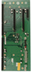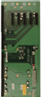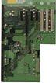IEI Server Grade Backplane Solution
Server Grade Backplane
Example
EX1: 2 x8 & 1 x4 slots
Corresponding Model
SPE-4S

EX2: 1 x8 & 3 x4 slots
SPE-9S
EX3: 5 x4 slots
SPE-6S
SHB x4 x4 x4 x4 x4
SHB x4 x8 x4 x4
SHB x8 x8 x4
Server grade backplane accommodates PCIe x8 and multiple PCIe x4 add-on cards. It is specially designed for intensive data transfer applications such as server data storage and any application that requires more than one PCIe x4 or four PCIe x1 cards. Given the multiple PCIe x4 and x1 support, it provides a more cost effective solution for end- users by reducing the number of systems required.

System Solution for options

Backplane | Total | PCIe |  |  |  |  |  | PSU Type | Chassis Option
 | Slot | x16 | x8 | x4 | x1 | PCI-X | PCI
SPE-4S | 4 | - | 2  (x16 connector) | 1 |  | - | - | 24+4-pin ATX | PAC-106G PAC-1000G
SPE-6S | 6 | - |  | 5 | - | - | - | 24+4-pin ATX | PAC-106G PAC-1000G
SPE-9S | 7 | - | 1  (x16 connector) | 3 |  |  | 3 | 24+4-pin ATX | PAC-125G
SPXE-11S | 11 | - | - | 6  (x16 connector) | - | - | 4 | 24+8-pin ATX | RACK-305G RACK-360G RACK-3000G
SPXE-14S | 14 | - | 1  (x16 connector) | - | 12  (x4 connector) | - | - | 24+8-pin ATX | RACK-305G RACK-360G RACK-3000G
SPE-4S-R10
Server Grade

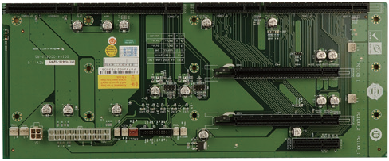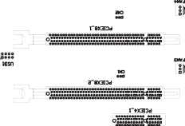

Ordering Information
SPE-4S-R10 | 4-slot PICMG 1.3 backplane with two PCIe x16 slots (x8 signal) and one PCIe x4 slot
PAC-106G | 6-slot full-size compact chassis
PAC-1000G | 6-slot full-size compact chassis

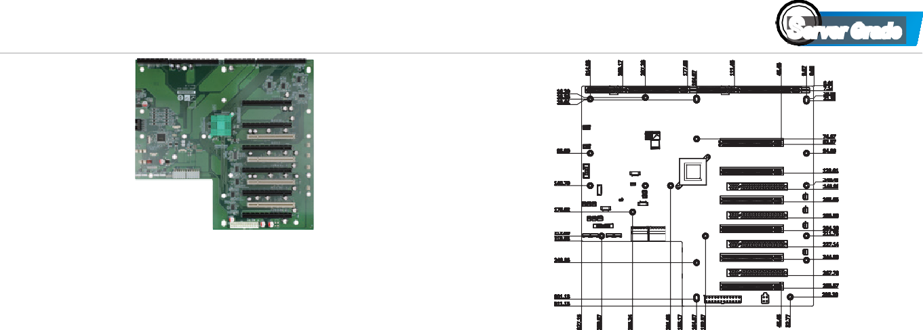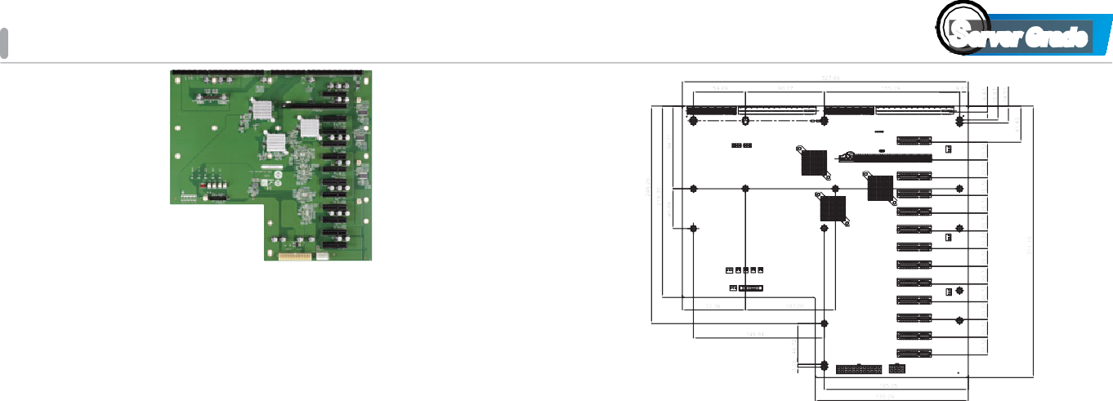
SPXE-11S-R10
Server Grade
SPXE-14S-R20
Server Grade
SPE-6S-R10
Server Grade

Ordering Information
SPE-6S-R10 | 6-slot PICMG 1.3 backplane with five PCIe x4 slots
PAC-106G | 6-slot full-size compact chassis
PAC-1000G | 6-slot full-size compact chassis
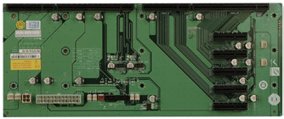
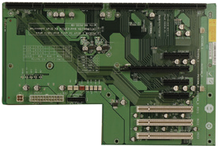
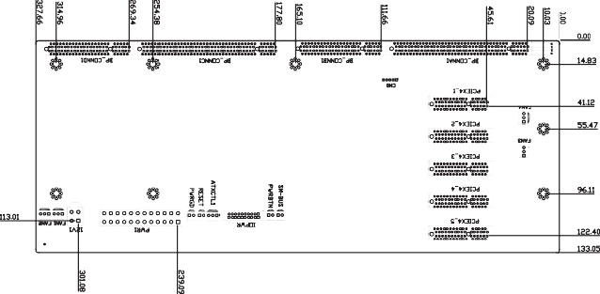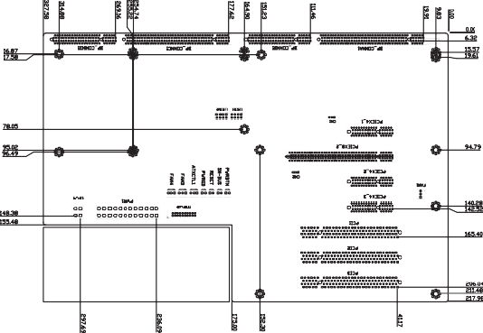Note: PCIEX4_3 can not work with SPCIE-C2060, SPCIE-C2160, SPCIE-C22260, SPCIE-C236 & HPCIE-C236.
SPE-9S-R11
Server Grade

Ordering Information
SPE-9S-R11 | 7-slot PICMG 1.3 backplane with one PCIe x16 slot (x8  signal), three PCIe x4 slots and three PCI slots
PAC-125G | 10-slot full-size compact chassis

Ordering Information
SPXE-11S-R10 | 11-Slot PICMG 1.3 PCIe to PCIe Switch (PLX PEX8724)  Backplane, 6 PCIe Gen 3.0 x4 w/ x16 slot,4 PCI, RoHS
RACK-305G | 4U 14-slot full-size rack-mount chassis
RACK-360G | 4U 14-slot full-size rack-mount chassis
RACK-3000G | 4U 14-slot full-size rack-mount chassis

Ordering Information
SPXE-14S-R20 | 14-slot PICMG 1.3 backplane with one PCIe x16 slot  (x8 signal) and twelve PCIe x4 slots (x1 signal)
RACK-305G | 4U 14-slot full-size rack-mount chassis
RACK-360G | 4U 14-slot full-size rack-mount chassis
RACK-3000G | 4U 14-slot full-size rack-mount chassis

